**Experiment 13**

**Aim:**

To write an ARM Assembly Language to implement the equations

* ax2 + by2
* 6(x+y)+2z+4

**Tool Used:** Keil uVision4

**Equation 1 Code**

  AREA PROGRAM, CODE, READONLY

 ENTRY

MAIN

        LDR R0, X

        LDR R1, Y

        LDR R2, A

        LDR R3, K

        MUL R4,R1,R1 ; y^2

        MUL R5,R0,R0 ; x^2

        MUL R6,R3,R4 ; ky^2

        MUL R7,R5,R2 ; ax^2

        ADDS R8,R7,R6 ; ax^2 + ky^2

        ADDCS R9,R9,#1

        SWI &11

 AREA PROGRAM, DATA, READONLY

X DCD &3

Y DCD &1

A DCD &2

K DCD &2

 END

**Output:**

The expected result 14 is displayed in R8.

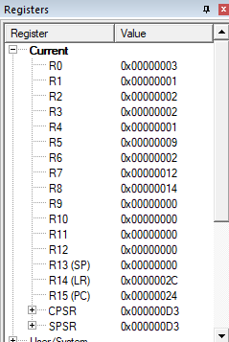

**Equation 2 Code**

  AREA PROGRAM, CODE, READONLY

 ENTRY

MAIN

        LDR R0, X

        LDR R1, Y

        LDR R2, Z

        MOV R7, #6;

        ADD R3,R0,R1 ; X+Y

        MUL R4,R3,R7 ; 6(X+Y)

        MOV R2,R2,LSL #1 ; 2Z

        ADDS R5,R2,R4 ; 6(X+Y) + 2Z

        ADDCS R5,R5,#5;

        ADDCC R5,R5,#4;

        SWI &11

 AREA PROGRAM, DATA, READONLY

X DCD &3

Y DCD &1

Z DCD &2

 END

**Output:**

The expected result 20 is displayed in R5.

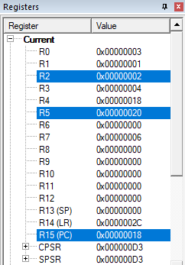

**Result:**

The experiment to implement both the equations is found valid and correct.