**Experiment 1**

**Aim:**

1. Load a value on to R0 and copy it using move command into other general purpose registers.
2. Addition of two values with immediate, direct and indirect mode of addressing

**Tool Used:**

Keil uVision4

**Theory:**

LDR loads the value into the register, MOV copies the value at 2nd register to the 1st register. Here we have loaded the value of R0 with the direct value using = keyword.

**Part A:**

**Code:**

 AREA PROGRAM, CODE, READONLY

 ENTRY

MAIN

  LDR R0, =0x00000001 ;Load value of R0

  ;copy the value to all other registers

  MOV R1, R0

  MOV R2, R0

  MOV R3, R0

  MOV R4, R0

  MOV R5, R0

  MOV R6, R0

  MOV R7, R0

 MOV R8, R0

 MOV R9, R0

 MOV R10, R0

 MOV R11, R0

 MOV R12, R0

 MOV R13, R0

 MOV R14, R0

 END

**Register Output:**

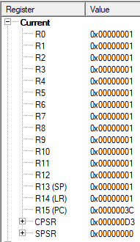

The program counter results in 3C indicating that 3C/4 = 15 instruction have been performed.

**Outputs:**

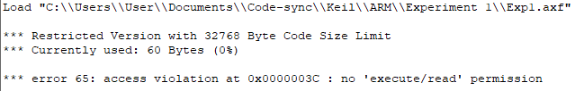

**Result:**

The value of R0 is copied onto all other registers and is verified to be correct.

**Part B**

**Theory:**

**Immediate Addressing:**Used in cases where we want to load a constant value into an address. Example: MOV R0, #10

**Register Direct Addressing:**Used in cases where you want to move data between two registers. Example: MOV R0, R1

**Register Indirect Addressing:**Used in cases where you want to load data from an address stored in a register. Example: LDR R0, [R1]

**Code:**

AREA PROGRAM, CODE, READONLY

ENTRY

MAIN

 LDR R0, =0x00120011

 LDR R1, =0x00000003

 LDR R2, VALUE1 ;00120011

 LDR R3, VALUE2 ;00000003

 LDR R4, MEM1 ;mem location of R2

 LDR R5, MEM2 ;mem location of R3

 LDR R6, [R4] ;R6 is loaded with data on memory location pointer by R4:=(R2)

 LDR R7, [R5] ;R7 is loaded with data on memory location pointer by R5:=(R3)

 ADD R8, R0, R1 ;immediate addressing

 ADD R9, R2, R3 ;direct addressing

 ADD R10, R6, R7 ;indirect addressing

 LDR R11, =0x00000008 ;mem location to store the result of R11

 STR R10, [R11] ;store value of R10 to mem location pointed by R11

 AREA PROGRAM, DATA, READONLY

VALUE1 DCD &00120011 ; DCD = Define Constant Double word

VALUE2 DCD &00000003

MEM1 DCD &00000000 ;memory address of 1st location

MEM2 DCD &00000004 ;memory address of 2nd location

 END

**Register Output:**

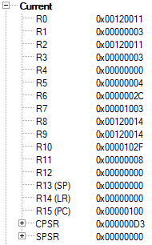

For Inputs at R0 and R1 the input is fed using immediate addressing and the output value is stored at R8.

For Inputs at R2 and R3 the input is loaded using direct addressing and the output is stored at R9.

The value at R6 and R7 is changed at the memory locations and loaded using indirect addressing. The output is stored at R10 and also stored back at memory location using indirect addressing.

**Indirect Addressing Result:**

Before Running

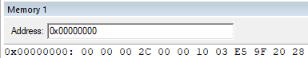

After Running

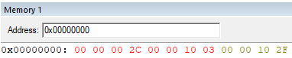

The result 0000102F is visible at the 3rd memory location.

**Outputs:**

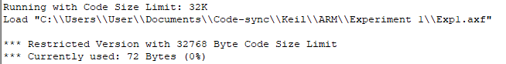

**Result:**

The values are verified after addition and found to be correct on all the three modes of addressing.

**Experiment 2**

**Aim:**

To write an ARM Assembly Language to load any register with 32 bit data and perform the following.

1. Shift left by 2 bit.
2. Shift right by number of bits stored in register.
3. Shift left 5 bits conditionally when ‘0’ flag is set.
4. Arithmetic Shift right by number of bits stored in register.

**Tool Used:**

Keil uVision4

**Theory:**

LSL shift the bits left and concatenate a 0 at the LSB. LSR shift the bits right and concatenate a 0 at the MSB. ASR shifts the bits right and concatenate the value of MSB at the new MSB.

**a) Shift left by 2 bit.**

**Code:**

AREA PROGRAM, CODE, READONLY

ENTRY

MAIN

LDR R0,=0x00000001 ;LOAD R0 WITH VALUE 1

  MOV R1,R0,LSL#0x02 ;SHIFT 1 TWO TIMES AN STORE IN R1

  END

**Output:**

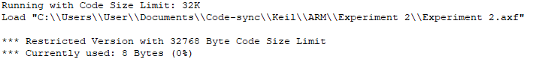

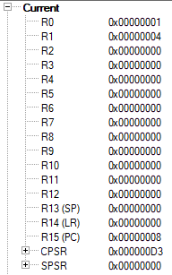

The Value at R0 is 1 and it is shifted 2 times resulting in R1 to be 4.

The program Counter has the value 0x00000008 indicating that 2 32-bit instructions have been executed.

**b) Shift right by number of bits stored in register.**

**Code:**

AREA PROGRAM, CODE, READONLY

 ENTRY

MAIN

 LDR R0, =0x00000009 ;LOAD VALUE 9 TO R0 REGISTER

 LDR R1, =0x00000003 ;LOAD THE NO OF TIMES TO BE SHIFTED

 MOV R2,R0,LSR R1 ;R2 WILL BE R0 SHIFTER 3 TIMES

 END

**Output:**

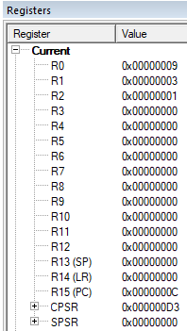

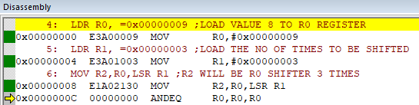

The value stored in R0 is 9 and it is shifted right 3 times resulting in a value of 1 at R2 where the lower bits are truncated.

**c) Shift left 5 bits conditionally when ‘0’ flag is set.**

**Code:**

AREA PROGRAM, CODE, READONLY

  ENTRY

MAIN

 LDR R0, =0x00000000 ;LOAD VALUE 0 TO R0 REGISTER

 LDR R1, =0x00000001 ;LOAD VALUE 3 TO R1 REGISTER

 ADDS R0,R0,R0 ;SETTING ZERO FLAG

 MOVEQ R2,R1,LSL #05 ;R2 WILL BE R1 SHIFTER 5 TIMES

 END

**Output:**

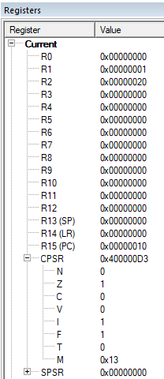

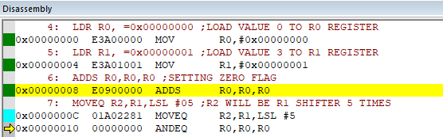

The value stored in R1 is 1 and it is shifted 5 times resulting in a value of 20 at R2 as the Zero flag in CPSR is set to zero.

**d) Arithmetic Shift right by number of bits stored in register.**

**Code:**

AREA PROGRAM, CODE, READONLY

ENTRY

MAIN

  LDR R0, =0x80000020 ;LOAD VALUE WITH MSB 1 TO R0 REGISTER

  LDR R1, =0x00000004 ;LOAD VALUE 4 TO R1 REGISTER

  MOV R2,R0,ASR R1 ;R2 WILL BE R0 SHIFTED RIGHT 4 TIMES

  END

**Output:**

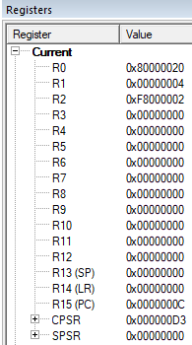

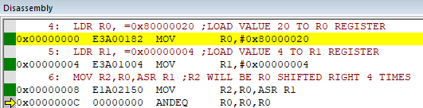

R0 has MSB as 1000_0000 which is shifted right

4 times resulting in 1111_1000(F8) in R2.

**Result:**

The experiments on shift operations have been performed and verified to be correct.

**Experiment 3**

**Aim:**

To write an ARM Assembly Language to copy words from consecutive location and store it in consecutive destination locations.

1. Multiple register transfer instructions.
2. Load and Store instruction in a loop.

**Tool Used:**

Keil uVision4

**Theory:**

LDM load multiple register locations with starting address mentioned. ! is used in LDM for updating pointer, else same value will be updated in all registers. STM load the value into consecutive memory locations with starting address mentioned.

**a) Multiple register transfer instructions.**

**Code:**

AREA PROGRAM, CODE, READONLY

ENTRY

MAIN

  LDR R0, =0x00000000; SOURCE MEMORY LOCATION

  LDR R1, =0x00000100; DESTINATION MEMORY LOCATION

  LDM R0!, {R2-R5}; COPIES CONTINUOSLY FROM EXTERNAL TO R2 TO R5

  STM R1!, {R2-R5}; COPIES CONTINUOSLY FROM R2 TO R5 TO DESTINATION

  END

**Output:**

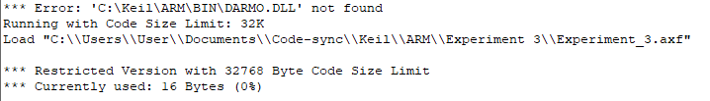

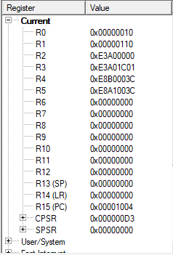

The input data to be copied



The data copied after running



4 words starting at 0x…000 is copied at destination address 0x…100.

**Using IA, IB, DA, DB**

**Code:**

  AREA PROGRAM, CODE, READONLY

ENTRY

MAIN

  LDR R0, =0x00000000; SOURCE MEMORY LOCATION

  LDR R1, =0x00000100; DESTINATION MEMORY LOCATION

  LDMIA R0!, {R2-R5}; COPIES CONTINUOSLY FROM EXTERNAL TO R2 TO R5

  STMIA R1!, {R2-R5}; COPIES CONTINUOSLY FROM R2 TO R5 TO DESTINATION

  END

**Output:**

For Increment after [IA]:

Input at 0x00000000



Input at 0x00000000



Value starts at 00 and 100 indicating that the increment is done after copying

For Increment before [IB]:

LDR R0, =0x00000000; SOURCE MEMORY LOCATION

  LDR R1, =0x000000F0; DESTINATION MEMORY LOCATION

LDMIB R0!, {R2-R5}; COPIES CONTINUOSLY FROM EXTERNAL TO R2 TO R5

  STMIB R1!, {R2-R5}; COPIES CONTINUOSLY FROM R2 TO R5 TO DESTINATION

Input at 0x00000000



Output at 0x00000000



Value starts at 04 and F4 instead of F0 indicating that the increment is done before copying

For Decrement After [DA]:

LDMDA R0!, {R2-R5}; COPIES CONTINUOSLY FROM EXTERNAL TO R2 TO R5

  STMDA R1!, {R2-R5}; COPIES CONTINUOSLY FROM R2 TO R5 TO DESTINATION

Input at 0x00000000



Output at 0x00000000



Value starts at 10 and F0 indicating that the decrement is done after copying

For Decrement Before [DB]:

LDMDB R0!, {R2-R5}; COPIES CONTINUOSLY FROM EXTERNAL TO R2 TO R5

  STMDB R1!, {R2-R5}; COPIES CONTINUOSLY FROM R2 TO R5 TO DESTINATION

Input at 0x00000000



Output at 0x000000E8



Value starts at 00 and ends at EC indicating that the decrement is done before copying.

**b) Load and Store Instructions in a loop**

**Code:**

  AREA PROGRAM, CODE,READONLY

    ENTRY

MAIN

    LDR R0, =0x00000000; SOURCE MEMORY LOCATION

    LDR R1, =0x00000100; DESTINATION MEMORY LOCATION

    MOV R2, #4; 4 LOCATIONS FOR 4 WORDS

FOR LDR R3, [R0], #4; MOVE THE RESPECTIVE VALUE TO R3

    STR R3, [R1], #4; STORE R3 TO THE RESPECTIVE LOCATION

    SUBS R2,R2,#1; DECREMENT THE COUNTER

    BNE FOR; IF NOT ZERO REPEAT THE LOOP

    END

**Output:**

Before Execution Input at 0x00000000



After Execution Output at 0x00000100



**Result:**

The experiments on shift operations have been performed and verified to be correct.

**Experiment 4**

**Aim:**

To write an ARM Assembly Language to

1. Add two 64 bit numbers.
2. Add ten 32 bit numbers.

**Tool Used:**

Keil uVision4

**Theory:**

LDM load multiple register locations with starting address mentioned. ! is used in LDM for updating pointer, else same value will be updated in all registers. STM load the value into consecutive memory locations with starting address mentioned. ADDCS adds the value if the carry flag is set.

**a) Add two 64 bit numbers.**

**Code:**

 AREA PROGRAM,CODE, READONLY

 ENTRY

MAIN

 LDR R0, =0X00000000; SOURCE MEMORY LOCATION

 LDM R0!, {R1-R4}; COPY TO REGISTERS R1 TO R4 FROM MEM LOCATIONS

 ADDS R6,R2,R4; ADDS THE LOWER NIBBLE

 ADCS R5,R1,R3; ADDS THE UPPER NIBBLE

 LDR R7, =0X00000010; DESTINATION MEMORY LOCATION

 STM R7!, {R5-R6}; STORE RESULTS IN DESTINATION

 END

**Output:**

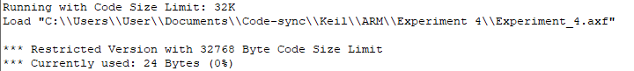

Register Contents

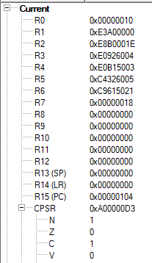

The memory location input data and the added value.



The input starts from 0x…0 to 0x0…08, the output is displayed from 0x00000010

**b) Add ten 32 bit numbers.**

**Code:**

  AREA PROGRAM,CODE, READONLY

 ENTRY

MAIN

    LDR R0, =0x00000000; SOURCE MEMORY LOCATION

    LDR R1, =0x00000050; DESTINATION MEMORY LOCATION

    MOV R3, #9; COUNTER WITH DATA 10

    LDR R4, [R0]; 1ST VALUE

FOR ADD R0, R0, #4; INCREMENTED ADDRESS

    LDR R5, [R0]; FURTHER VALUES

    ADDS R4,R4,R5; ADD CONSECUTIVE VALUES

    ADDCS R7,R7,#1; CARRY COUNT

    SUBS R3,R3,#1; DECREMENT THE COUNTER

    BNE FOR; IF NOT ZERO REPEAT THE LOOP

    STR R4, [R1], #4; STORE THE ADDED VALUE

    STR R7, [R1]; STORE NUMBER OF CARRYS IN NEXT LOCATION

    END

**Output:**

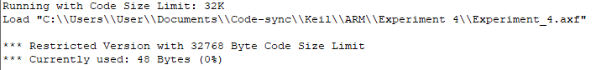

Register Contents

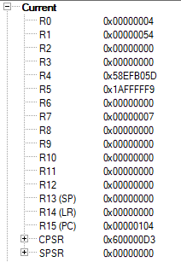

The 10 input words 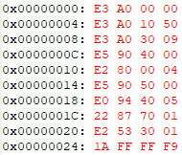

The sum and carry



The input words range from 0x0…0 to 0x0…024 and the sum is displayed at 0x0…050 and the carry is in 0x0…054.

**Result:**

The experiments on add operations have been performed and verified to be correct.

**Experiment 5**

**Aim:**

To write an ARM Assembly Language to find the number of bytes in a set of 10 locations that match the value 0xAC

**Tool Used:**

Keil uVision4

**Theory:**

LDRB is used to copy just 1 Byte of data to the lower location of the register. CMP compares two operands and if zero sets the zero flag. The EQ condition checks the zero flag for set to let the process happen.

**Code:**

  AREA PROGRAM, CODE, READONLY

  ENTRY

MAIN

        LDR R0, =0X00001000 //starting location

        MOV R2, #10 // counter for 10 locations

LOOP    LDRB R1, [R0], #1 // load the value

        CMP R1, #0XAC // check if same

        ADDEQ R3,R3,#1 //if equal label

        SUBS R2,R2,#1 // decrement counter

        BNE LOOP // run 10 times

 END

**Output:**

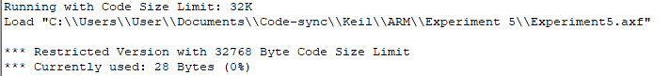

Register Contents

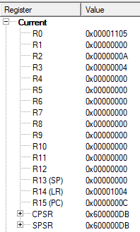

The memory location of input data.



The input starts from 0x00001000 to 0x0000100A. Output is at R3.

**Result:**

The experiments on compare operation has been performed and verified to be correct.

**Experiment 6**

**Aim:**

To write an ARM Assembly Language to find the number of 1’s and 0’s in a given word.

**Tool Used:**

Keil uVision4

**Theory:**

RRX rotates the value of the register and store the left most bit to carry, and bring the carry bit if appended at the right most bit.

**Code:**

  AREA PROGRAM, CODE, READONLY

 ENTRY

MAIN

        MOV R0, #32 // counter value

        LDR R1, =0x00001000 // input location

        LDR R2, [R1] // load the input at the register

LOOP    MOVS R2,R2,RRX //rotate the value of reg

        ADDCS R3,R3,#1 // increment if bit is set

        SUBS R0,R0,#1 // decrement counter

        BNE LOOP // loop branch

        RSB R4,R3,#32 // count no of 0's

 END

**Output:**

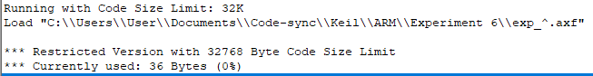

Register Contents

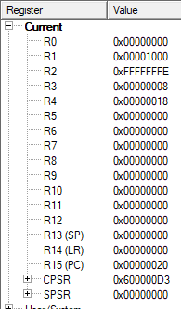

The memory location of input data.



The input start is at 0x00001000. Number of 1’s are at R3 and 0’s are at R4.

**Result:**

The experiments on compare operation has been performed and verified to be correct.

**Experiment 7**

**Aim:**

To write an ARM Assembly Language to multiply two numbers using repeated addition.

**Tool Used:**

Keil uVision4

**Theory:**

One number can be used as counter and the other number can be decremented every loop. On every loop the 1st number is adder on to the result.

**Code:**

 AREA PROGRAM, CODE, READONLY

 ENTRY

MAIN

        LDR R0, =0X00001000 // location of input data

        LDR R1, [R0], #4 // loading 1st data

        LDR R2, [R0], #4 // loaing 2nd data

LOOP    ADD R3,R3,R1 // add 1st number to result

        SUBS R2,R2,#1 // decrementing number 2

        BNE LOOP //loop branch

        STR R3, [R0] // store the result in the memory location

        END

**Output:**

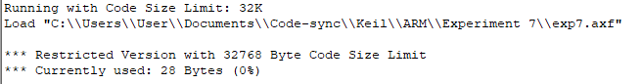

Register Contents

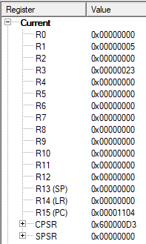

The memory location of

Input 1 = 0x00001000

Input 2 = 0x00001004

Output = 0x00001008



**Result:**

The experiments on multiplication operation has been performed and verified to be correct.