**Experiment 3**

**Aim:**

To write an ARM Assembly Language to copy words from consecutive location and store it in consecutive destination locations.

1. Multiple register transfer instructions.
2. Load and Store instruction in a loop.

**Tool Used:**

Keil uVision4

**Theory:**

LDM load multiple register locations with starting address mentioned. ! is used in LDM for updating pointer, else same value will be updated in all registers. STM load the value into consecutive memory locations with starting address mentioned.

**a) Multiple register transfer instructions.**

**Code:**

AREA PROGRAM, CODE, READONLY

ENTRY

MAIN

  LDR R0, =0x00000000; SOURCE MEMORY LOCATION

  LDR R1, =0x00000100; DESTINATION MEMORY LOCATION

  LDM R0!, {R2-R5}; COPIES CONTINUOSLY FROM EXTERNAL TO R2 TO R5

  STM R1!, {R2-R5}; COPIES CONTINUOSLY FROM R2 TO R5 TO DESTINATION

  END

**Output:**

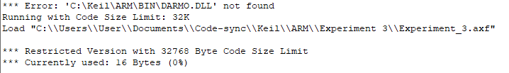

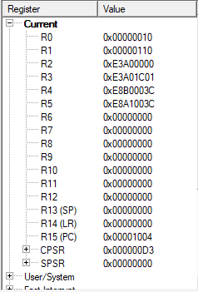

The input data to be copied



The data copied after running



4 words starting at 0x…000 is copied at destination address 0x…100.

**Using IA, IB, DA, DB**

**Code:**

  AREA PROGRAM, CODE, READONLY

ENTRY

MAIN

  LDR R0, =0x00000000; SOURCE MEMORY LOCATION

  LDR R1, =0x00000100; DESTINATION MEMORY LOCATION

  LDMIA R0!, {R2-R5}; COPIES CONTINUOSLY FROM EXTERNAL TO R2 TO R5

  STMIA R1!, {R2-R5}; COPIES CONTINUOSLY FROM R2 TO R5 TO DESTINATION

  END

**Output:**

For Increment after [IA]:

Input at 0x00000000



Input at 0x00000000



Value starts at 00 and 100 indicating that the increment is done after copying

For Increment before [IB]:

LDR R0, =0x00000000; SOURCE MEMORY LOCATION

  LDR R1, =0x000000F0; DESTINATION MEMORY LOCATION

LDMIB R0!, {R2-R5}; COPIES CONTINUOSLY FROM EXTERNAL TO R2 TO R5

  STMIB R1!, {R2-R5}; COPIES CONTINUOSLY FROM R2 TO R5 TO DESTINATION

Input at 0x00000000



Output at 0x00000000



Value starts at 04 and F4 instead of F0 indicating that the increment is done before copying

For Decrement After [DA]:

LDMDA R0!, {R2-R5}; COPIES CONTINUOSLY FROM EXTERNAL TO R2 TO R5

  STMDA R1!, {R2-R5}; COPIES CONTINUOSLY FROM R2 TO R5 TO DESTINATION

Input at 0x00000000



Output at 0x00000000



Value starts at 10 and F0 indicating that the decrement is done after copying

For Decrement Before [DB]:

LDMDB R0!, {R2-R5}; COPIES CONTINUOSLY FROM EXTERNAL TO R2 TO R5

  STMDB R1!, {R2-R5}; COPIES CONTINUOSLY FROM R2 TO R5 TO DESTINATION

Input at 0x00000000



Output at 0x000000E8



Value starts at 00 and ends at EC indicating that the decrement is done before copying.

**b) Load and Store Instructions in a loop**

**Code:**

  AREA PROGRAM, CODE,READONLY

    ENTRY

MAIN

    LDR R0, =0x00000000; SOURCE MEMORY LOCATION

    LDR R1, =0x00000100; DESTINATION MEMORY LOCATION

    MOV R2, #4; 4 LOCATIONS FOR 4 WORDS

FOR LDR R3, [R0], #4; MOVE THE RESPECTIVE VALUE TO R3

    STR R3, [R1], #4; STORE R3 TO THE RESPECTIVE LOCATION

    SUBS R2,R2,#1; DECREMENT THE COUNTER

    BNE FOR; IF NOT ZERO REPEAT THE LOOP

    END

**Output:**

Before Execution Input at 0x00000000



After Execution Output at 0x00000100



**Result:**

The experiments on shift operations have been performed and verified to be correct.