**Experiment 5**

**Aim:**

To write an ARM Assembly Language to find the number of bytes in a set of 10 locations that match the value 0xAC

**Tool Used:**

Keil uVision4

**Theory:**

LDRB is used to copy just 1 Byte of data to the lower location of the register. CMP compares two operands and if zero sets the zero flag. The EQ condition checks the zero flag for set to let the process happen.

**Code:**

  AREA PROGRAM, CODE, READONLY

  ENTRY

MAIN

        LDR R0, =0X00001000 //starting location

        MOV R2, #10 // counter for 10 locations

LOOP    LDRB R1, [R0], #1 // load the value

        CMP R1, #0XAC // check if same

        ADDEQ R3,R3,#1 //if equal label

        SUBS R2,R2,#1 // decrement counter

        BNE LOOP // run 10 times

 END

**Output:**

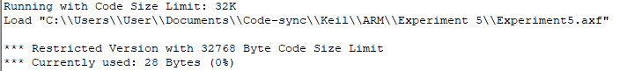

Register Contents

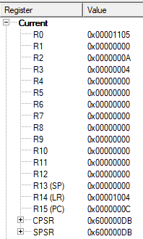

The memory location of input data.



The input starts from 0x00001000 to 0x0000100A. Output is at R3.

**Result:**

The experiments on compare operation has been performed and verified to be correct.