**Experiment 6**

**Aim:**

To write an ARM Assembly Language to find the number of 1’s and 0’s in a given word.

**Tool Used:**

Keil uVision4

**Theory:**

RRX rotates the value of the register and store the left most bit to carry, and bring the carry bit if appended at the right most bit.

**Code:**

  AREA PROGRAM, CODE, READONLY

 ENTRY

MAIN

        MOV R0, #32 // counter value

        LDR R1, =0x00001000 // input location

        LDR R2, [R1] // load the input at the register

LOOP    MOVS R2,R2,RRX //rotate the value of reg

        ADDCS R3,R3,#1 // increment if bit is set

        SUBS R0,R0,#1 // decrement counter

        BNE LOOP // loop branch

        RSB R4,R3,#32 // count no of 0's

 END

**Output:**

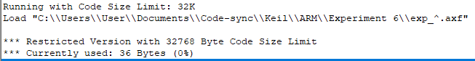

Register Contents

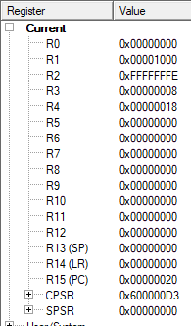

The memory location of input data.



The input start is at 0x00001000. Number of 1’s are at R3 and 0’s are at R4.

**Result:**

The experiments on compare operation has been performed and verified to be correct.