**Experiment 7**

**Aim:**

To write an ARM Assembly Language to multiply two numbers using repeated addition.

**Tool Used:**

Keil uVision4

**Theory:**

One number can be used as counter and the other number can be decremented every loop. On every loop the 1st number is adder on to the result.

**Code:**

 AREA PROGRAM, CODE, READONLY

 ENTRY

MAIN

        LDR R0, =0X00001000 // location of input data

        LDR R1, [R0], #4 // loading 1st data

        LDR R2, [R0], #4 // loaing 2nd data

LOOP    ADD R3,R3,R1 // add 1st number to result

        SUBS R2,R2,#1 // decrementing number 2

        BNE LOOP //loop branch

        STR R3, [R0] // store the result in the memory location

        END

**Output:**

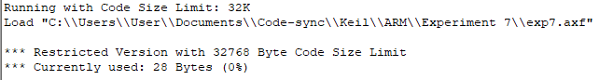

Register Contents

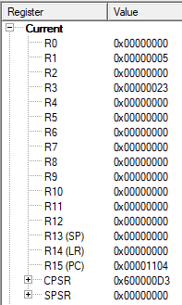

The memory location of

Input 1 = 0x00001000

Input 2 = 0x00001004

Output = 0x00001008



**Result:**

The experiments on multiplication operation has been performed and verified to be correct.