**Experiment 8**

**Aim:**

To write an ARM Assembly Language to divide two numbers using repeated subtraction.

**Tool Used:**

Keil uVision4

**Theory:**

One number can be used as counter and the other number can be decremented every loop. On every loop the 1st number is subtracted be the divider.

**Code:**

 AREA PROGRAM, CODE, READONLY

 ENTRY

MAIN

        LDR R0,=0X00001000 ;start of input address

        LDR R1, [R0], #4 ; load dividend

        LDR R2, [R0], #4 ; load divisor

LOOP0   CMP R1,R2 ; compare if dividend is greater

        BMI LOOP2 ;if not end loop

        ADD R4,R4,#1 ; add quotient

        SUB R1,R1,R2 ; repetitive subtraction

        BNE LOOP0 ; repeat loop until zero

LOOP2   STR R4, [R0], #4 ; store quotient

        STR R1, [R0] ; store reminder

LOOP1   B LOOP1

        END

**Output:**

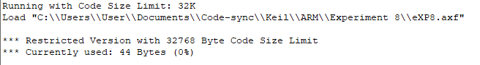

Register Contents

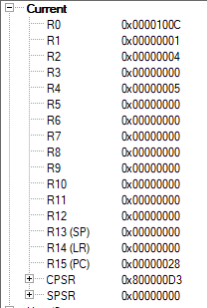

The memory location of

Dividend = 0x00001000

Divisor = 0x00001004

Quotient = 0x00001008

Reminder = 0x0000100C



**Result:**

The experiments on division operation has been performed and verified to be correct.