**Experiment 9**

**Aim:**

To write an ARM Assembly Language to arrange the numbers in ascending and descending order.

**Tool Used:**

Keil uVision4

**Theory:**

The numbers in the memory location are repeatedly compared in iterative manner and using the carry flag’s result they are restored in either ascending or descending order.

**Code:**

**Ascending:**

AREA PROGRAM, CODE, READONLY

ENTRY

MAIN

        MOV R0, #9 ; n-1 memory loctions

LOOP1   LDR R1, =0X1000 ; starting memory location

        ADD R2,R1,#1 ; the 2nd number location

        MOV R3,R0 ; copy the value

LOOP2   LDRB R4, [R1], #1 ; load 1st number

        LDRB R5, [R2], #1 ; load 2nd number

        CMP R4,R5 ; compare both  numbers

        STRCSB R4, [R2,#-1] ; swap is greater

        STRCSB R5, [R1,#-1] ; r4 is expected to be lesser

        SUBS R3,R3,#1 ; decrement counter

        BNE LOOP2

        SUBS R0,R0,#1 ; decrement counter

        BNE LOOP1

     END

**Decending:**

AREA PROGRAM, CODE, READONLY

 ENTRY

MAIN

        MOV R0, #9 ; n-1 memory loctions

LOOP1   LDR R1, =0X1000 ; starting memory location

        ADD R2,R1,#1 ; the 2nd number location

        MOV R3,R0 ; copy the value

LOOP2   LDRB R4, [R1], #1 ; load 1st number

        LDRB R5, [R2], #1 ; load 2nd number

        CMP R4,R5 ; compare both  numbers

        STRCCB R4, [R2,#-1] ; swap is lesser

        STRCCB R5, [R1,#-1] ; r4 is expected to be greater

        SUBS R3,R3,#1 ; decrement counter

        BNE LOOP2

        SUBS R0,R0,#1 ; decrement counter

        BNE LOOP1

     END

**Output:**

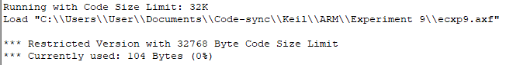

Input given before running:



Output after Ascending:



Output after Descending:



**Result:**

The experiments on division operation has been performed and verified to be correct.