EXPERIMENT 3
Multiplication of 16 bit numbers
Submitted by,
T Raja Aadhithan
Code:
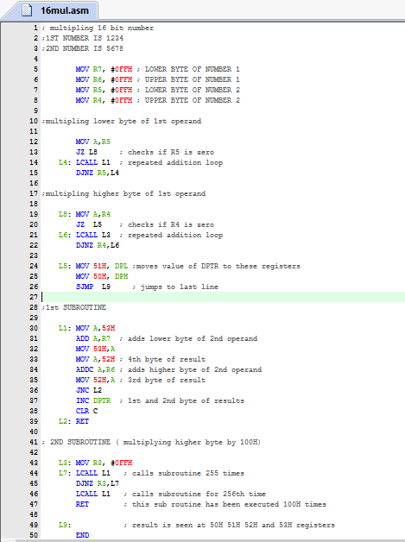
OUTPUT:
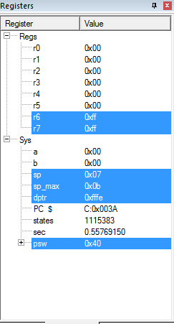
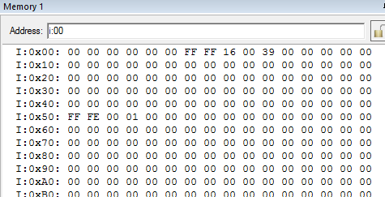

The outputs are found at 50H to 53H registers

