EXPERIMENT 3.2

Sorting of ten 8-bits numbers stored in internal data memory in decending order
Code:
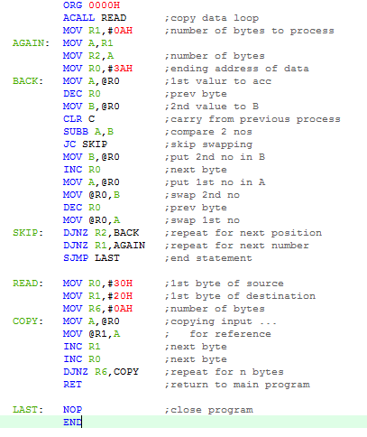

Output:

Internal memory:

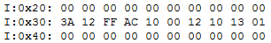
before running the code:

after running the code:
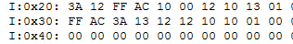

SFRs:

