FILE ON EMBEDDED SYSTEMS LAB

ESCC303

ON KEIL AND MULTISIM



DEPARTMENT OF ELECTRONIC SCIENCE

UNIVERSITY OF DELHI

By,

T Raja Aadhithan

19/1031

TABLE OF CONTENTS
NO | EXPERIMENT | PAGE | SOFTWARE
1.1 | Addition and subtraction using immediate addressing mode | 3 | KEIL
1.2 | Addition and subtraction using register indirect addressing mode | 4 | KEIL
1.3 | Addition and subtraction of two eight bit BCD numbers | 5 | KEIL
1.4 | Multiplication using successive addition | 6 | KEIL
1.5 | Multiplication and division using command. | 7 | KEIL
2 | Multiplication of 16 bit numbers | 8 | KEIL
2.1 | Hexadecimal number to BCD equivalent | 11 | KEIL
2.2 | Hexadecimal number to ASCII equivalent | 12 | KEIL
2.3 | Decimal number to Hexadecimal equivalent | 13 | KEIL
3.1 | Sorting of ten 8-bits numbers in ascending order | 14 | KEIL
3.2 | Sorting of ten 8-bits numbers in descending order | 16 | KEIL
4 | Delay and Toggle port 1 | 18 | KEIL
5.1 | 16 bit timer mode | 19 | KEIL
5.2 | 8 bit auto reload timer mode | 20 | KEIL
6 | LED toggling | 21 | MULTISIM
7 | Generating a Square Wave | 22 | MULTISIM
8 | Seven segment Display | 23 | MULTISIM
9 | LCD | 26 | MULTISIM

EXPERIMENT 1.1

Addition and subtraction of two eight bit hexadecimal numbers by immediate addressing mode and store the result in general purpose registers.

Code:
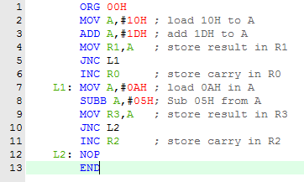

Output:

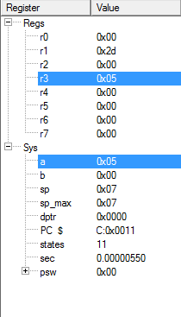

EXPERIMENT 1.2

Addition and subtraction of two eight bit hexadecimal numbers by register indirect addressing mode and store the result in scratch pad memory location.

Code:
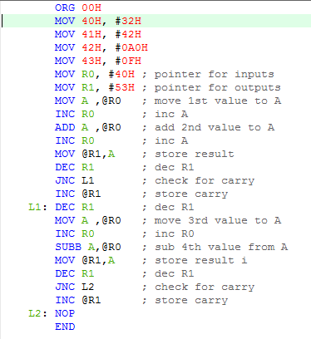

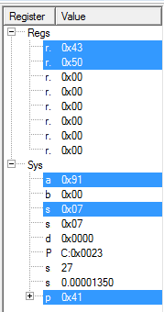
Output:

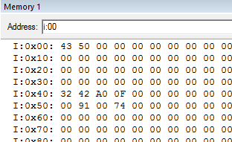

EXPERIMENT 1.3

Addition and subtraction of two eight bit BCD numbers.

Code:
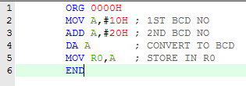

Output:

stored in R0

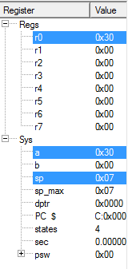

EXPERIMENT 1.4

Multiplication of two eight-bit hexadecimal numbers by successive addition.

Code:
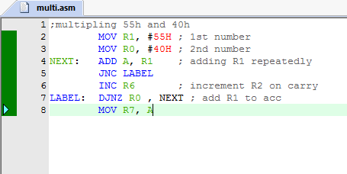

Output:

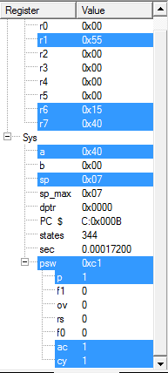
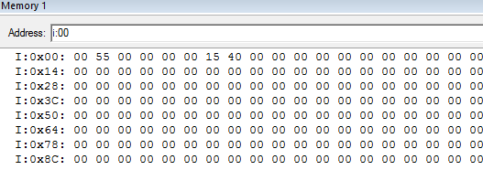

THE OUTPUT IS FOUND AT R7,R6

EXPERIMENT 1.5

Multiplication of two eight-bit hexadecimal numbers using MUL command and division of two eight-bit hexadecimal numbers

Code:

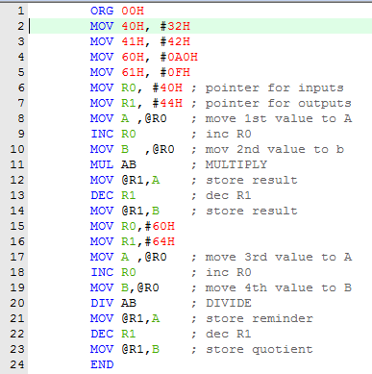

MULTIPLICATION:

inputs: 40H , 41H
outputs: 43H , 44H

DIVISION:

inputs: 40H , 41H
outputs: 43H , 44H

Output:
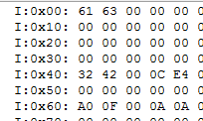
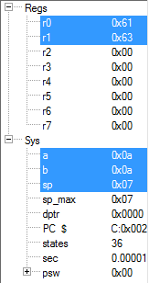

EXPERIMENT 2
Multiplication of 16 bit numbers

Code:
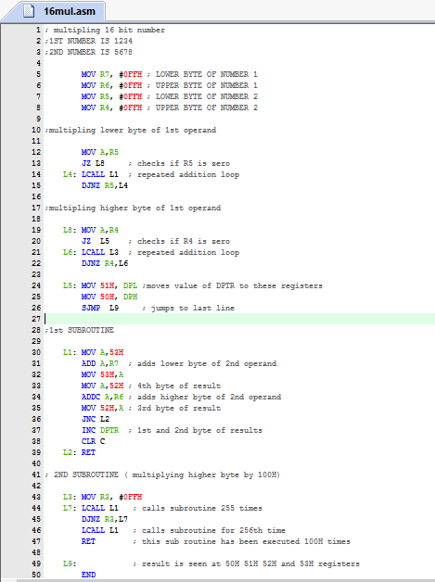
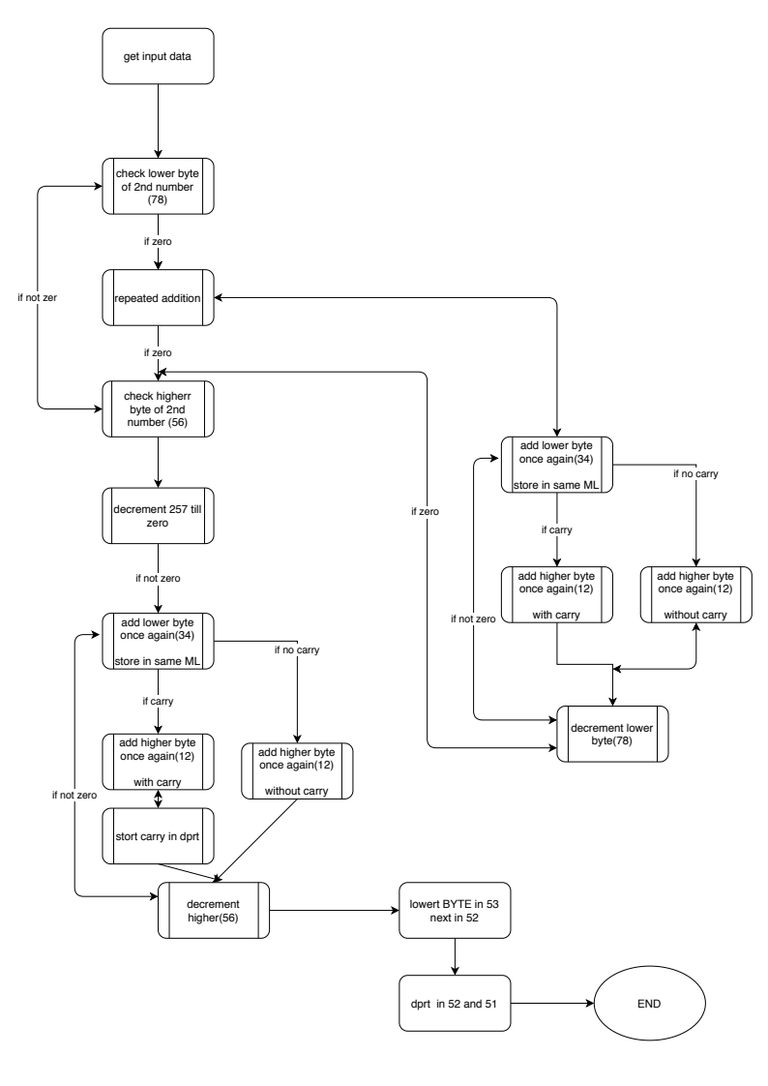
FLOW CHART:
OUTPUT:
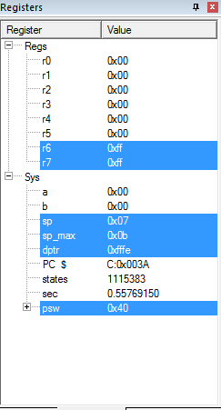
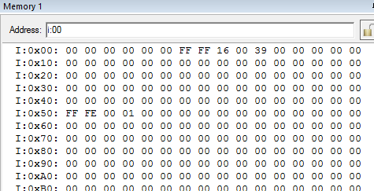

The outputs are found at 50H to 53H registers

EXPERIMENT 2.1

Hexadecimal number to BCD equivalent

Code:
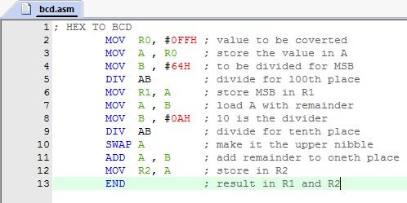

Output:

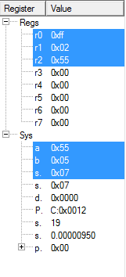
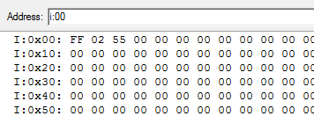

input: R0
output: R1 and R2

EXPERIMENT 2.2

Hexadecimal number to ASCII equivalent

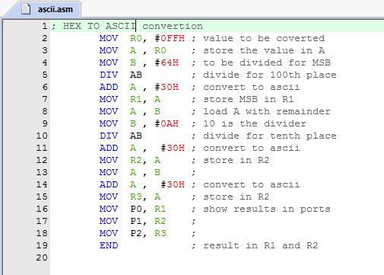
Code:

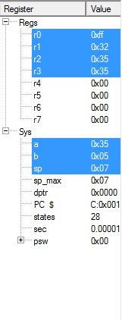
Output:

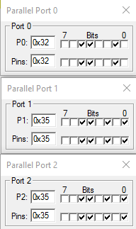
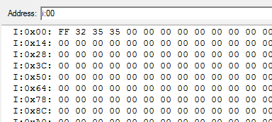

EXPERIMENT 2.3

Decimal number to Hexadecimal equivalent
Code:
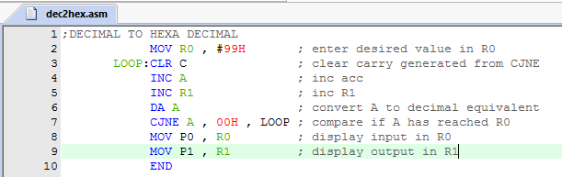
Outputs:
various values of inputs have been displayed:
port 0 is input and port 1 is output

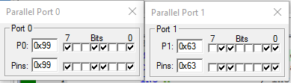
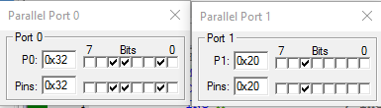
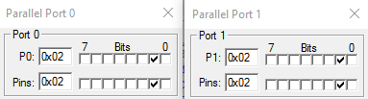
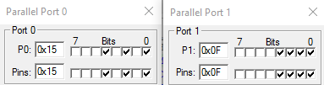
DECIMAL HEX

99 63H

32 20H

02 02H

15 0FH

EXPERIMENT 3.1

Sorting of ten 8-bits numbers stored in internal data memory in ascending order
Code:
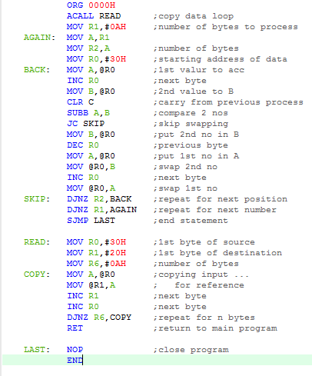

Output:

Internal memory:

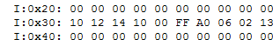
before running the code:

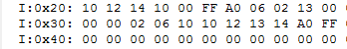
after running the code:

SFRs:

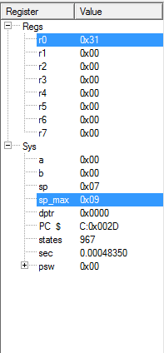

EXPERIMENT 3.2

Sorting of ten 8-bits numbers stored in internal data memory in descending order
Code:
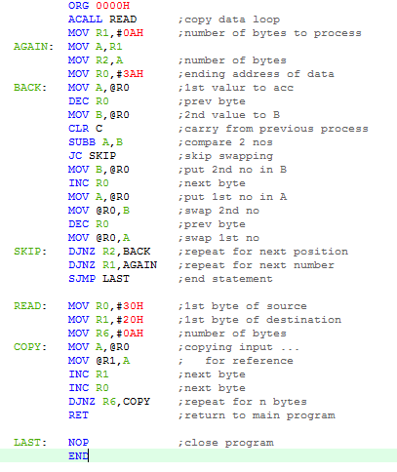

Output:

Internal memory:

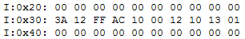
before running the code:

after running the code:
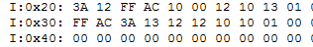

SFRs:

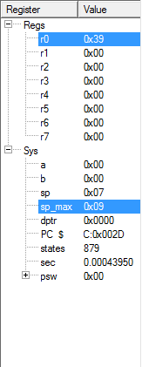

EXPERIMENT 4

Write an assembly language program to generate the delay of X microseconds and toggle the Y bit of port 1. Using KEIL software.
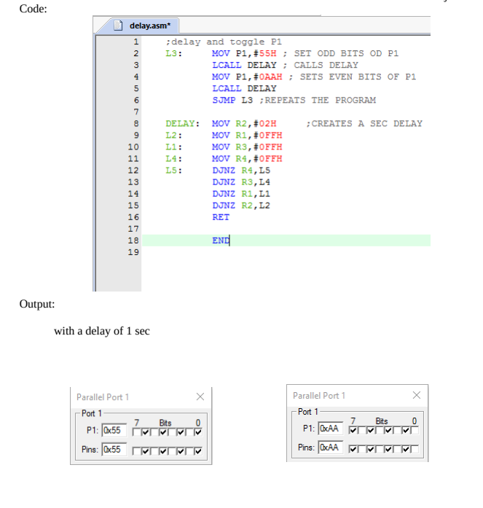
EXPERIMENT 5.1

Delay of 250 microseconds and toggle the bit P1.5 using 16 bit timer mode
Code:

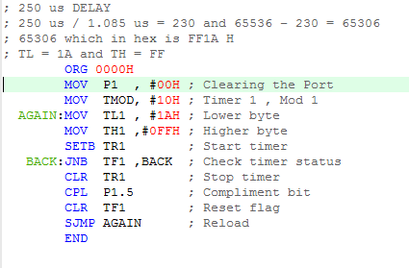
Output:

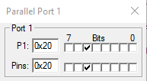
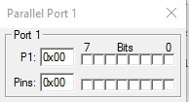

The port toggles between these two states every 250us.

EXPERIMENT 5.2

Delay of 4 seconds and toggle the bit P1.0 using 8 bit auto reload timer mode
Code:

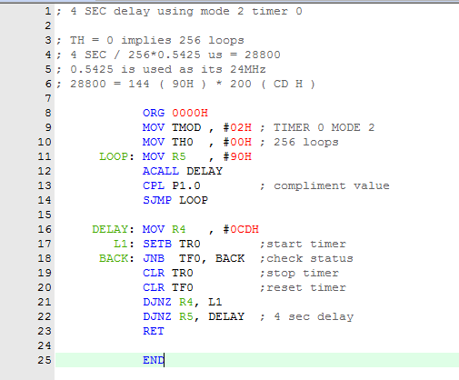
Output:

TMOD REG:

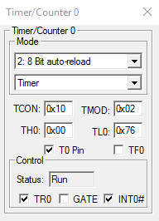
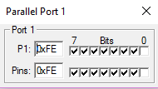
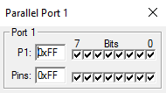
The port toggles between these two states every 4 s.

EXPERIMENT 6
Toggling two LEDS in such fashion when one is on the Another is off for equal time delay

Code:
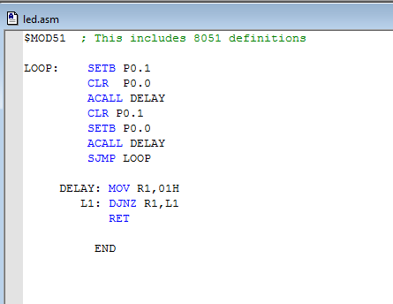

Outputs:

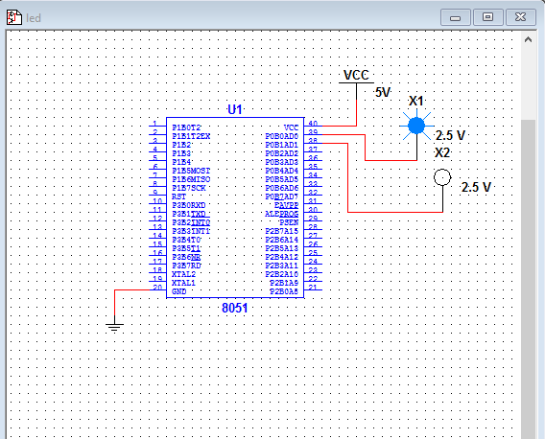

EXPERIMENT 7
Generating a square wave of bit P1.0 shown on oscilloscope.

Code: Circuit:

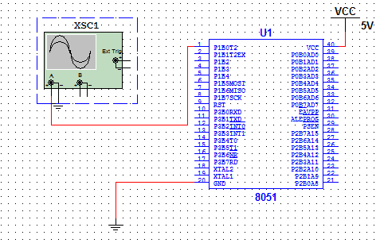
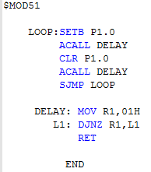

Outputs:

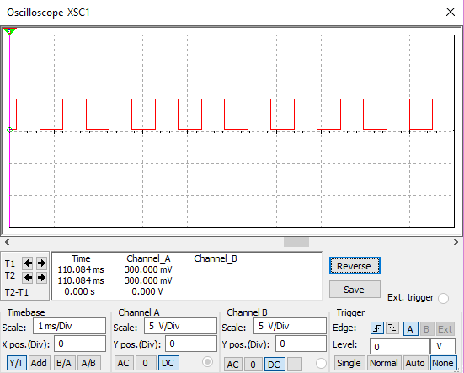

EXPERIMENT 8
Seven segment display and 2x2 matrix keyboard

Code:

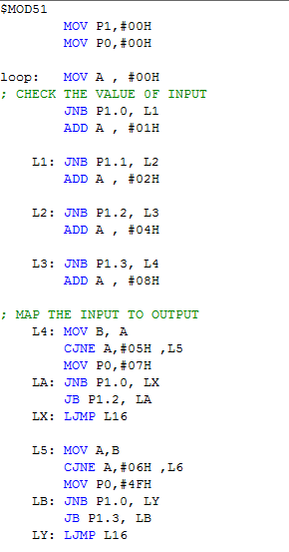
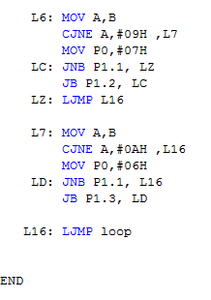

Theory:

Above, the button at B1 is held. As the scan progresses, it does the following:
- Nothing is selected. Outputs A and B are both high, and we don't worry about inputs 1 and 2.
- Column A is selected with a logical low.
  - The system reads inputs 1 and 2. Both are open, so the pull-up resistors cause the inputs to be pulled high. Since this is an active low matrix, the high inputs indicate nothing is pressed.
- The system deselects column A by driving it high and selects column B is by driving it low.
  - The system reads inputs 1 and 2. Since switch B1 is held, the low level from the column selection shows up at input 1.
  - By pairing the column output (B) with the detected switch (1), the system knows that switch B1 is pressed.
- Finally, everything is deselected by driving both outputs high.

Circuit and Output:

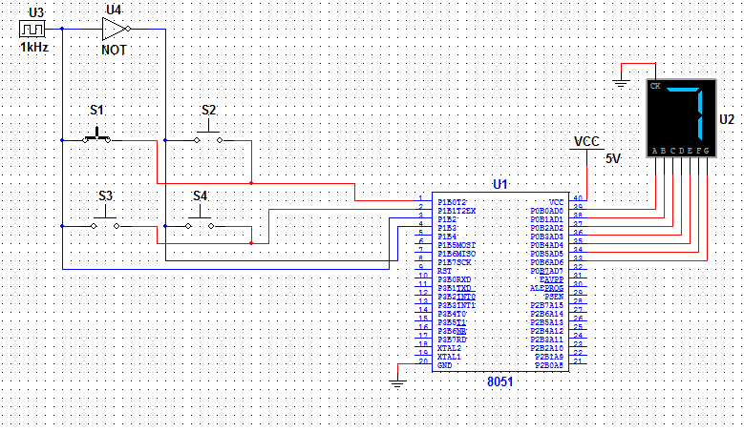
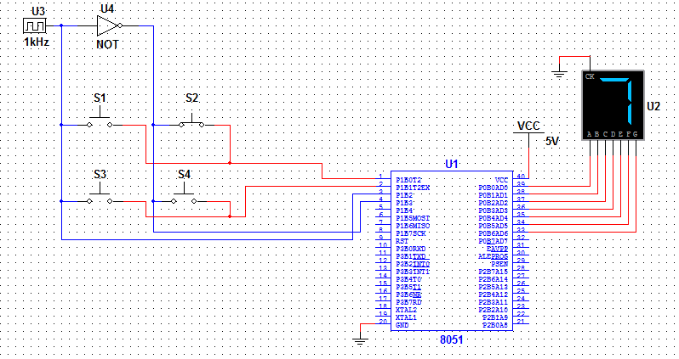

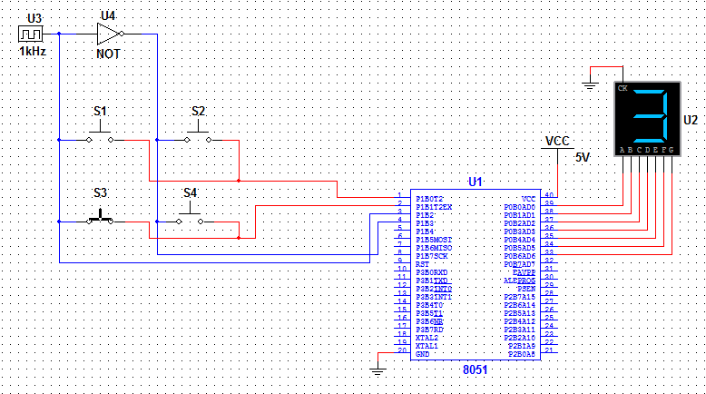

EXPERIMENT 9
16x1 LCD DISPLAY

Code:
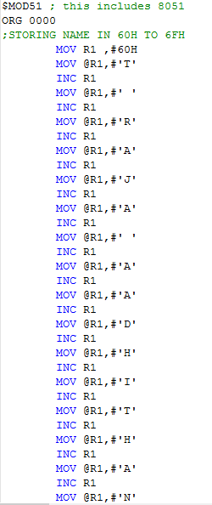
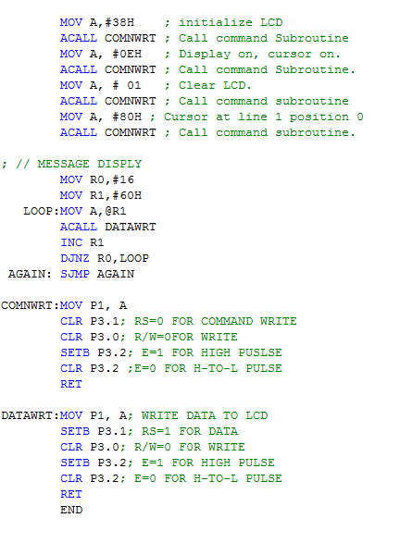

Theory:

16×1 LCD module is a very common type of LCD module that is used in 8051 based embedded projects. It consists of 16 rows and 1 column of 5×7 or 5×8 LCD dot matrices. The module were are talking about here is a type which is a very popular one . It is available in a 16 pin package with back light ,contrast adjustment function and each dot matrix has 5×8 dot resolution.

Circuit and Output:

