EXPERIMENT 3.1

Sorting of ten 8-bits numbers stored in internal data memory in ascending order
Code:
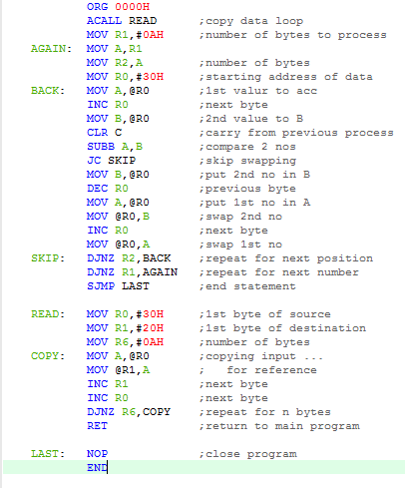

Output:

Internal memory:

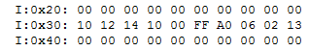
before running the code:

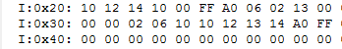
after running the code:

SFRs:

