EXPERIMENT 7
DECIMAL TO HEX

Submitted by,
T Raja Aadhithan
Code:
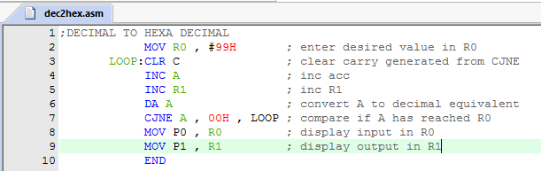
Outputs:
various values of inputs have been displayed:
port 0 is input and port 1 is output

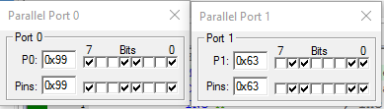
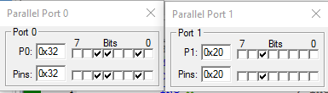
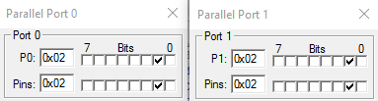
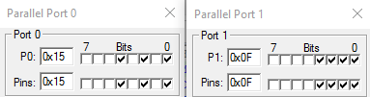
DECIMAL HEX

99 63H

32 20H

02 02H

15 0FH

