EXPERIMENT 2: Multiply 2 numbers.
22.9.2020
CODE:
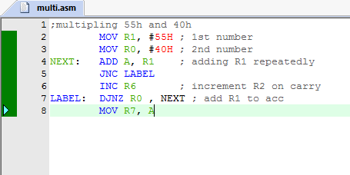

OUTPUT:

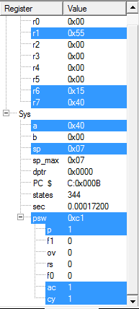
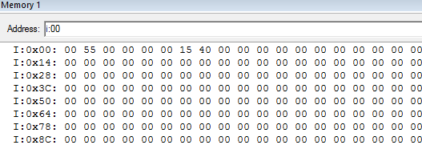

THE OUTPUT IS FOUND AT R7,R6

