EXPERIMENT 1
DATE: 15.9.20

To add two hex numbers 10H and 1DH

CODE:

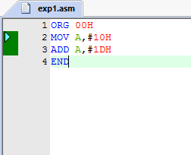

OUTPUT:
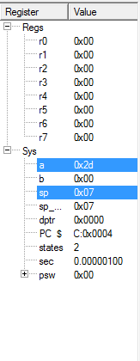
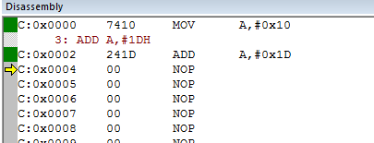

EXPERIMENT 2
DATE: 22.9.20

To add two hex numbers 55H and 40H
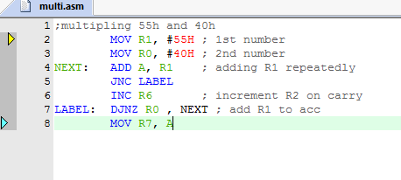
CODE:

OUTPUT:
