EXPERIMENT : ASK MODULATION and DEMODULATION

Submitted by,
T Raja Aadhithan

Aim:

To design the modulation and demodulation of ASK.

Theory:

Amplitude-shift keying (ASK) is a form of amplitude modulation that represents digital data as variations in the amplitude of a carrier wave. ... If the signal value is 1 then the carrier signal will be transmitted; otherwise, a signal value of 0 will be transmitted.

Modulation:

The carrier generator, sends a continuous high-frequency carrier. The binary sequence from the message signal makes the unipolar input to be either High or Low. The high signal closes the switch, allowing a carrier wave. Hence, the output will be the carrier signal at high input. When there is low input, the switch opens, allowing no voltage to appear. Hence, the output will be low.

Demodulator:

The modulated ASK signal is given to the half-wave rectifier, which delivers a positive half output. The low pass filter suppresses the higher frequencies and gives an envelope detected output from which the comparator delivers a digital output.

Circuit:

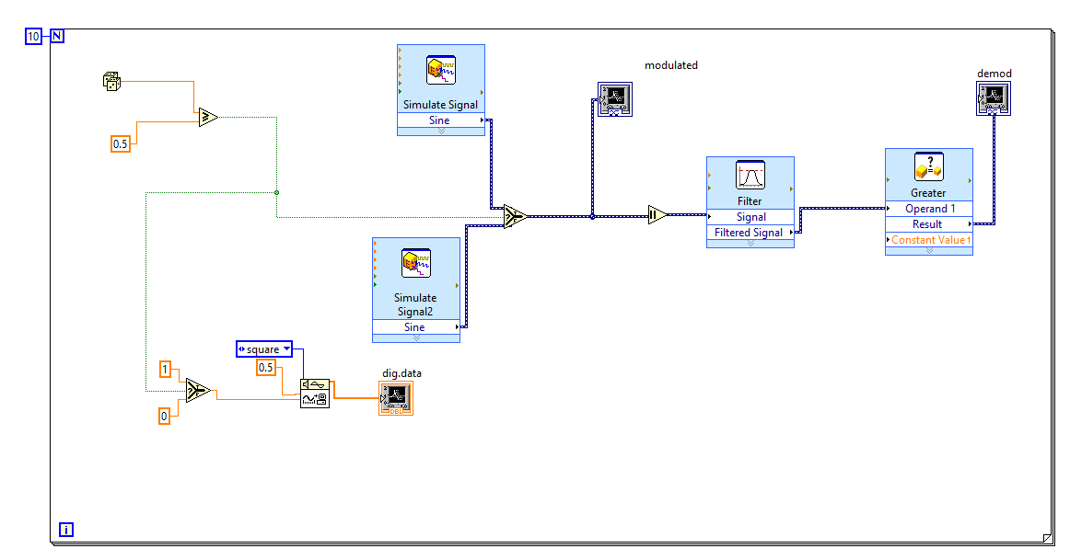
Waveform:
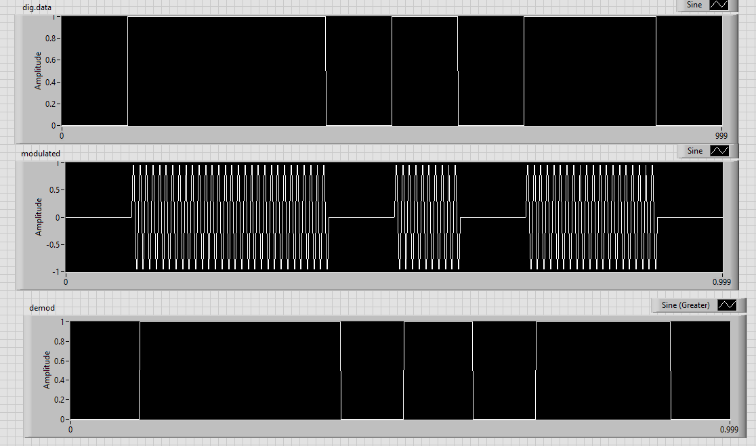

STIMULATION:

- Open LabVIEW Software.
- Click=> New =>Design
- Click save as in and rename the .vi to your circuit name.
- Specify the value of amplitude and frequency for the same value below mentioned.
- Design the ask modulator circuit.
- Implement the demodulator circuit below.
- Click simulate button or press F5 key =>RUN
- Record the waveforms.

RESULT: The ASK modulator and demodulator circuits was set up and the waveforms were plotted.

