EXPERIMENT : DPSK MODULATION and DEMODULATION

Submitted by,
T Raja Aadhithan

Aim:

To design the modulation and demodulation of DPSK.

Theory:

DPSK is a technique of BPSK, in which there is no reference phase signal. Here, the transmitted signal itself can be used as a reference signal. Following is the diagram of DPSK Modulator. DPSK encodes two distinct signals, i.e., the carrier and the modulating signal with 180° phase shift each

Modulation:

DPSK encodes two distinct signals, i.e., the carrier and the modulating signal with 180° phase shift each. The serial data input is given to the XNOR gate and the output is again fed back to the other input through 1-bit delay. The output of the XNOR gate along with the carrier signal is given to the balance modulator, to produce the DPSK modulated signal.

Demodulator:

In DPSK demodulator, the phase of the reversed bit is compared with the phase of the previous bit. Following is the block diagram of DPSK demodulator.

Circuit:

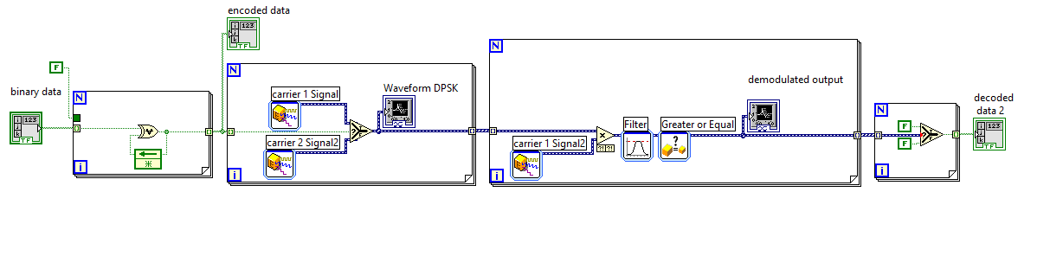
Waveform:
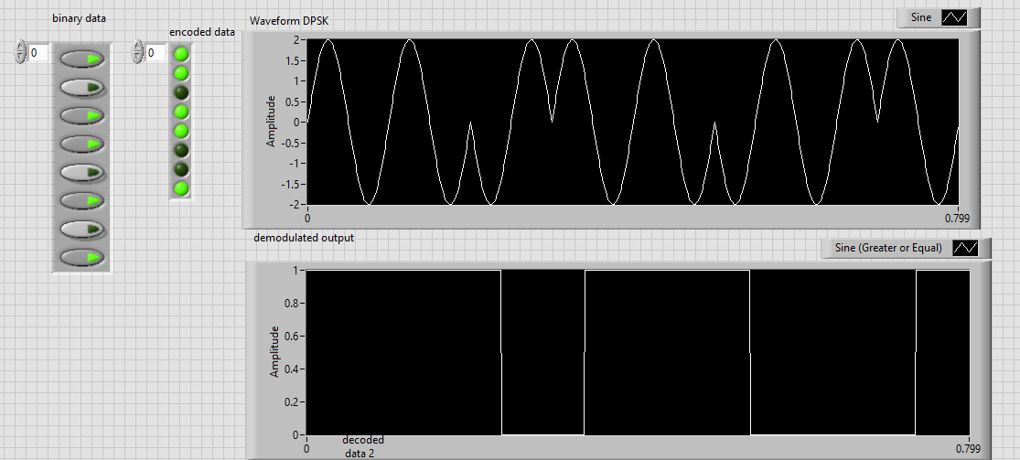

STIMULATION:

- Open LabVIEW Software.
- Click=> New =>Design
- Click save as in and rename the .vi to your circuit name.
- Specify the value of amplitude and frequency for the same value below mentioned.
- Design the dpsk modulator circuit.
- Implement the demodulator circuit below.
- Click simulate button or press F5 key =>RUN
- Record the waveforms.

RESULT: The DPSK modulator and demodulator circuits was set up and the waveforms were plotted.

