EXPERIMENT : FSK MODULATION and DEMODULATION

Submitted by,
T Raja Aadhithan

Aim:

To design the modulation and demodulation of FSK.

Theory:

Frequency Shift Keying (FSK) is a digital modulation scheme where the digital data is transmitted using a high frequency carrier signal. For logic ‘0’ and ‘1’ the carrier signal switches between two preset frequencies, hence the name FSK.

Modulation:

The two signal generators, producing a higher and a lower frequency signals, are connected to a switch along with an internal clock. To avoid the abrupt phase discontinuities of the output waveform during the transmission of the message, a clock is applied to both the oscillators, internally. The binary input sequence is applied to the transmitter so as to choose the frequencies according to the binary input.

Demodulator:

The output of fsk is fed into a high pass filter and an encoder circuit. This produces a capacitor charge and discharge type waveform which is fed into a differentiator. The output is fed into a comparator to attain two distinct value of output.

Circuit:

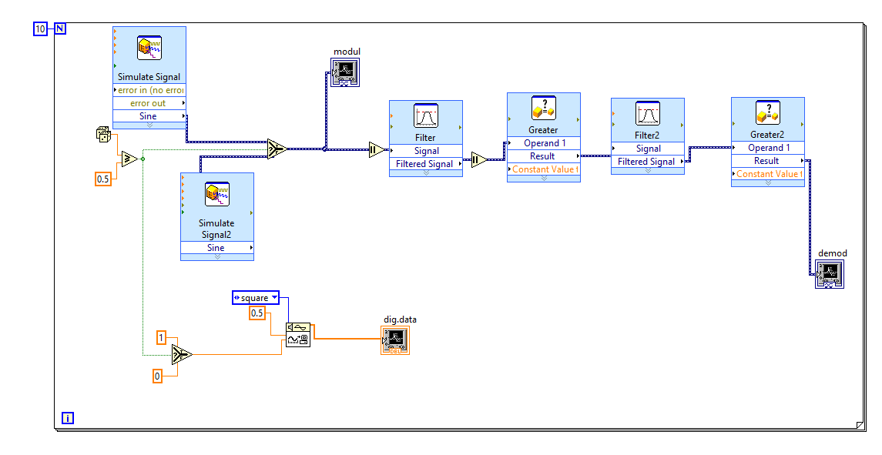
Waveform:
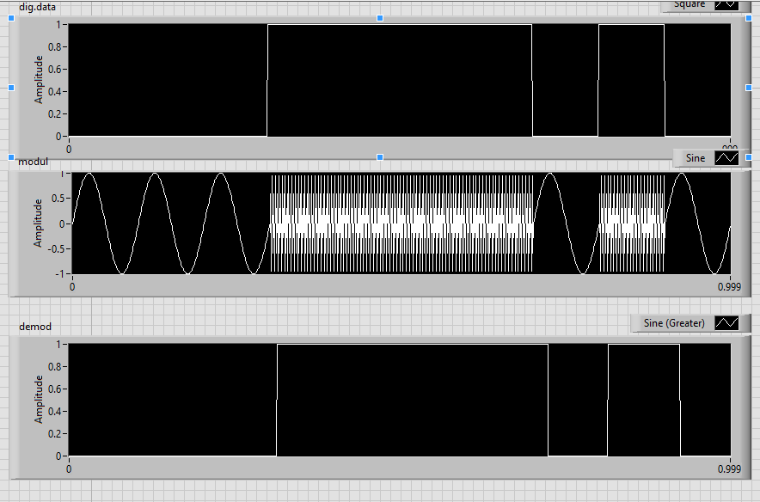

STIMULATION:

- Open LabVIEW Software.
- Click=> New =>Design
- Click save as in and rename the .vi to your circuit name.
- Specify the value of amplitude and frequency for the same value below mentioned.
- Design the fsk modulator circuit.
- Implement the demodulator circuit below.
- Click simulate button or press F5 key =>RUN
- Record the waveforms.

RESULT: The FSK modulator and demodulator circuits was set up and the waveforms were plotted.

