EXPERIMENT : PSK MODULATION and DEMODULATION

Submitted by,
T Raja Aadhithan

Aim:

To design the modulation and demodulation of PSK.

Theory:

The modulation of BPSK is done using a balance modulator, which multiplies the two signals applied at the input. For a zero binary input, the phase will be 0° and for a high input, the phase reversal is of 180°.

Modulation:

A. Case “0” digit as input

When the 0 digit as an input the Transistor is off, then the current through transistor R1 and R5 is nearly 0 Amps ,that means the op-amp is works as buffer with unity gain .As a results the output is in phase of the input (0°).

B. Case “1” digit as input

When the “1” digit as an input the Transistor is on, then the transistor node is grounded, due to the op-amp principle, the positive node is at high input impedance, then the op-amp circuit work as inverting with gain of (-1)

Demodulator:

The BPSK signal matches the input when the input is zero. Hence the output is attained as zero srom the opamp. Where as when the phases do not match(logic high), the input is doubled. Which is passed on to a diode which removes the negative voltage part of it. The signal is sent to an envelope signal which bridges the peaks of the sine wave and the comparator gives a proper binary signal.

Circuit:

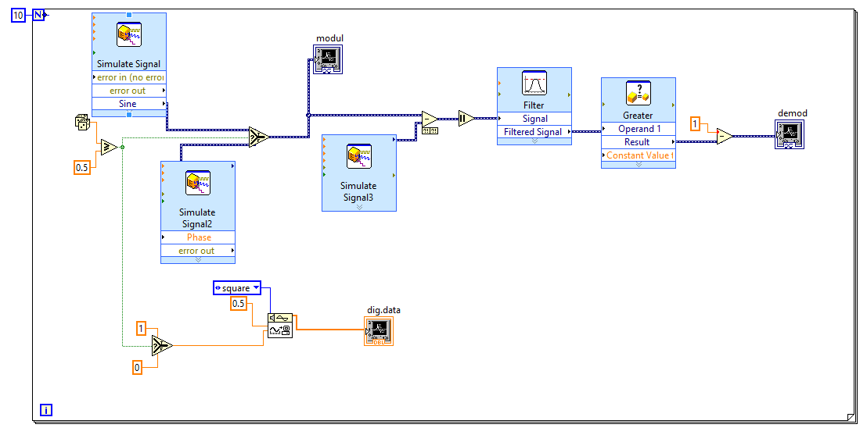
Waveform:
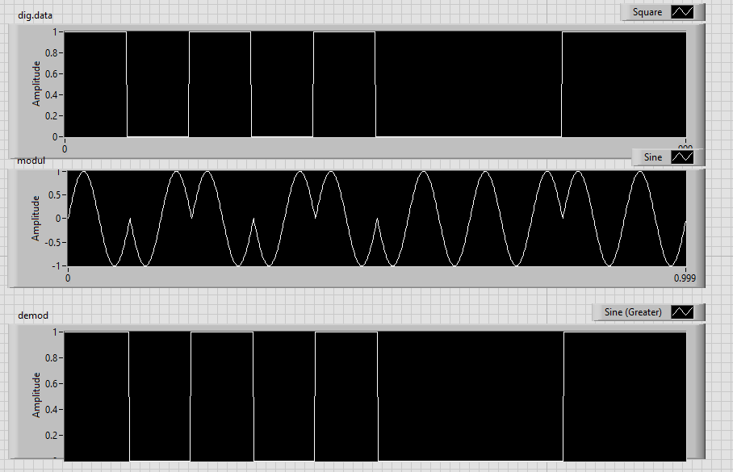

STIMULATION:

- Open LabVIEW Software.
- Click=> New =>Design
- Click save as in and rename the .vi to your circuit name.
- Specify the value of amplitude and frequency for the same value below mentioned.
- Design the psk modulator circuit.
- Implement the demodulator circuit below.
- Click simulate button or press F5 key =>RUN
- Record the waveforms.

RESULT: The PSK modulator and demodulator circuits was set up and the waveforms were plotted.

