EXPERIMENT : QPSK MODULATION and DEMODULATION

Submitted by,
T Raja Aadhithan

Aim:

To design the modulation and demodulation of QPSK.

Theory:

The Quadrature Phase Shift Keying QPSK is a variation of BPSK, and it also sends two bits of digital information at a time, called as bigits.

Instead of the conversion of digital bits into a series of digital stream, it converts them into bit pairs. This decreases the data bit rate to half, which allows space for the other users.

Modulation:

At the modulator’s input, the message signal’s even bits (i.e., 2nd bit, 4th bit, 6th bit, etc.) and odd bits (i.e., 1st bit, 3rd bit, 5th bit, etc.) are separated by the bits splitter and are multiplied with the same carrier to generate odd BPSK (called as PSKI) and even BPSK (called as PSKQ). The PSKQ signal is anyhow phase shifted by 90° before being modulated.

Demodulator:

The QPSK Demodulator uses two product demodulator circuits with local oscillator, two band pass filters, two integrator circuits, and a 2-bit parallel to serial converter. Following is the diagram for the same.

The two product detectors at the input of demodulator simultaneously demodulate the two BPSK signals. The pair of bits are recovered here from the original data. These signals after processing, are passed to the parallel to serial converter.

Circuit:

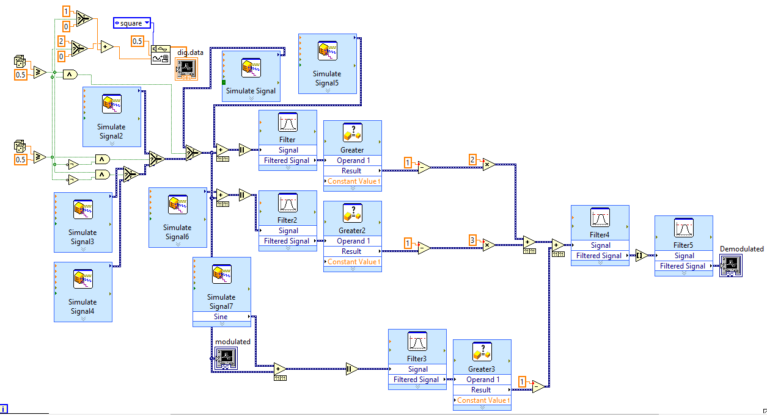
Waveform:
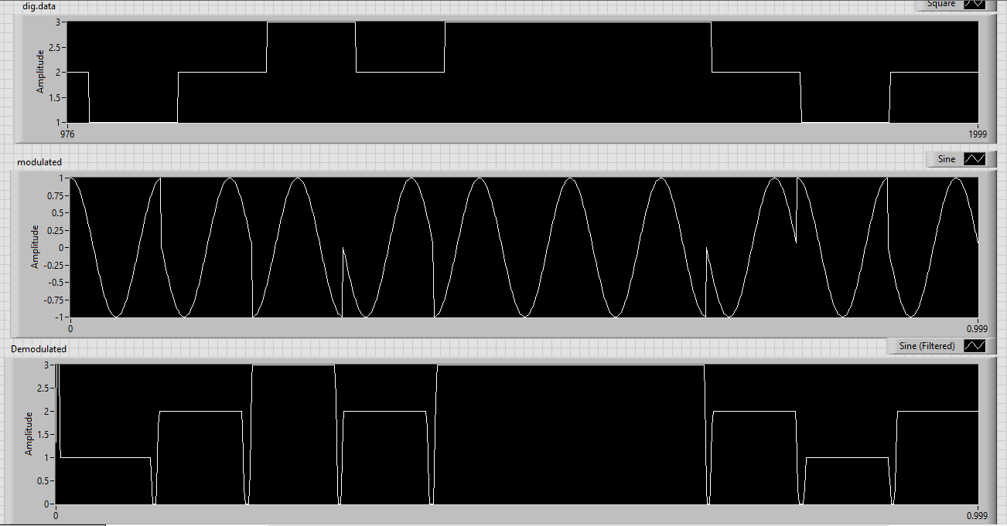

STIMULATION:

- Open LabVIEW Software.
- Click=> New =>Design
- Click save as in and rename the .vi to your circuit name.
- Specify the value of amplitude and frequency for the same value below mentioned.
- Design the qpsk modulator circuit.
- Implement the demodulator circuit below.
- Click simulate button or press F5 key =>RUN
- Record the waveforms.

RESULT: The QPSK modulator and demodulator circuits was set up and the waveforms were plotted.

