FILE ON DIGITAL AND DATA COMMUNICATION SYSTEMS LAB

ESCC301

ON LABVIEW



DEPARTMENT OF ELECTRONIC SCIENCE

UNIVERSITY OF DELHI

To,

Dr . Prasanth Garg
Mr . Arjav

By,
T Raja Aadhithan

19/1031

EXPERIMENT 1: ASK MODULATION and DEMODULATION

Aim:

To design the modulation and demodulation of ASK.

Theory:

Amplitude-shift keying (ASK) is a form of amplitude modulation that represents digital data as variations in the amplitude of a carrier wave. ... If the signal value is 1 then the carrier signal will be transmitted; otherwise, a signal value of 0 will be transmitted.

Modulation:

The carrier generator, sends a continuous high-frequency carrier. The binary sequence from the message signal makes the unipolar input to be either High or Low. The high signal closes the switch, allowing a carrier wave. Hence, the output will be the carrier signal at high input. When there is low input, the switch opens, allowing no voltage to appear. Hence, the output will be low.

Demodulator:

The modulated ASK signal is given to the half-wave rectifier, which delivers a positive half output. The low pass filter suppresses the higher frequencies and gives an envelope detected output from which the comparator delivers a digital output.

Circuit:

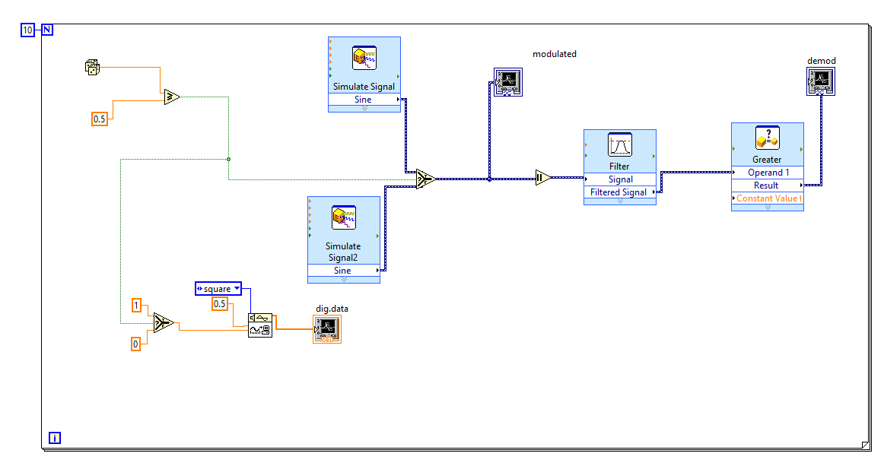
Waveform:
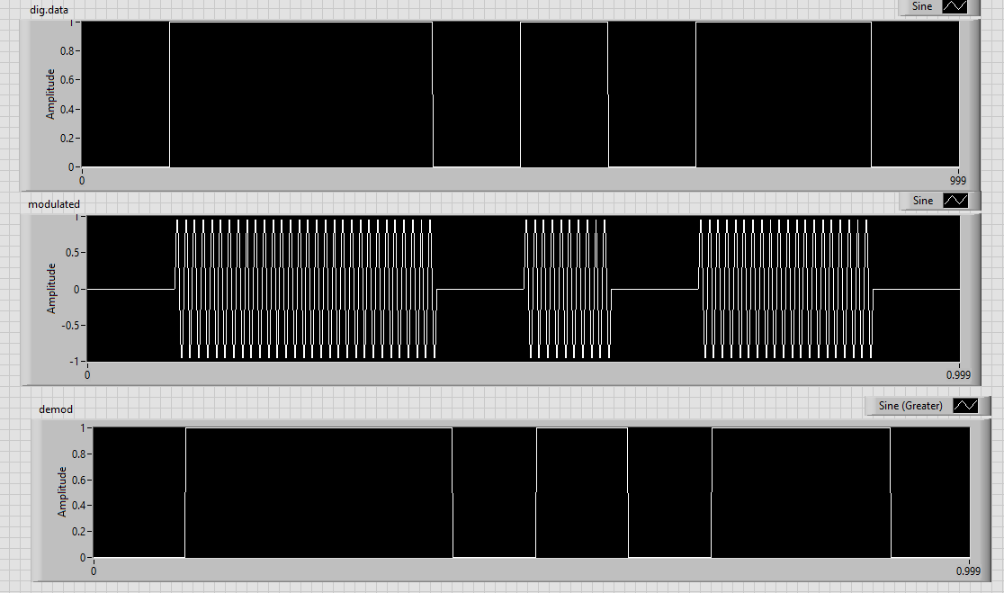

STIMULATION:

- Open LabVIEW Software.
- Click=> New =>Design
- Click save as in and rename the .vi to your circuit name.
- Specify the value of amplitude and frequency for the same value below mentioned.
- Design the ask modulator circuit.
- Implement the demodulator circuit below.
- Click simulate button or press F5 key =>RUN
- Record the waveforms.

RESULT: The ASK modulator and demodulator circuits was set up and the waveforms were plotted.

EXPERIMENT 2: FSK MODULATION and DEMODULATION

Aim:

To design the modulation and demodulation of FSK.

Theory:

Frequency Shift Keying (FSK) is a digital modulation scheme where the digital data is transmitted using a high frequency carrier signal. For logic ‘0’ and ‘1’ the carrier signal switches between two preset frequencies, hence the name FSK.

Modulation:

The two signal generators, producing a higher and a lower frequency signals, are connected to a switch along with an internal clock. To avoid the abrupt phase discontinuities of the output waveform during the transmission of the message, a clock is applied to both the oscillators, internally. The binary input sequence is applied to the transmitter so as to choose the frequencies according to the binary input.

Demodulator:

The output of fsk is fed into a high pass filter and an encoder circuit. This produces a capacitor charge and discharge type waveform which is fed into a differentiator. The output is fed into a comparator to attain two distinct value of output.

Circuit:

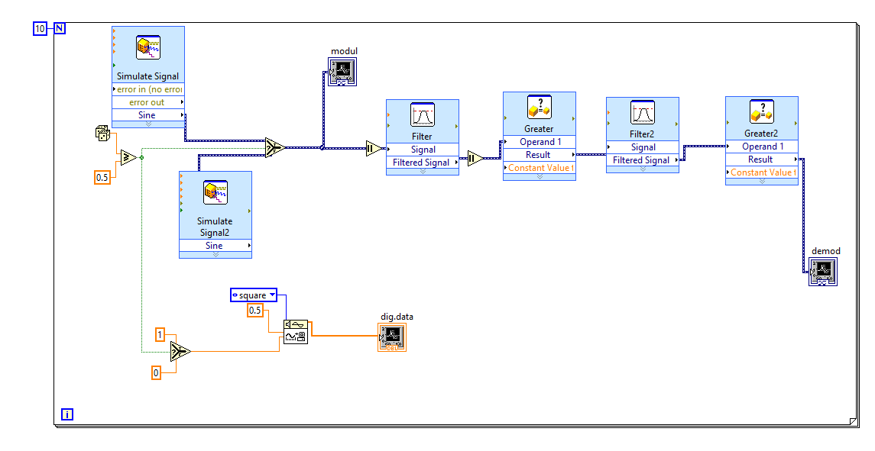
Waveform:
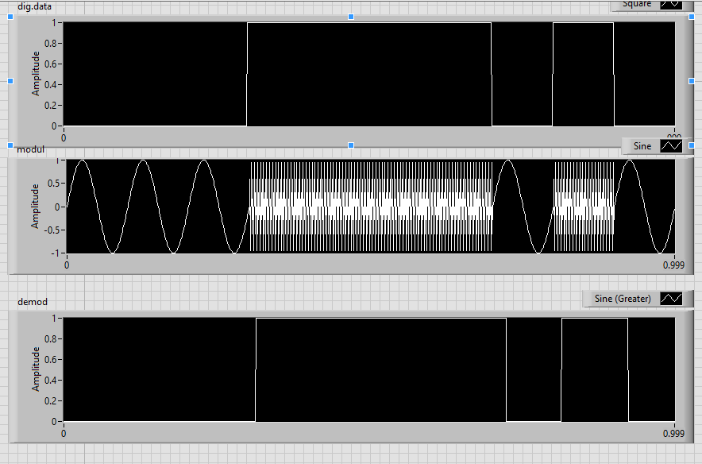

STIMULATION:

- Open LabVIEW Software.
- Click=> New =>Design
- Click save as in and rename the .vi to your circuit name.
- Specify the value of amplitude and frequency for the same value below mentioned.
- Design the fsk modulator circuit.
- Implement the demodulator circuit below.
- Click simulate button or press F5 key =>RUN
- Record the waveforms.

RESULT: The FSK modulator and demodulator circuits was set up and the waveforms were plotted.

EXPERIMENT 3: PSK MODULATION and DEMODULATION

Aim:

To design the modulation and demodulation of PSK.

Theory:

The modulation of BPSK is done using a balance modulator, which multiplies the two signals applied at the input. For a zero binary input, the phase will be 0° and for a high input, the phase reversal is of 180°.

Modulation:

A. Case “0” digit as input

When the 0 digit as an input the Transistor is off, then the current through transistor R1 and R5 is nearly 0 Amps ,that means the op-amp is works as buffer with unity gain .As a results the output is in phase of the input (0°).

B. Case “1” digit as input

When the “1” digit as an input the Transistor is on, then the transistor node is grounded, due to the op-amp principle, the positive node is at high input impedance, then the op-amp circuit work as inverting with gain of (-1)

Demodulator:

The BPSK signal matches the input when the input is zero. Hence the output is attained as zero srom the opamp. Where as when the phases do not match(logic high), the input is doubled. Which is passed on to a diode which removes the negative voltage part of it. The signal is sent to an envelope signal which bridges the peaks of the sine wave and the comparator gives a proper binary signal.

Circuit:

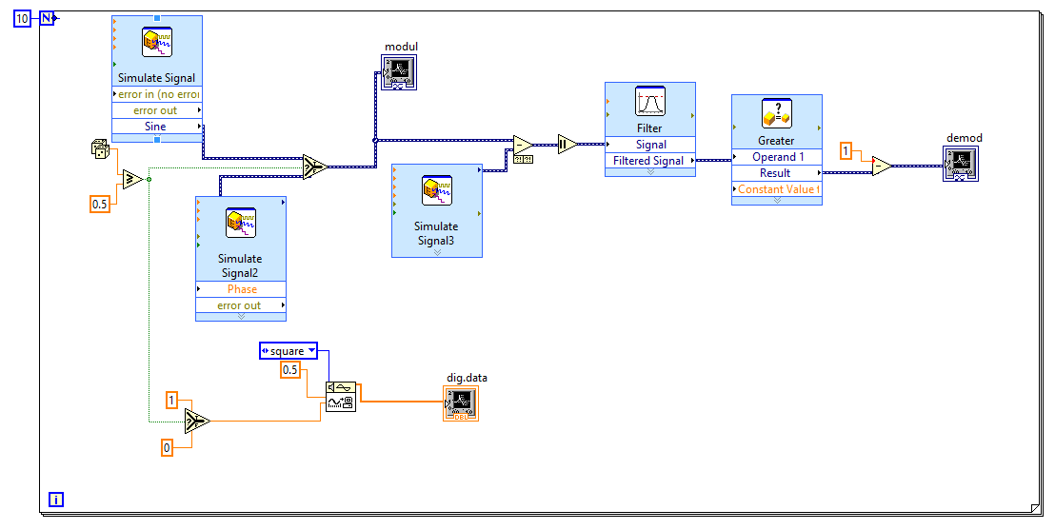
Waveform:
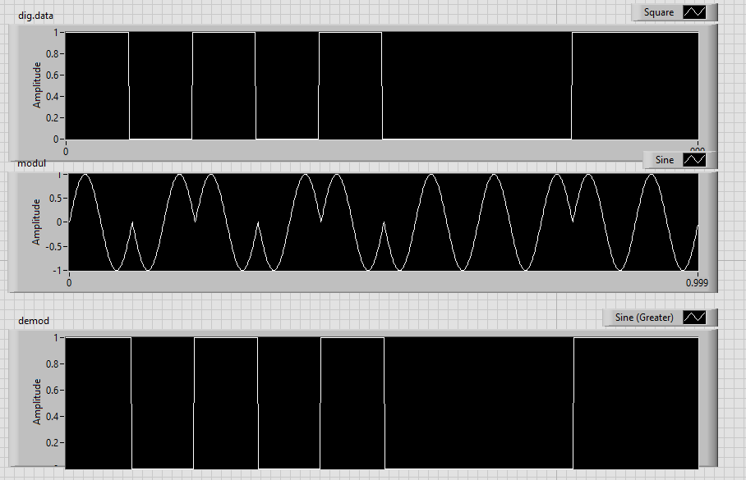

STIMULATION:

- Open LabVIEW Software.
- Click=> New =>Design
- Click save as in and rename the .vi to your circuit name.
- Specify the value of amplitude and frequency for the same value below mentioned.
- Design the psk modulator circuit.
- Implement the demodulator circuit below.
- Click simulate button or press F5 key =>RUN
- Record the waveforms.

RESULT: The PSK modulator and demodulator circuits was set up and the waveforms were plotted.

EXPERIMENT 4: QPSK MODULATION and DEMODULATION

Aim:

To design the modulation and demodulation of QPSK.

Theory:

The Quadrature Phase Shift Keying QPSK is a variation of BPSK, and it also sends two bits of digital information at a time, called as bigits.

Instead of the conversion of digital bits into a series of digital stream, it converts them into bit pairs. This decreases the data bit rate to half, which allows space for the other users.

Modulation:

At the modulator’s input, the message signal’s even bits (i.e., 2nd bit, 4th bit, 6th bit, etc.) and odd bits (i.e., 1st bit, 3rd bit, 5th bit, etc.) are separated by the bits splitter and are multiplied with the same carrier to generate odd BPSK (called as PSKI) and even BPSK (called as PSKQ). The PSKQ signal is anyhow phase shifted by 90° before being modulated.

Demodulator:

The QPSK Demodulator uses two product demodulator circuits with local oscillator, two band pass filters, two integrator circuits, and a 2-bit parallel to serial converter. Following is the diagram for the same.

The two product detectors at the input of demodulator simultaneously demodulate the two BPSK signals. The pair of bits are recovered here from the original data. These signals after processing, are passed to the parallel to serial converter.

Circuit:

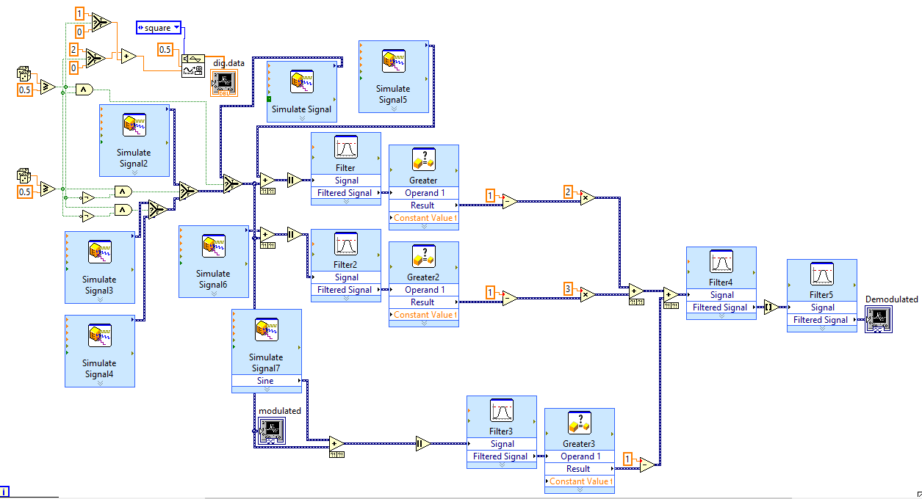
Waveform:
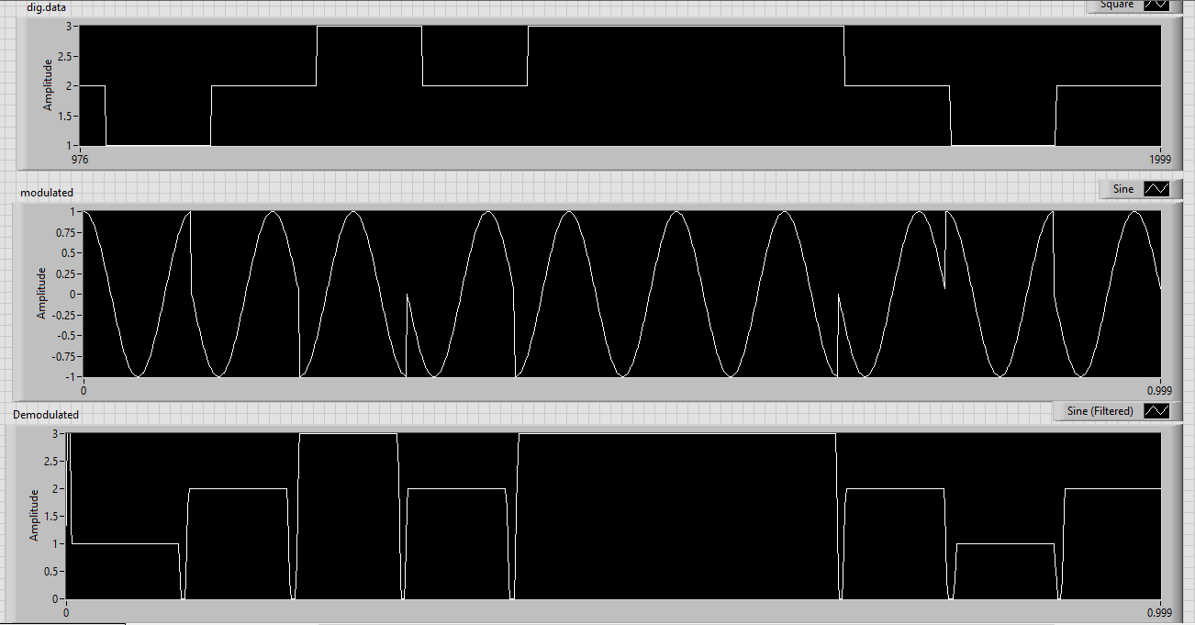

STIMULATION:

- Open LabVIEW Software.
- Click=> New =>Design
- Click save as in and rename the .vi to your circuit name.
- Specify the value of amplitude and frequency for the same value below mentioned.
- Design the qpsk modulator circuit.
- Implement the demodulator circuit below.
- Click simulate button or press F5 key =>RUN
- Record the waveforms.

RESULT: The QPSK modulator and demodulator circuits was set up and the waveforms were plotted.

EXPERIMENT 5: DPSK MODULATION and DEMODULATION

Aim:

To design the modulation and demodulation of DPSK.

Theory:

DPSK is a technique of BPSK, in which there is no reference phase signal. Here, the transmitted signal itself can be used as a reference signal. Following is the diagram of DPSK Modulator. DPSK encodes two distinct signals, i.e., the carrier and the modulating signal with 180° phase shift each

Modulation:

DPSK encodes two distinct signals, i.e., the carrier and the modulating signal with 180° phase shift each. The serial data input is given to the XNOR gate and the output is again fed back to the other input through 1-bit delay. The output of the XNOR gate along with the carrier signal is given to the balance modulator, to produce the DPSK modulated signal.

Demodulator:

In DPSK demodulator, the phase of the reversed bit is compared with the phase of the previous bit. Following is the block diagram of DPSK demodulator.

Circuit:

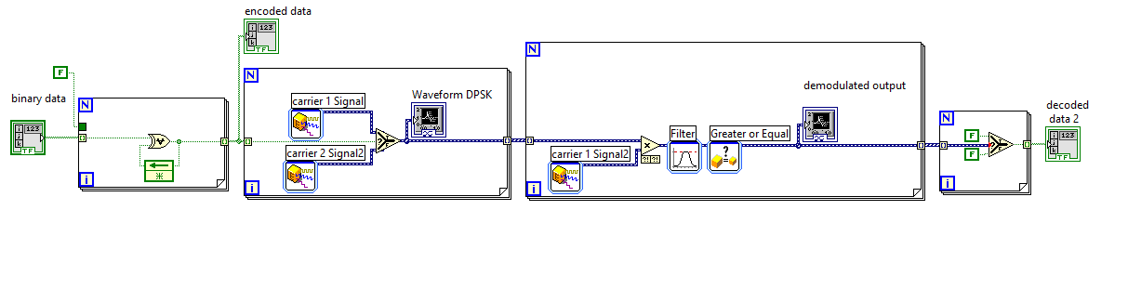
Waveform:
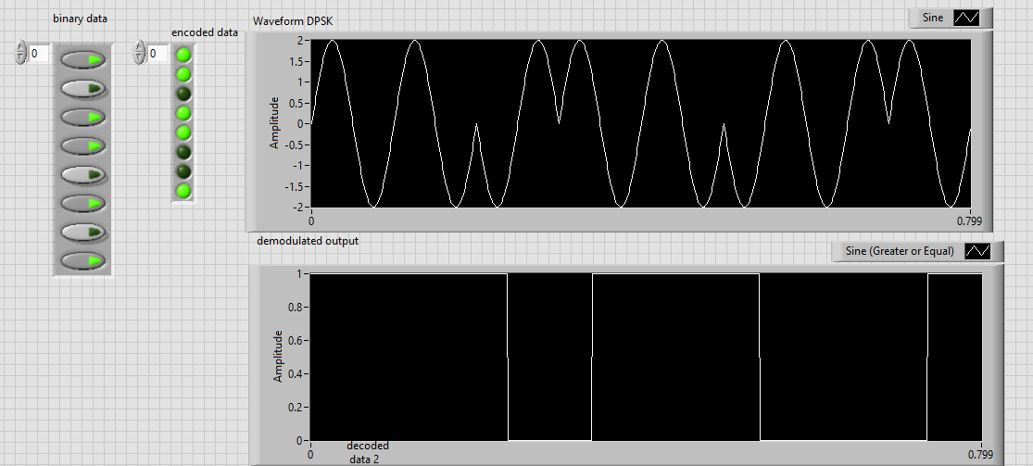

STIMULATION:

- Open LabVIEW Software.
- Click=> New =>Design
- Click save as in and rename the .vi to your circuit name.
- Specify the value of amplitude and frequency for the same value below mentioned.
- Design the dpsk modulator circuit.
- Implement the demodulator circuit below.
- Click simulate button or press F5 key =>RUN
- Record the waveforms.

RESULT: The DPSK modulator and demodulator circuits was set up and the waveforms were plotted.

