**Experiment 2 – Fixed , Dynamic Arrays and Queues**

**Part 1:**

**Aim:**

Write the code to design a D Flip Flop and write test bench in System Verilog.

**Code:**

**DUT:**

module dff(input d,clk, output reg q);

  always@(posedge clk) q<=d;

endmodule

**TB:**

module tb();

  bit d,clk,q,y;

  dff duv(d,clk,q);

  int x = 0;

  initial forever #5 clk = !clk;

  initial begin

    repeat(10)begin

      @(negedge clk) begin

        d <= $random;y <= d;

      end

      @(posedge clk) if(q != y) x = x+1;

      $display("%0d ip is %d op is %d",$time,d,q);

    end

    if(!x) $display("Success"); else $display("Failure");

  end

endmodule

**Output**

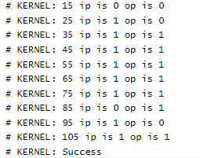

**Part 2:**

**Aim:**

Write the code to design a 4 bit adder and write its test bench is System Verilog

**Code:**

**DUT:**

module add(input [3:0] a,b, input cin, output [3:0] sum, output cout);

  assign {cout,sum} = a+b+cin;

endmodule

**TB:**

module tb();

  reg [3:0] a,b;

  wire [3:0] sum;

  reg cin;

  wire cout;

  int x=0;

  add duv(a,b,cin,sum,cout);

  initial begin

    repeat(10) begin

      {a,b,cin} = $random;

      #1;

      if({cout,sum} != a+b+cin) x = x+1;

      $display("ip is %d,%d, %b op is %d",a,b,cin,{cout,sum});

    end

    if(!x) $display("Success");

    else $display("Failure");

  end

endmodule

**Output:**

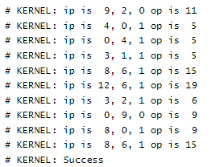

**Result:**

The given problem statement is executed and verified to be correct.