**Experiment 5 – Tasks and Functions**

**PART 1:**

**Aim:**

* Write the SV “task” code for the addition of two integer numbers and check it correctness.
* Observe the difference between simple and automatic tasks:
  + Write a simple task which increments the value of a local variable by a specified amount.
  + Write an automatic task which increments the value of a local variable by a specified amount.
* Write the code using SV “function” for the addition of two integer numbers.
* Write the SV void function to print the current simulation time. Check its corrections.

**Code:**

module add();

  int y;

  task sum(input int a,b, output int y);

    y = a+b;

  endtask

  task stat_inc;

    begin

      static int g = 0;

      g += 5;

      $display("value of static variable is %d",g);

    end

  endtask

  task auto_inc;

    begin

      automatic int u = 0;

      u += 5;

      $display("value of automatic variable is %d",u);

    end

  endtask

  function int add(int x, int y);

    add = x+y;

  endfunction

  function void time_print();

    $display("simulation time is %0d",$time);

  endfunction

  initial begin

    int a = $random;

    int b = $random;

    $display("\n\nTASK ADD");

    sum(a,b,y);

    if(y == a+b) $display("success in addition");

    else $display("failure");

    $display("\nSTATIC INCREMENT");

    repeat(3) stat_inc();

    $display("\nAUTOMATIC INCREMENT");

    repeat(3) auto_inc();

    $display("\nADD FUNCTION");

    y= add(a,b);

    if(y == a+b) $display("success in add function");

    else $display("failure");

    $display("\nTIME PRINT FUNCTION");

    time_print();

    $display("\n\n");

  end

endmodule

**Output:**

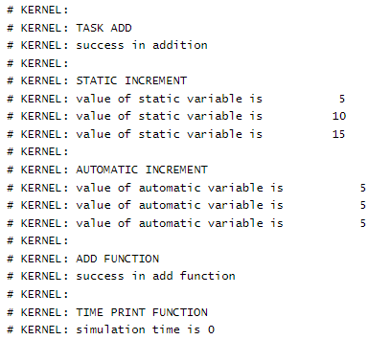

**PART 2:**

**Aim: Demonstrate the difference between static and automatic variables used in SV task.**

**Code:**

module auto_variable_task;

  task auto_delay(input time delay);

    logic static_var = 1'b0;

    automatic logic auto_var = 1'b0;

    $display("@time : %0d - static variable is %b, auto variable is %b",$time,static_var, auto_var);

    #delay;

static_var = !static_var;

    auto_var = !auto_var;

    $display("@time : %0d - static variable is %b, auto variable is %b",$time,static_var, auto_var);

endtask : auto_delay

  initial repeat(3) auto_delay(10ns);

endmodule

**Output:**

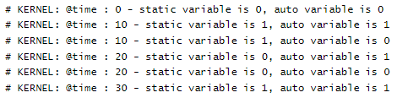

**Result:**

The given problem statement is executed and verified to be correct.