EXP.NO: 2 Write JavaScript Programme to validate the
following fields of the HTML Registration page.:

AIM:
To write JavaScript code to validate user input in a registration form. The validation will
ensure that the data entered by the user meets specific criteria for each field. This will help in
maintaining data integrity and prevent invalid submissions.

ALGORITHM:
1. Input:
• The user fills in the following fields: First Name, Password, E-mail, Mobile
Number, Last Name, and Address.
2. Validation Steps:
1. Validate First Name:
o Check if the first name contains only alphabets.
o Ensure the length of the First Name is at least 6 characters.
o If any of these conditions fail, display an error message indicating the required
input.
2. Validate Password:
o Check if the password is at least 6 characters long.
o If it is less than 6 characters, display an error message.
3. Validate E-mail:
o Use a regular expression to check if the email follows the standard pattern:
name@domain.com.
o Ensure that the email contains no invalid characters and matches the required
pattern.
o If it doesn&#39;t match, display an error message indicating an invalid email
format.

4. Validate Mobile Number:
o Check if the mobile number contains exactly 10 digits.
o Ensure there are no alphabets or special characters.
o If the number is invalid, display an error message indicating the correct
format.
5. Validate Last Name:
o Ensure the Last Name field is not empty.
o If it is empty, display an error message.
6. Validate Address:
o Ensure the Address field is not empty.
o If it is empty, display an error message.
CODE:
HTML:
<!DOCTYPE html>
<html>
<head>
<title>Registration Form Validation</title>
<script>
function validateForm() {
var fname = document.getElementById("fname").value;
var lname = document.getElementById("lname").value;
var password = document.getElementById("password").value;
var email = document.getElementById("email").value;
var mobile = document.getElementById("mobile").value;
var address = document.getElementById("address").value;

var namePattern = /^[A-Za-z]+$/;
var emailPattern = /^[^\s@]+@[^\s@]+\.[^\s@]+$/;
var mobilePattern = /^[0-9]{10}$/;

// First Name Validation
if (!namePattern.test(fname) || fname.length < 6) {
alert("First Name must contain only alphabets and minimum 6 characters");
return false;
}

// Password Validation
if (password.length < 6) {
alert("Password must be at least 6 characters long");
return false;
}

// Email Validation
if (!emailPattern.test(email)) {
alert("Invalid Email format");
return false;
}

// Mobile Number Validation
if (!mobilePattern.test(mobile)) {
alert("Mobile number must contain exactly 10 digits");
return false;
}

// Last Name Validation
if (lname === "") {
alert("Last Name cannot be empty");
return false;
}

// Address Validation
if (address === "") {
alert("Address cannot be empty");
return false;
}

alert("Registration Successful!");
return true;
}
</script>
</head>

<body>
<h2>Registration Form</h2>

<form onsubmit="return validateForm()">
First Name:
<input type="text" id="fname"><br><br>

Last Name:
<input type="text" id="lname"><br><br>

Password:
<input type="password" id="password"><br><br>

E-mail:
<input type="text" id="email"><br><br>

Mobile Number:
<input type="text" id="mobile"><br><br>

Address:
<textarea id="address"></textarea><br><br>

<input type="submit" value="Register">
</form>
</body>
</html>

Output:
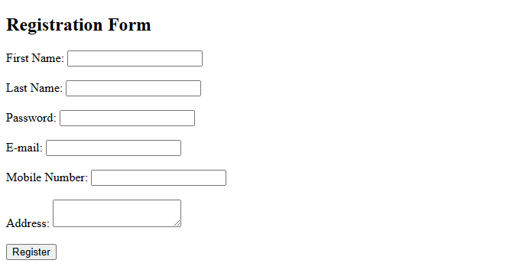

RESULT:
HTML page with Form is created and is validated using Javascript

