Exp:1 Web Page Creation using HTML

AIM:
To create a web page that embeds a map with hotspots, frames, and links. The web page
should be designed using HTML, incorporating embedded, external, and inline CSS for
styling. This exercise aims to enhance understanding of integrating multimedia elements like
maps, creating interactive hotspots, and organizing content using frames while applying
different CSS techniques for styling.
ALGORITHM:
Create the HTML structure:
• Set up the basic HTML document with &lt;!DOCTYPE html&gt;, &lt;html&gt;, &lt;head&gt;, and
&lt;body&gt; tags.
• In the &lt;head&gt;, link the external CSS file (&lt;link&gt; tag), define the title, and include any
metadata.
• In the &lt;body&gt;, create the necessary elements:
o Frames: Use the &lt;frameset&gt; tag to create a frame layout (for older browsers,
use &lt;iframe&gt; instead).
o Map: Use the &lt;img&gt; tag to display a map.
o Hotspots: Create clickable regions using the &lt;map&gt; and &lt;area&gt; tags.
o Links: Add hyperlinks (&lt;a&gt;) to navigate to different parts of the page or
external sites.

Create CSS Styles:
• External CSS: In a separate file, define styles such as colors, fonts, and layout for the
entire page.
• Inline CSS: Use the style attribute within specific tags to apply styles (e.g., in &lt;div&gt;
or &lt;p&gt; tags).
• Embedded CSS: Inside the &lt;style&gt; tag in the &lt;head&gt;, define styles for specific
elements like the map, frames, and text.
Map with Hotspots:
• Use the &lt;map&gt; tag to create an image map.
• Define the &lt;area&gt; tag for each hotspot, specifying the coordinates (e.g.,
coords=&quot;x,y,x2,y2&quot;) for clickable areas on the map.
Frames:
• Use the &lt;iframe&gt; tag for embedding external content like a map or another webpage,
with attributes such as src for the URL, width, and height.
Add Links:
• Inside the &lt;body&gt;, use the &lt;a&gt; tag to create links for navigation (for example, to link
to specific parts of the page or external sites).
Test the Page:
• Test the webpage to check the functionality of frames, hotspots, and links. Ensure that
the map hotspots are clickable and the linked content displays correctly.
• Ensure that the styles are applied properly using inline, embedded, and external CSS.
Code:
HTML:
<!DOCTYPE html>
<html lang="en">
<head>
<meta charset="UTF-8">
<title>Chennai Map with Hotspots</title>

<style>
/* Embedded CSS */
h1 {
color: darkblue;
text-align: center;
}

.map-container {
text-align: center;
margin: 20px;
}

iframe {
border: 2px solid black;
}
</style>
</head>

<body>

<h1>Chennai City Map</h1>

<!-- Inline CSS -->
<p style="text-align:center; font-size:16px; color:green;">
Click on the hotspots in the map to explore important places in Chennai.
</p>

<div class="map-container">
<!-- Online Image (No download needed) -->
<img src="https://upload.wikimedia.org/wikipedia/commons/3/32/Chennai_district_map.png"
alt="Chennai Map"
usemap="#chennaitheme"
width="500">

<map name="chennaitheme">
<area shape="rect" coords="50,50,150,150"
href="https://en.wikipedia.org/wiki/Marina_Beach"
target="contentFrame"
alt="Marina Beach">

<area shape="circle" coords="250,250,40"
href="https://en.wikipedia.org/wiki/Chennai_Central_railway_station"
target="contentFrame"
alt="Chennai Central">

<area shape="rect" coords="300,100,450,200"
href="https://en.wikipedia.org/wiki/Kapaleeshwarar_Temple"
target="contentFrame"
alt="Kapaleeshwarar Temple">
</map>
</div>

<div class="links" style="text-align:center;">
<a href="https://www.tn.gov.in" target="_blank">Tamil Nadu Government</a> |
<a href="https://en.wikipedia.org/wiki/Chennai" target="_blank">About Chennai</a>
</div>

<br>

<center>
<iframe name="contentFrame" width="600" height="300"></iframe>
</center>

</body>
</html>
CSS:
body {
font-family: system-ui;
background: #f06d06;
color: white;
text-align: center;
}
JS:
document.getElementsByTagName("h1")[0].style.fontSize = "6vw";

output:
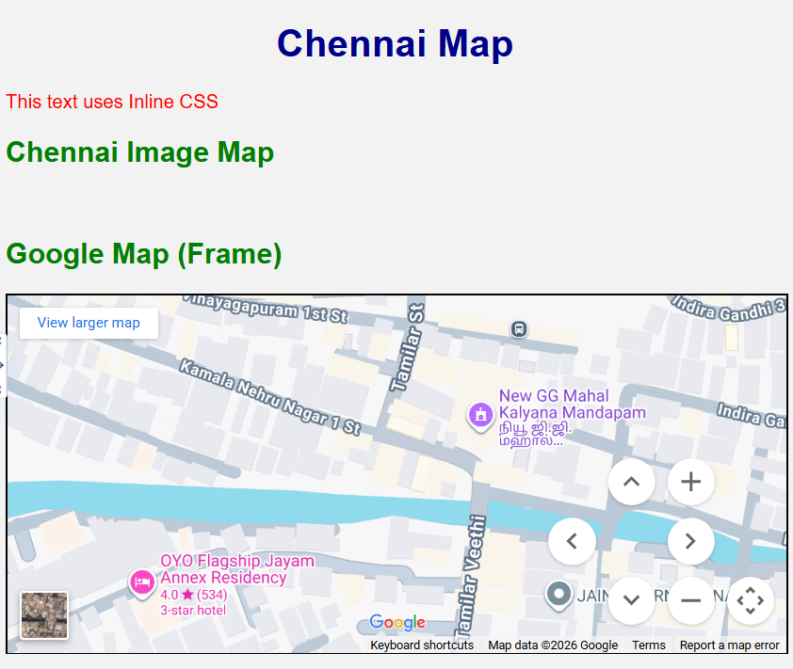

RESULT:
Html Page is created with embedded Chennai map along with hot spot, frames &amp;
links.

