UQAAB Voice Assistant
README: Setup Instructions
Requirements
Python 3.10+ (recommended)
Packages:
speechrecognition
pyttsx3
pyaudio
tkinter
Sample Voice Commands and Responses:
Example:
Voice Command | Expected Response
Update my route to Lahore | Route updated to Lahore. New ETA is X hours.
What's my next job? | Your next job is from Lahore to Islamabad...
When is my next delivery? | Your current delivery to Lahore is due at...
Cancel my job | Job JOB-78912 has been cancelled. Please await new assignment.
Confirm drop-off in Lahore | Drop-off in Lahore confirmed. Payment will be processed shortly.

List of Supported Voice Intents
1. Update Route
Pattern:
(update|change) (my )?route (to )?(?P<city>[\w\s]+)
Example: "Update my route to Lahore"
2. Next Job Inquiry
Pattern:
what('s| is) my next job\??
Example: "What's my next job?"
3. Next Delivery Inquiry
Pattern:
when('s| is) my next delivery\??
Example: "When is my next delivery?"
4. Cancel Job
Pattern:
cancel my (current )?job
Example: "Cancel my job"
5. Confirm Drop-off
Pattern:
confirm drop[ -]?o?f{1,2} (in |at )?(?P<city>[\w\s]+)
Example: "Confirm drop-off in Lahore"
Screenshot of GUI:
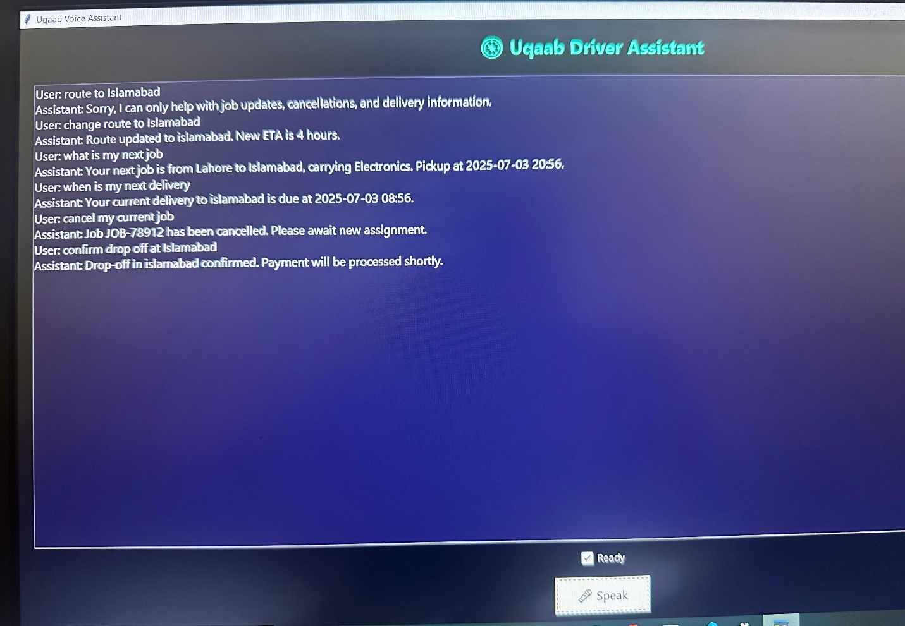

Working Overview:
1. Voice Recognition (Speech-to-Text)
Uses the speech_recognition library and Google Speech Recognition API to capture and convert the driver's spoken commands into text.
Example: "What's my next job?" is captured and transcribed.
2. Intent Parsing
Text is analyzed with regex pattern matching to determine the user’s intent.
Example patterns:
"what's my next job" → next_job
"update my route to Lahore" → update_route
Regex captures extra info like the city name (Lahore) for dynamic responses.
3. Intent Handling (Business Logic)
Each intent triggers a function with logic that simulates a backend.
For example:
If the command is "update my route to Lahore":
It updates the destination in driver_data["current_job"]
Returns a random ETA like "3 hours"
If the command is “cancel my job”, it nullifies the current job.
4. Text-to-Speech Output
The assistant speaks back using pyttsx3 TTS engine.
Also displays the response in the Tkinter GUI chat window.
5. Multithreading (GUI Smoothness)
threading.Thread is used to run speech recognition in parallel so the GUI doesn’t freeze while listening.
6. GUI (Tkinter)
A clean chat-like interface is built with tkinter:
Chat log window
Status label (e.g., “Listening…”)
A single “ Speak” button to trigger interaction

