Software Requirements Specification (SRS)

1. Functional Requirements
The system will support the following functional requirements:
1.1 Register and Log In Users
- The system shall allow Admins, Teachers, and Students to register using their email and password.
- The system shall provide secure login functionality with password encryption.
- The system shall implement a password recovery option using email verification.
1.2 Manage Users
- Admins shall create, edit, delete, and manage user accounts.
- Admins shall assign user roles (Student, Teacher, or Admin) during user management.
- The system shall ensure users have appropriate access based on their assigned roles.
1.3 Create, Edit, and Delete Quizzes
- Teachers shall create quizzes by selecting questions from the question bank.
- Teachers shall edit and delete quizzes as needed before the quiz start time.
- The system shall allow setting time limits, difficulty levels, and pass criteria.
1.4 Manage Question Bank
- Teachers shall add, edit, and delete questions in the question bank.
- The system shall support multiple question types (e.g., multiple choice, short answer, essay).
- The system shall categorize and store questions for future reuse.
1.5 Schedule Exams
- Teachers shall schedule exams with defined start and end times.
- Teachers shall assign quizzes to specific student groups.
- The system shall send notifications to students about upcoming exams.
1.6 Attempt and Submit Quizzes
- Students shall attempt quizzes within the specified time.
- The system shall auto-submit quizzes when the time expires.
- Students shall receive a confirmation message upon successful submission.
1.7 Grade and Manage Results
- The system shall automatically grade objective questions.
- Teachers shall manually grade subjective questions.
- The system shall generate score reports for students and teachers.
1.8 Send Messages or Queries
- Students shall send queries to Teachers or Admins using the in-system messaging feature.
- Teachers shall respond to student queries.
- The system shall maintain a log of all messages for future reference.
1.9 View Exam Schedule and Results
- Students shall view their exam schedule on their dashboard.
- The system shall display exam results after grading is completed.
- Teachers and Admins shall generate and export reports for analysis.

2. Non-Functional Requirements
The system must meet the following non-functional requirements:
2.1 Product Requirements
- The system shall support up to 500 concurrent users without performance degradation.
- Results for objective quizzes shall be available within 5 seconds.
- The system shall use AES-256 encryption for password storage and sensitive data protection.
- The system shall ensure 99.9% uptime for all users.
- It shall have a responsive design accessible on desktops, tablets, and mobile devices.
2.2 Organizational Requirements
- The system shall integrate with the institution's Learning Management System (LMS).
- The system shall provide user training materials for Admins, Teachers, and Students.
- Regular system updates and maintenance shall be conducted monthly by the IT department.
- A dedicated support team shall be available during office hours to handle technical issues.
2.3 External Requirements
- The system shall comply with GDPR and local data privacy laws.
- It shall integrate with third-party email services for notifications.
- It shall use external cloud storage for data backup, ensuring disaster recovery capabilities.
- The system shall support multi-factor authentication (MFA) for added security.

3. Use Case Diagram
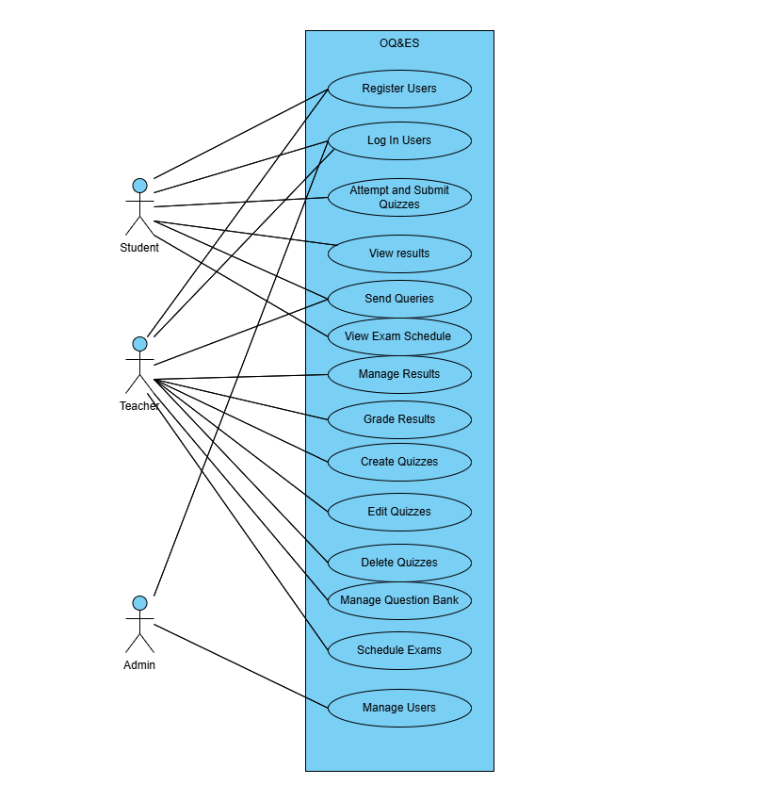
4. User Stories
This section presents user stories based on the identified use cases. Each user story includes the actor, goal, reason, and corresponding pre- and post-conditions.

4.1 Register Users
- As a User (Teacher, or Student)
- I want to register and create an account
- So that I can access the system and perform my respective tasks.
Pre-conditions:
- The user is not registered.
- The registration page is accessible.
Post-conditions:
- The user’s account is successfully created.
- The user can proceed to log in.

4.2 Log In Users
- As a User (Admin, Teacher, or Student)
- I want to log in using my credentials
- So that I can access my personalized dashboard.
Pre-conditions:
- The user has a registered account.
- Valid login credentials are available.
Post-conditions:
- The user is authenticated.
- The appropriate dashboard is displayed.

4.3 Attempt and Submit Quizzes
- As a Student
- I want to attempt quizzes assigned to me
- So that I can complete assessments within the given time.
Pre-conditions:
- The student is logged in.
- The quiz is scheduled and accessible.
Post-conditions:
- The quiz is submitted successfully.
- Objective questions are automatically graded.

4.4 View Results
- As a Student
- I want to view my quiz results
- So that I can track my performance.
Pre-conditions:
- The quiz has been graded.
- Results are published.
Post-conditions:
- The student can see their score and feedback.

4.5 Send Queries
- As a Student
- I want to send queries to my teacher
- So that I can clarify doubts regarding quizzes or results.
Pre-conditions:
- The student is logged in.
- The messaging system is available.
Post-conditions:
- The teacher receives the query.
- The student is notified when a response is available.

4.6 View Exam Schedule
- As a Student
- I want to view my upcoming exams
- So that I can manage my time effectively.
Pre-conditions:
- The student is logged in.
- Exams have been scheduled by the teacher.
Post-conditions:
- The student can see the exam schedule on their dashboard.

4.7 Manage Results
- As an Admin or Teacher
- I want to manage quiz results
- So that I can update or correct them if needed.
Pre-conditions:
- The teacher is logged in.
- Quiz results exist.
Post-conditions:
- Results are updated and saved.
- Students are notified of any changes.

4.8 Grade Results
- As a Teacher
- I want to grade subjective answers manually
- So that I can ensure fair evaluation.
Pre-conditions:
- The teacher is logged in.
- Quiz submissions include subjective answers.
Post-conditions:
- Subjective answers are graded.
- Results are updated.

4.9 Create Quizzes
- As a Teacher
- I want to create quizzes with different question types
- So that I can effectively assess students’ knowledge.
Pre-conditions:
- The teacher is logged in.
- A question bank exists.
Post-conditions:
- The quiz is created and saved.
- Students can attempt it when scheduled.

4.10 Edit Quizzes
- As a Teacher
- I want to edit quizzes before they are published
- So that I can correct mistakes or improve the assessment.
Pre-conditions:
- The teacher is logged in.
- The quiz has not been attempted by students.
Post-conditions:
- The quiz is updated.
- The changes are saved successfully.

4.11 Delete Quizzes
- As a Teacher
- I want to delete unwanted quizzes
- So that I can manage the quiz repository efficiently.
Pre-conditions:
- The teacher is logged in.
- The quiz is not linked to active exams.
Post-conditions:
- The quiz is removed from the system.

4.12 Manage Question Bank
- As a Teacher
- I want to manage the question bank
- So that I can add, edit, or delete questions for future use.
Pre-conditions:
- The teacher is logged in.
Post-conditions:
- The question bank is updated.
- Questions are available for quiz creation.

4.13 Schedule Exams
- As a Teacher
- I want to schedule exams
- So that students can take quizzes at specified times.
Pre-conditions:
- The teacher is logged in.
- Quizzes have been created.
Post-conditions:
- The exam is scheduled.
- Notifications are sent to students.

4.14 Manage Users
- As an Admin
- I want to manage users
- So that I can ensure proper access and security.
Pre-conditions:
- The admin is logged in.
Post-conditions:
- Users are created, updated, or deleted.
- Role assignments are updated.

5. Domain Model
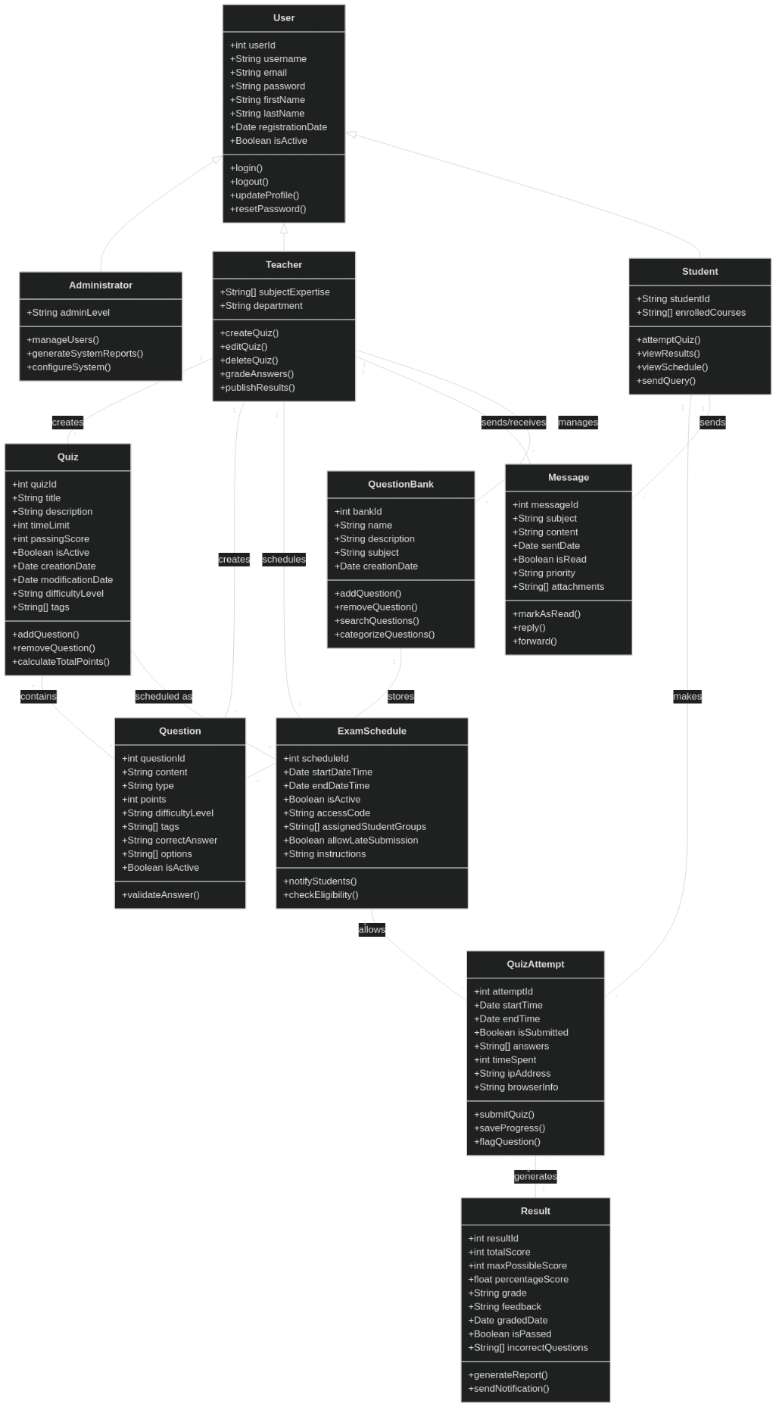
6. Class Diagram


