PROJECT DOCUMENTATION
EduGenie
Google Gemini Powered Learning Assistant

1. Project Description
EduGenie is a lightweight AI-powered educational assistant that simplifies learning through generative AI. Designed for students of all academic levels, EduGenie enables users to:
- Ask questions and receive smart, concise answers
- Understand complex concepts through simplified explanations
- Generate quizzes from topics or text
- Receive personalized learning recommendations
- Summarize large educational passages
The application is built with FastAPI for the backend and a simple HTML + CSS + JavaScript frontend. It combines a lightweight, locally-run model with Google's cloud-based Gemini 1.5 Pro model, balancing local efficiency with cloud reasoning power, so it runs comfortably on standard laptops and is accessible to a broad range of learners and developers.

1.1 Scenarios
Scenario 1: A student who wants to know about oceans and rivers uses EduGenie to ask “Which is the largest ocean?”
Scenario 2: A student wants to check her understanding of “The Pythagoras Theorem” and clicks “Generate Quiz.”
Scenario 3: A learner exploring SQL requests a learning path — a structured plan with beginner to advanced topics, timelines, and resource suggestions.

2. Architectural Diagram
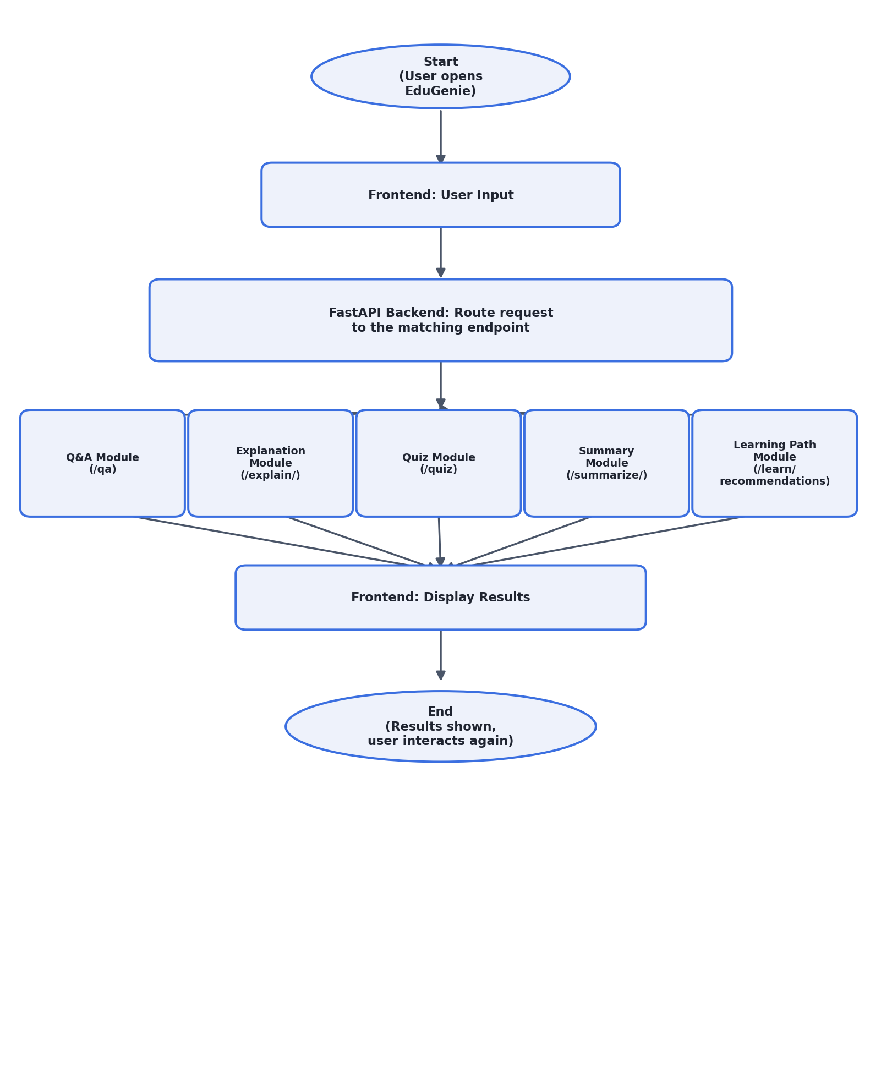
Fig 2.1 — EduGenie request flow: frontend → FastAPI router → module → response

3. Pre-requisites

3.1 Python 3.10+
Download and install Python 3.10 or later, checking “Add Python to PATH” during setup. Verify with:
python --version

3.2 FastAPI Framework
The backend web framework used to expose REST endpoints for every module.

3.3 HTML & CSS
Basic templating used in /templates and /static for the frontend interface.

3.4 Google Gemini API Key
Required for the Q&A, Quiz, Summary and Learning Path modules. Setup steps:
- Visit Google AI Studio and sign in with a Google account.
- Create a new project and enable the Gemini API.
- Generate an API key and store it securely in a .env file.

3.5 Uvicorn (ASGI Server)
pip install uvicorn

3.6 Jinja2 (HTML Templating Engine)
pip install jinja2

3.7 Transformers + Torch (local model)
Required only for the Explanation module, which runs the LaMini-Flan-T5-783M model locally on CPU.
pip install transformers torch sentencepiece accelerate

4. Project Workflow

MILESTONE 1: Model Selection and Architecture

Activity 1.1: Select AI Models
- Gemini 1.5 Pro (via API) — used for: Q&A, summarization, quiz generation, learning paths. Benefits: advanced reasoning, structured outputs, cloud inference.
- LaMini-Flan-T5-783M (local) — used for: concept explanation. Benefits: instruction-tuned, lightweight, CPU-compatible.

Folder Architecture
EduGenie/
main.py | # FastAPI app & all route definitions
gemini_client.py | # Shared Gemini configuration helper
qna.py | # Question answering module
explanation_module.py | # Concept explanation logic (local model)
quiz_module.py | # Quiz generation module
summary_module.py | # Summarization module
learning_path.py | # Learning recommendations module
templates/index.html | # HTML frontend
static/style.css | # Styling
requirements.txt | # Python dependencies
.env.example | # Environment variable template

MILESTONE 2: Core Functionalities Development

Activity 2.1: Module Implementation
1. Explanation Module
EduGenie utilises the LaMini-Flan-T5 model, a lightweight yet powerful generative model, to deliver educational content in a simplified, highly readable manner. It is instruction-tuned to provide concise, context-aware responses that break complex topics into easy language — particularly valuable for beginners and self-learners.
# explanation_module.py
from transformers import AutoTokenizer, AutoModelForSeq2SeqLM

MODEL_NAME = "MBZUAI/LaMini-Flan-T5-783M"

def explain_topic(topic: str) -> str:
_load_model()
input_text = f"Explain the concept of '{topic}' in a simple",
f" and clear way for a school student."
inputs = _explain_tokenizer(input_text, return_tensors="pt")
outputs = _explain_model.generate(
**inputs, max_new_tokens=150, temperature=0.7,
top_k=50, top_p=0.95, do_sample=True,
)
return _explain_tokenizer.decode(outputs[0], skip_special_tokens=True)
Fig 4.1 — Explanation module logic
2. QnA Module
Powered by Gemini 1.5 Pro, this module handles a wide range of general knowledge and academic question-answering tasks with precision and contextual understanding.
# qna.py
def answer_question_with_gemini(question: str) -> str:
configure_gemini()
model = genai.GenerativeModel(model_name=GEMINI_MODEL_NAME)
prompt = f"You are EduGenie, a helpful AI tutor. "
f"Answer clearly and accurately:\n\n{question}"
response = model.generate_content(prompt)
return response.text.strip()
Fig 4.2 — Q&A module logic
3. Quiz Module
EduGenie generates three multiple-choice questions from a given passage, each with four options. It uses Gemini to comprehend context and craft plausible distractors, returning structured JSON for easy frontend integration.
# quiz_module.py
def generate_quiz(text: str) -> list:
configure_gemini()
model = genai.GenerativeModel(model_name=GEMINI_MODEL_NAME)
prompt = f"""You are a quiz generator. From the passage,
create 3 MCQs, each with a 'question', 4 'options' and
an 'answer' matching one option exactly. Return valid JSON.
Passage: {text}"""
response = model.generate_content(prompt)
cleaned = clean_json_block(response.text.strip())
return json.loads(cleaned)
Fig 4.3 — Quiz module logic
4. Summary Module
This feature leverages Gemini's generative capabilities to condense long paragraphs into concise, easy-to-revise summaries while retaining core information.
# summary_module.py
def summarize_text(text: str) -> str:
configure_gemini()
model = genai.GenerativeModel(model_name=GEMINI_MODEL_NAME)
prompt = f"Summarize the following text in simple language:\n\n{text}"
response = model.generate_content(prompt)
return response.text.strip()
Fig 4.4 — Summary module logic
5. Learning Path Module
The get_learning_recommendations function uses Gemini to generate a personalised, structured learning path for any topic — organised by difficulty (beginner / intermediate / advanced) and supported with resource suggestions such as videos, articles and books.
# learning_path.py
def get_learning_recommendations(topic: str) -> str:
prompt = f"""You are an AI tutor. The student wants to learn
about: {topic}. Suggest a structured, adaptive learning path
with key topics, order of learning, and resources. Include
beginner, intermediate and advanced levels if needed."""
configure_gemini()
model = genai.GenerativeModel(model_name=GEMINI_MODEL_NAME)
response = model.generate_content(prompt)
return response.text
Fig 4.5 — Learning path module logic

Activity 2.2: Backend API with FastAPI
Defined RESTful endpoints for each module and connected every endpoint to its respective module logic:
Endpoint | Method | Module | Purpose
/qa | GET | qna.py | Answer a free-form question using Gemini 1.5 Pro
/explain/ | POST | explanation_module.py | Explain a concept simply (local LaMini-Flan-T5-783M)
/quiz | POST | quiz_module.py | Generate a 3-question MCQ quiz from a topic/passage
/summarize/ | POST | summary_module.py | Summarize a long passage into key points
/learn/recommendations | GET | learning_path.py | Build a structured beginner-to-advanced learning path
/health | GET | main.py | Health check / verifies Gemini API key is configured

Fig 4.6 — REST endpoints exposed by main.py

MILESTONE 3: Frontend Development

Activity 3.1: Build Web Interface
- HTML form (index.html) with five sections: Ask a Question, Need an Explanation, Summarize a Paragraph, Generate a Quiz, Get Learning Recommendations
- Each section has a text input and a submit button, with a result panel directly below it
- CSS styling (style.css): responsive layout, styled cards, buttons, and result containers

Activity 3.2: Live Integration
- Each form submits an async fetch() request (GET or POST) to the matching FastAPI endpoint
- Results are rendered below the input box in real time, without a page reload
- The Quiz module additionally renders selectable options with instant right/wrong feedback per question

MILESTONE 4: Deployment

Activity 4.1: Run Locally
Run the application locally with:
uvicorn main:app --reload
# Navigate to: http://127.0.0.1:8000

Activity 4.2: Functional Testing
- Ask a question
- Get an explanation
- Generate a quiz
- Summarize content
- Get a personalized learning plan

5. Conclusion
EduGenie has been developed as a robust and accessible AI-powered educational assistant that seamlessly integrates cloud-based intelligence with an intuitive, low-footprint web interface. Designed to support self-learners, educational institutions, and content platforms, EduGenie democratizes learning by simplifying complex concepts, providing instant question-and-answer interactions, generating personalized quizzes, offering detailed summaries, and tailoring smart learning paths based on individual needs.
Throughout development, the project achieved key milestones in AI integration, user experience design, and content adaptability. Leveraging generative AI, it transforms static learning into a dynamic, interactive process, while its modular design allows for easy future upgrades and its cloud-based backend ensures scalability.
Key challenges included ensuring accuracy in AI-generated responses, maintaining performance across devices, and balancing personalization with general usability — addressed through continuous testing, prompt refinement, and UI optimisation. Future enhancements could include voice-based interaction, multilingual support, a dedicated mobile app, progress-tracking dashboards, gamified elements, and LMS integrations (e.g. Moodle, Google Classroom).
In conclusion, EduGenie is a strong foundation for personalized, inclusive, and intelligent education — smart, scalable, and learner-first.

Submitted by:
Tella Divya Sree
Mentor: Siri
Date: 27/09/2026

