**School of computer science and Engineering**

**INT 301**

**Open-source Technologies**

**CA – 3**

**Name of the student:** Seelam Raja shekar Reddy

**Registration Number**: 11904144

**Roll No.**: 04

**Subject**: Int-301

Introduction:

**Objective of the Project:**

A list of open-source software that can be used to check for missing security updates on a Windows operating system. Free system information about the hardware and software installed on the system. The reason for asking this question could be to improve the security of a Windows system by ensuring that all security updates are installed. It can also be helpful to have information about the hardware and software installed on a system for troubleshooting, upgrading, or compatibility purposes.

Secunia PSI and Speccy are two free tools that can help you keep your Windows system up to date and provide useful information about your hardware and software. In this document, we will provide a description of each tool, their scope, and how they can be used to improve the performance and security of your Windows system.

**Description of the project:**

Secunia PSI (Personal Software Inspector) is a free tool that helps users to identify and update outdated software and missing security updates on their Windows operating system. It scans your system and generates a report of all the installed applications and identifies the ones that are outdated or have known vulnerabilities. Secunia PSI provides links to download the latest software updates, and it can also automatically update some software for you. It helps you keep your system secure by ensuring that all software and security updates are up to date.

Launch the application and wait for it to scan your system.

Once the scan is complete, Secunia PSI will generate a report of all the installed applications on your system and their current status.

Check the report for any outdated software or missing security updates.

For any outdated software or missing security updates, click on the link provided by Secunia PSI to download and install the latest updates.

Some applications may allow Secunia PSI to automatically update them for you. In this case, you can enable the automatic update feature in Secunia PSI to save time and effort in updating software.

Speccy is a free system information tool developed by Piriform, the same company that created CCleaner. It provides detailed information about your system's hardware, including CPU, motherboard, RAM, graphics card, and hard drive. Speccy also displays real-time temperature readings of your CPU and GPU, which can be useful in monitoring your system's performance and preventing overheating. Additionally, Speccy provides information about your system's operating system, installed software, and network adapters. This information can be useful for troubleshooting, upgrading, or compatibility purposes.

Launch the application and wait for it to scan your system.

Once the scan is complete, Speccy will generate a report of all the hardware and software components installed on your system, including CPU, RAM, motherboard, graphics card, hard drive, operating system, and installed software.

Browse through the report to view the detailed information about each component. You can click on any component to get more information about it, including the model, serial number, and temperature (if available).

You can save the report as a text file, XML file, or snapshot file for future reference.

Speccy also offers real-time monitoring of hardware temperatures, fan speeds, and other system parameters.

**Scope of the project:**

Secunia PSI can be used on any Windows system to identify outdated software and missing security updates. It covers a wide range of applications, including operating systems, web browsers, and other commonly used software. It can also automatically update some software for you, saving you time and effort. Its scope is limited to checking for software updates and security patches and does not provide any hardware information.

Speccy can be used on any Windows system to provide detailed information about the hardware and software installed. It covers a wide range of hardware components, including CPU, motherboard, RAM, graphics card, and hard drive. It can also provide information about your system's operating system, installed software, and network adapters. Its scope is limited to providing information about the hardware and software installed and does not provide any information about missing security updates or patches.

**System Snapshots and full analysis of the Report:**

For Finding the missing security updates:

Secunia PSI does not require any specific configuration as it is designed to automatically scan and report on outdated software and missing security updates on your Windows system. However, there are some basic settings that you can configure to optimize your experience with Secunia PSI:

1. Automatic scanning: By default, Secunia PSI will automatically scan your system once a week. You can change the frequency of the scans by going to the "Settings" menu and selecting "Advanced Settings."

2. Automatic updates: Some applications may allow Secunia PSI to automatically update them for you. In this case, you can enable the automatic update feature in Secunia PSI to save time and effort in updating software. You can also disable this feature if you prefer to manually update your software.

3. Exclusions: You can exclude certain applications from being scanned by Secunia PSI if you do not want them to be included in the report. To do this, go to the "Settings" menu and select "Exclusions."

4. Notifications: Secunia PSI can send notifications when new security updates are available for your installed software. You can enable or disable these notifications in the "Settings" menu.

System tray icon: You can choose to show or hide the Secunia PSI icon in the system tray by going to the "Settings" menu and selecting "User Interface.

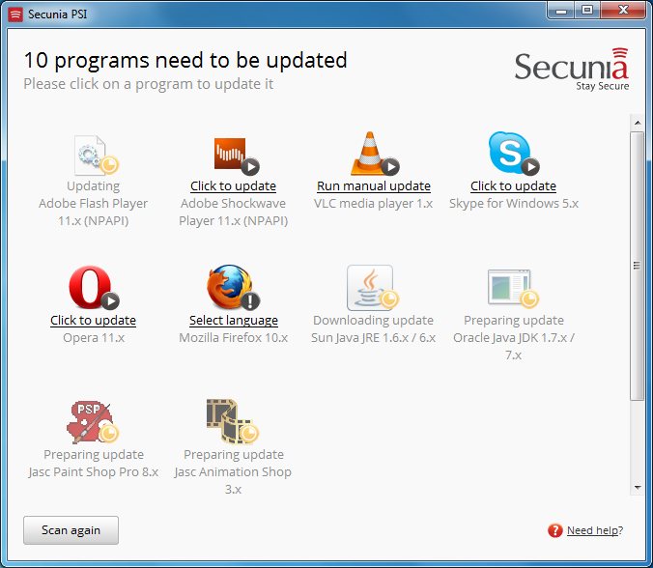

Speccy is an open source tool used for finding the software and hardware details of the system.

Speccy is a system information tool that doesn't require any complex configuration or setup to use. Once you've downloaded and installed Speccy on your Windows computer, you can launch the program and it will automatically detect your system's hardware and display detailed information about it.

What can speccy find:

1. Operating System: Speccy can identify the operating system running on the computer, including the version number, build number, and architecture (32-bit or 64-bit).

2. CPU: Speccy can detect the type of processor installed on the computer, its clock speed, number of cores, and cache size.

3. RAM: Speccy can show the amount of RAM installed on the computer, its type (DDR, DDR2, DDR3, DDR4), and speed.

4. Motherboard: Speccy can identify the motherboard manufacturer, model number, chipset, and BIOS version.

5. Storage: Speccy can detect the type and capacity of the hard drive or solid-state drive (SSD) installed on the computer, as well as the amount of free space available.

6. Graphics: Speccy can show the type of graphics card installed on the computer, including the model, chip type, and amount of dedicated video memory.

7. Audio: Speccy can detect the sound card installed on the computer, including the manufacturer, model, and driver version.

8. Network: Speccy can show the network adapter installed on the computer, including the manufacturer, model, and driver version.

9. Peripherals: Speccy can detect the connected peripheral devices, such as printers, scanners, and cameras, and show information about them.

10. Temperatures: Speccy can display the temperature of the CPU, GPU, and other system components.

Overall, Speccy is a useful tool for identifying the hardware and software components of a computer and can be helpful in diagnosing issues or upgrading components



