Chapter 1

Exercises

1 List four significant differences between a file-processing and a DBMS.

2 Explain View of Data--Levels of Abstraction, Explain the difference between physical and logical data independence.

3 There is a BANK database( Figure 1.1, the Database Schema is follow:
branch (branch_name, branch_city, assets)
customer (customer_name, customer_street, customer_city)
loan (loan_number, branch_name, amount)
borrower (customer_name, loan_number)
account (account_number, branch_name, balance)
depositor (customer_name, account_number)

Figure 1.1
1) write the SQL DDL definition of the BANK database, the primary key is underline.
2) Use insert to add three lines data in every table of BANK database.
3) Use update to modify one line data in every table of BANK database.
4) Use delete to delete one line data in every table of BANK database.
4 Consider the employee database of Figure 1.2 where the primary keys are underlined. Give the expression in SQL for each of the following queries.
Employee(employee_name, street, city)
Works(employee_name, company_name, salary)
Company(company_name, city)
Manages(employee_name, manager_name)

Figure 1.2
- Find the names and cities of residence of all employees who work for First Bank Corporation.
- Find the names, street addresses, and cities of residence of all employees who work for First Bank Corporation and earn more than $10,000.
- Find all employees in the database who do not work for First Bank Corporation.
- Find all employees in the database who earn more than each employee of First Bank Corporation.
- Assume that the companies may be located in several cities. Find all companies located in every city in which Small Bank Corporation is located.
- Find the company that has most employees.
- Find those companies whose employees earn a higher salary, on average, than the average salary at First Bank Corporation.

5 Consider an employee database with two ralations:
Employee(employee_name, street, city)
Works(employee_name, company_name, salary)
where the primary keys are underlined. Write the query to find companies whose employees earn a higher salary, on average, than the average salary at “First Bank Corporation”.
- Using SQL functions as appropriate.
- Without using SQL functions.

6. Support we have the following relations:
Inventory(item, level)
Minlevel(item, level)
Recorder(item, amount)
Orders(item, amount)
Create trigger recorder after update of amount on inventory
Referencing old row as onow, new row as nrow
For each row
When nrow.level <= (select level from minlevel where minlevel.item = orow.item)
And orow.level > (select level from minlevel where minlevel.item = orow.item)
Begin atomic
Insert into orders (select item, amount from recorder
where recorder.item = orow.item)
end
Please explain the meaning of the relations, and the function of the trigger.

7 The execution of a trigger can cause another action to be triggered. Most database systems place a limit on how deep the nesting can be. Explain why they might place such a limit.

8 Consider the relation r, shown in following,
Building room_number time_slot_id course_id sec_id
Garfield 359 A BIO-101 1
Garfield 359 B BIO-101 2
Saucon 651 A CS-101 2
Saucon 350 C CS-319 1
Painer 705 D MU-199 1
Painer 403 D FIN-201 1
give the result of the following query:
Select building, room_number, time_slot_id, count(*) from r
Group by rollup(building, room_number, time_slot_id)

9 Show how to express group by cube(a,b,c,d)using rollup, your answer should have only one group by clause.
10 Given a relation S(student, subject, marks), write a query to find the top n students by total marks, by using ranking.
4． Consider the balance attribute of the account relation. Write an SQL query to computer a histogram of balance values, dividing the range 0 to the maximum account balance present, into three equal ranges.

11 Consider the bank database of figure 1.1 and the balance attribute of the account relation. Write SQL query to computer a histogram of balance values, dividing the range 0 to the maximum account balance present, into three equal ranges.

12 List the ACID properties of transaction. Explain the usefulness of each.
13 During its execution, a transaction passes through several states, until it finally commits or aborts. List all possible sequences of states through which a transaction may pass. Explain why each state transition may occur.

14 Show that the two-phase locking protocol ensures conflict serializability, and that transactions can be serialized according to their lock point. What benefit does strict two-phase locking provide? What disadvantages result?

15 List all of the protocols in concurrent control? And describe the detail of these protocol.

16 Describe the recovery algorithm, include transaction rollback and recovery after a system crash. Explain the log records for transactions on the undo-list must be processed in reverse order, whereas redo is performed in a forward direction.

Experiment:
Install postgresql, and set up the university database as:
The entity:
Classroom(building, room_number, capacity)
Department(dept_name, building, budget )
Course(course_id, title, credits)
Instructor(ID, name salary)
Section(course_id, sec_id, semester, year)
Student(s_id, name, tot_cred)
Time_slot(time_slot_id, {(day, start_time, end_time)})
The relationship sets:
Inst_dept---- instructors with department
Stud_dept --- student with department
Teaches --- instructor with sections
Takes ---- student with section
Course_dept -- courses with department
Sec_course --- sections with courses
Sec_class --- section with classrooms
Sec_time_slot --- section with time slots
Advisor -- student with instructors
Prereq -- courses with prerequisite courses
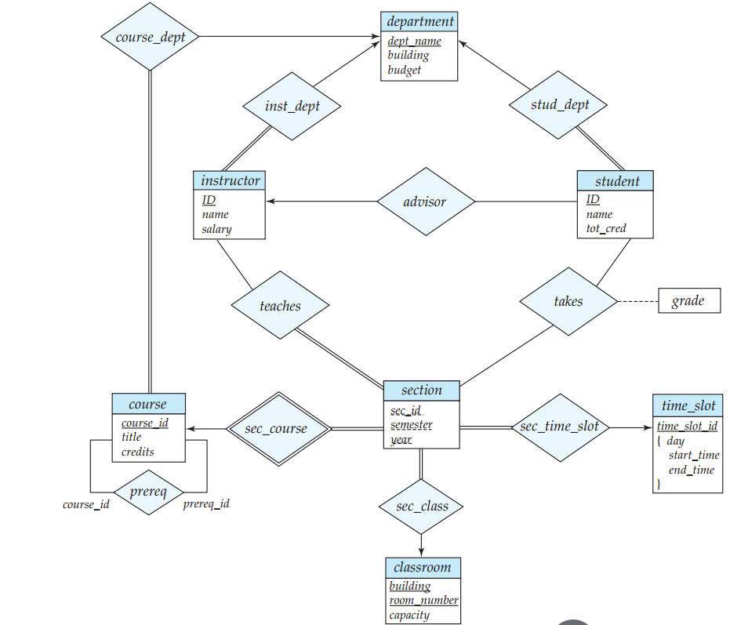
The E-R diagram for a university enterprise

- Create university database
- Create the relationship in the database
- User insert, update, delete statement to operate the data in the table
- Develop student, teacher interface

