**Step1.** Open Envelope and you should write user and password for login

THE UNIVERSITY OF SINDH

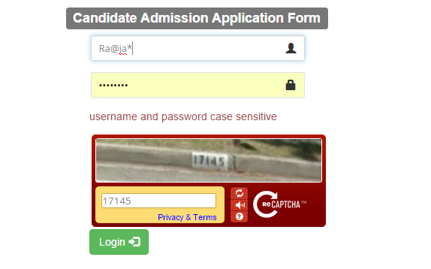

**Step2. Write down your personal information**

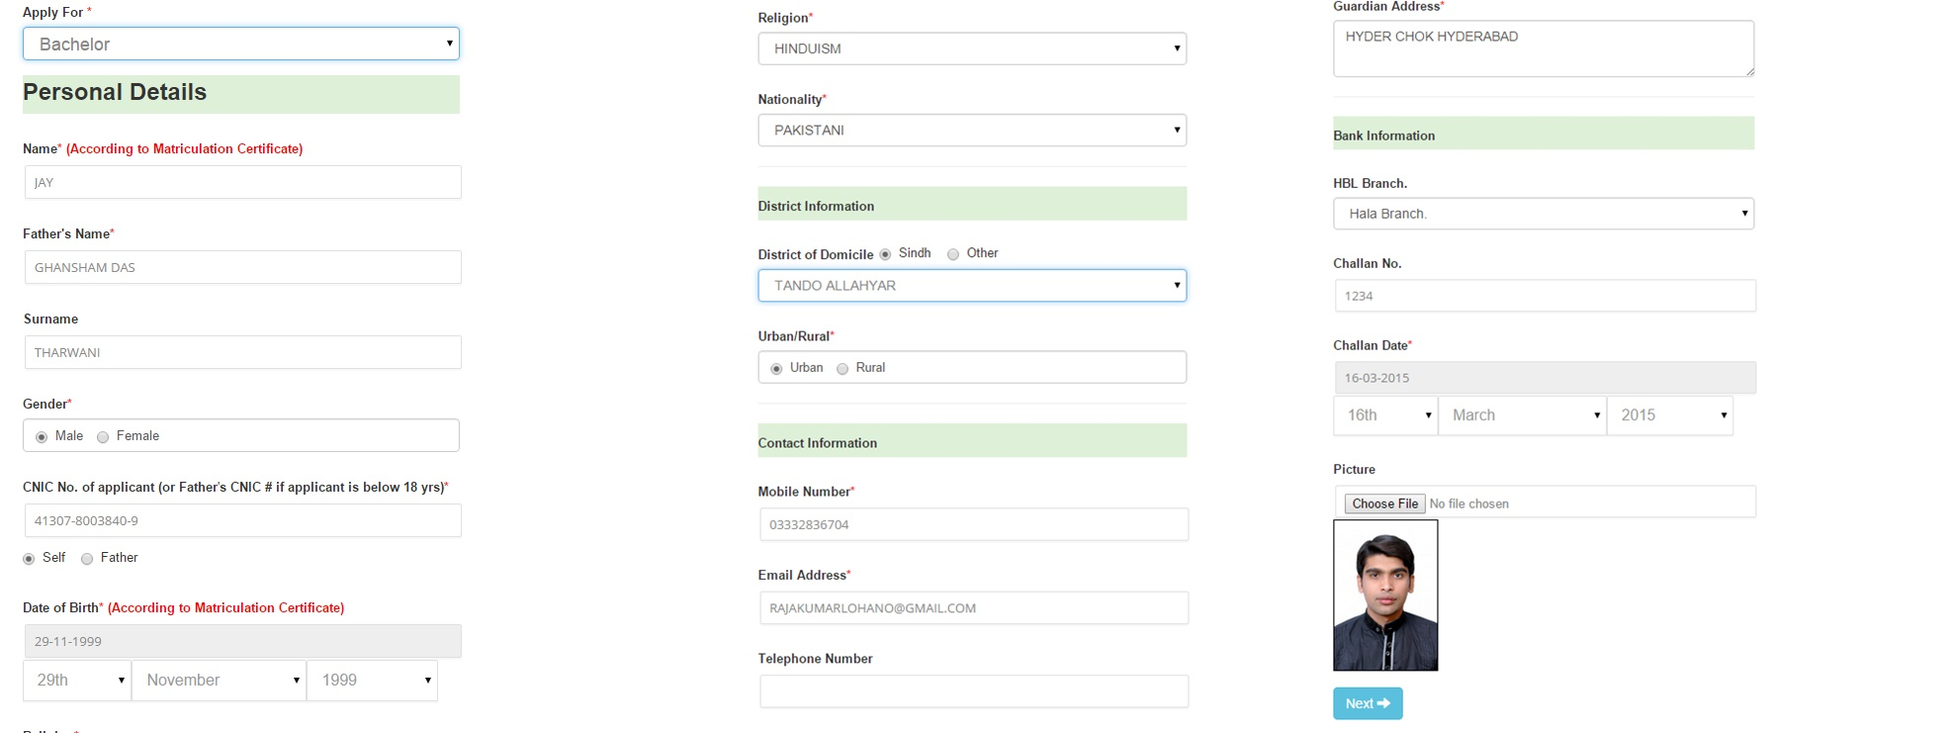

**Step3. Write down your Educational information**

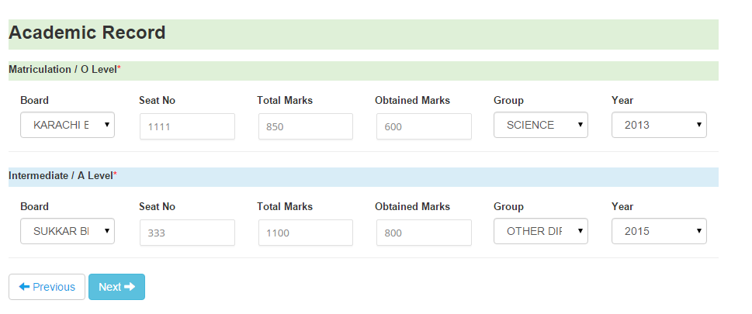

**Step 4. Select your campus and choices.**

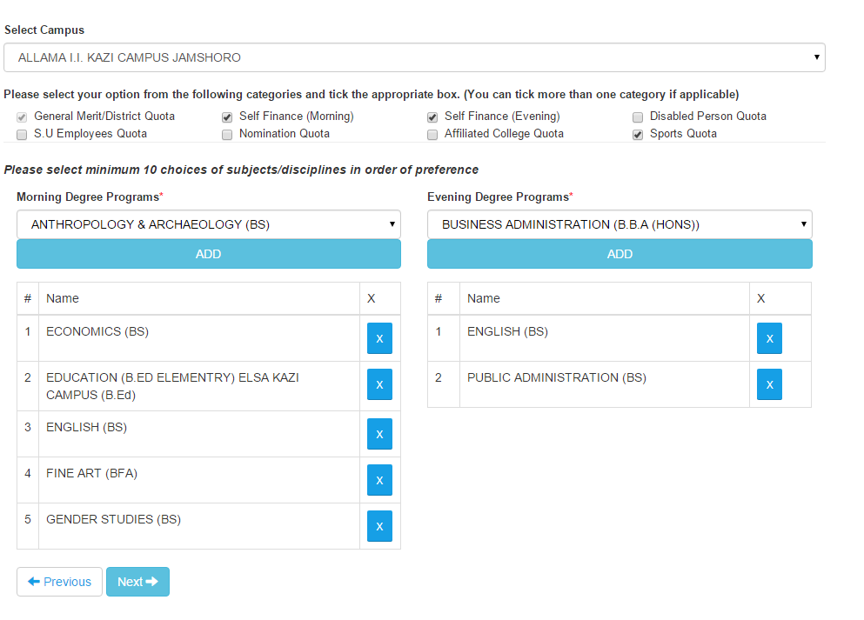

**Step 5. Review information**

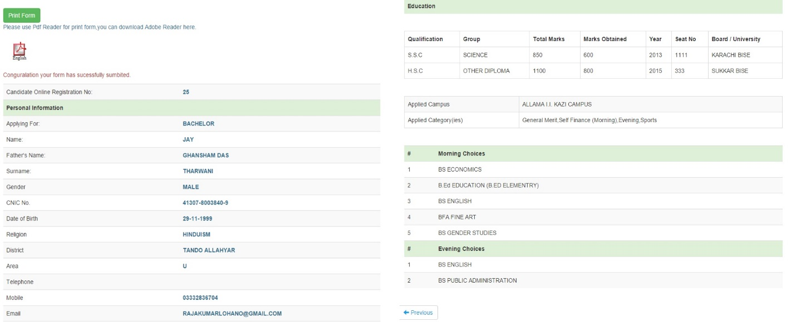

**Step 6. Print Form**

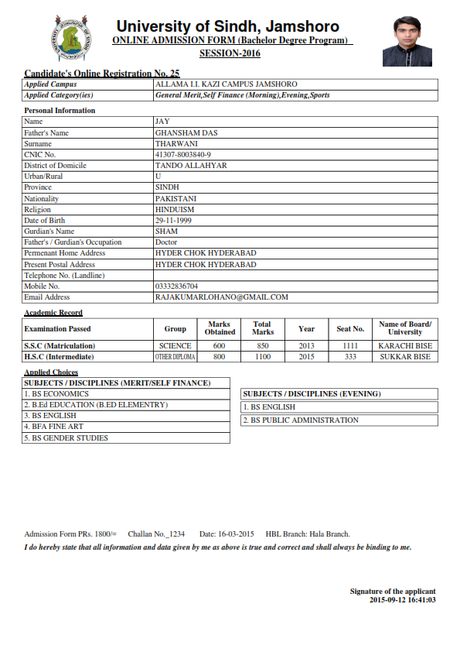

**Step 7. Please submit your form with attested documents.**

1. Marks and Pass Certificates of Matriculation (SSC-Part II).
2. Marks and Pass Certificates of Intermediate (HSC-Part II) **(One Original + Two photocopies)**

**OR**

Applicants having O-Level and A-level shall submit Equivalence Certificate issued by Inter Board   
Committee of Chairman (IBCC), Islamabad.

3. Two (2) Recent Passport size photographs.

4. Computerized National Identity Card (CNIC) / B-Form from NADRA.

1. Original Bank Challan of Admission Form+Pre-Entry test fees. (Rs. 1800/=)
2. Domicile Certificate of the candidate (or of Father/ Mother if the applicant is under 18 Years of age and his/her name is included in it) and Permanent Residence Certificate (Form C) obtained from the concerned District authorities. **(Original Domicile Certificate and PRC to be shown at the time of payment of admission fee challan in case of admission to Quota-Oriented Disciplines/ Subjects.**
3. Affidavit and undertaking on non-judicial stamp of Rs. 30/=.
4. In case the candidate applies for admission against the reserved seats for Sons / Daughters and Real Brothers/ Sisters of Sindh University Employees, he /she will have to attach **service certificate** of his/her father/mother/brother/sister, who is employee of the University of Sindh. **(Original)**
5. In case the candidate applies for admission against the reserved seats for Sons / Daughters Employees of Affiliated Colleges, he /she will have to attach **service certificate** of his/her father/mother duly counter signed by the Director of Colleges Education **(Original)**
6. Disability Medical Certificate issued by the Medical Board to be constituted by the Government, if applicable.
7. In case the candidate applies for admission against the reserved Sports seats, he /she will have to attach the Sports Certificates issued by National Board/Provincial Board/Interversity Board/Inter Board/Secondary Board/Division Board/District Board.