Introduction
This project based on android platform which is used to sharing vehicles. Peoples traveling same destination can share their vehicles with others by sharing this application.
It is very useful in our country (Pakistan) where peoples are facing fuel (CNG) droughts’-so vehicles sharing can help and save some fuel.

Purpose
It is android based vehicle sharing service for mobile phone. Peoples can find the vehicles for same destination where they want to go.
This application connects drivers who have empty seats with people looking for a ride through the largest Vehicle share service.

Peoples traveling to same destination can share their vehicles’ with others to save expense and fuel. Also helpful for environment (pollution) protection as well as peoples of their interest using this application
Your best chance of finding others going your way. The best Vehicle sharing.
where people rent cars for short periods of time, often by the hour. They are attractive to customers who make only occasional use of a vehicle, as well as others who would like occasional access to a vehicle of a different type than they use day-to-day. The organization renting the cars may be a commercial business or the users may be organized as a company, public agency, cooperative, or ad hoc grouping.

FEATURES

Share Vehicle
This application facility to share Vehicle share service any one can share vehicle .

Find Vehicle
Just enter your country and city and your travel date, then choose a driver offering a ride going your way

Get in touch
Click on Contact Driver button and then contact your driver via phone or private message to book
your seat with them.

How do I book a ride

Once you’ve chosen your ride, click on “Contact Driver”. If you’re not logged-in, you will need to do so. There are then two possibilities:
1. The driver has chosen to communicate their mobile phone number, which will be given to you so you can get in touch by phone and plan your car share.
2. The driver has chosen to hide their mobile phone number, in which case you can get in touch by private message. We suggest that you write giving your mobile number so the driver can contact you directly. In our experience, a quick call is really the easiest way to plan a car share!

How it work

User Account and Accuracy of Information
In order to use the Services each Member must create a User Account and agrees to provide any personal information requested by . In particular, Members will be required to provide their first name, last name, age, title, valid telephone number and email address.

Verify Account Information
Members must be verify email Address and successfully use the vehicle sharing application

Share and Search Vehicle
This application offers a free service which allows Members to contact each other to arrange a car, bus, track or any type of vehicle share.
The Passenger will contact the Driver directly to arrange a car, bike, van and bus share and any conditions of travel (including size of luggage, whether smoking is permitted, whether pets are permitted, whether music can be played etc).

Liability
This is not a agreement between a Driver and Passenger and will not be liable to member not come with you.

CONCULTION

Vehicle Sharing is when several people travel together by any vehicle. You can share your vehicle every time.
In much same way, this application connect drivers with empty seats and passengers looking for a ride, so that they can share a long distance trip together, and both save money

PROBLEM DESCRIPTION

Share and Search Vehicle

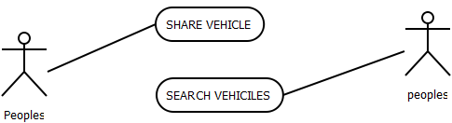
Figure 3.1: Share And Search Vehicle

Name: Share and search Vehicle
Description: Some peoples add own Vehicle and some people search Vehicle for traveling
Actor: PEOPLES
Main scenario:
  - The drivers or clients share his vehicles vaccines. And some peoples want to travel he serach and contacts

Architecture Diagrram

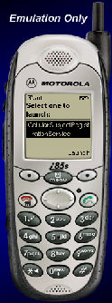

Cell Phone Clients

PHP (APPACHE)SERVER

Database

Figure 3.2: Architecture Diagram
Description: This system architectural diagram consists of three parts, Computer, Database (Server), (Cell Phone) and PHP (SERVER ) as shown in figure 4.1. mobile device is connected with php server which provides facility of sending and receiving data from database.

Database Design
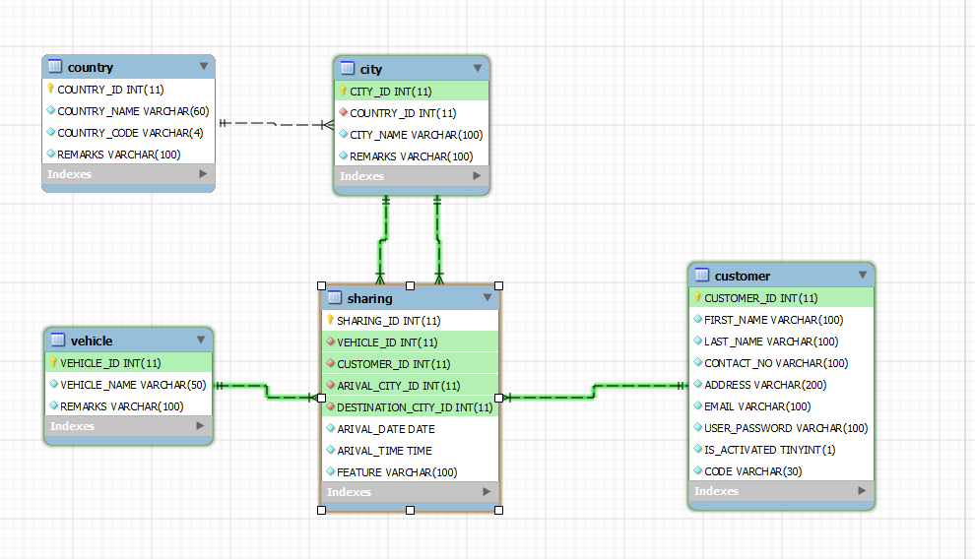
Figure 3.3: Database Design

IMPLEMATATION
IN THIS CHAPTER WE LERAN HOW TO USE SOFTWARE

Login Account
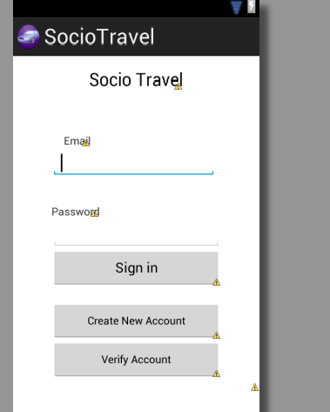
Figure 4.1: Login Account

Create Account
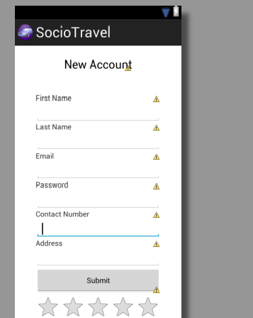
Figure 4.2: Create Account

Verify Account
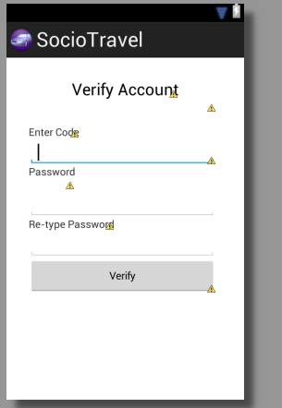
Figure 4.1: Verify Account

Login Menu
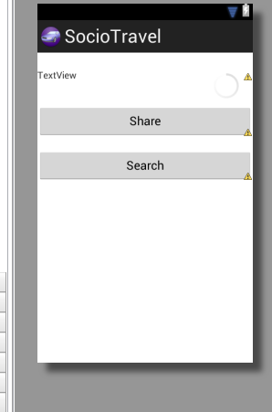
Figure 4.1: Login Menu

Search Menu
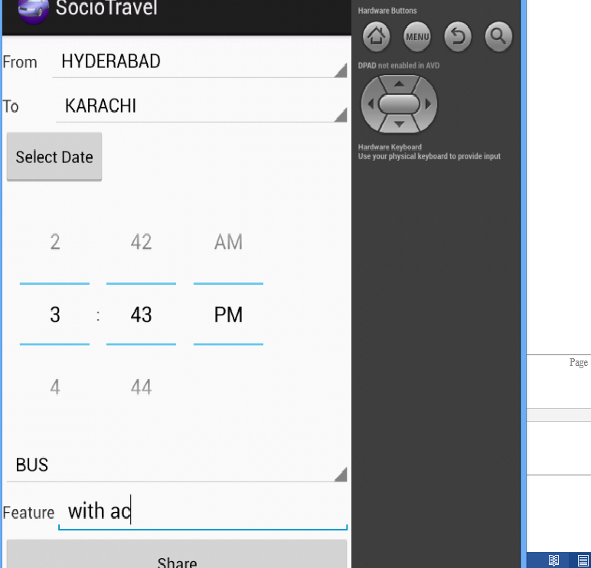
Figure 4.1: Search Menu

Country
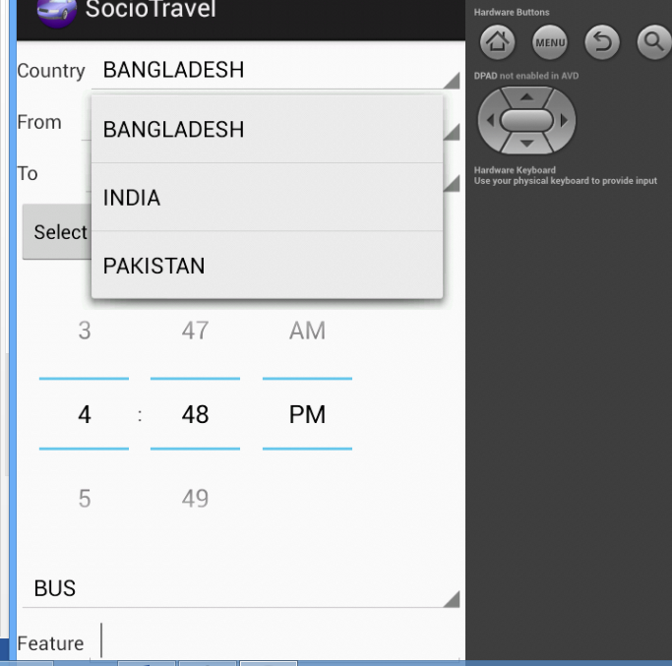
Figure 4.6: Select Country

Select Vehicle
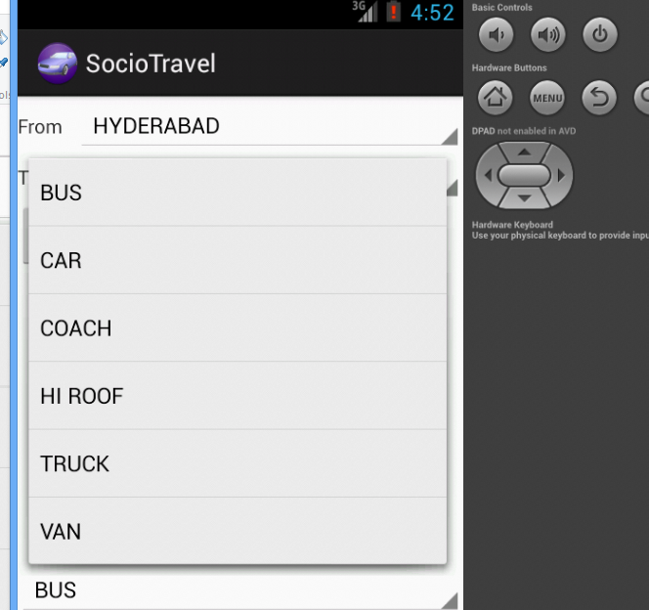
Figure 4.1: Select Vehicle

Select Date
Figure 4.1: Select Date

Seach Vehicle
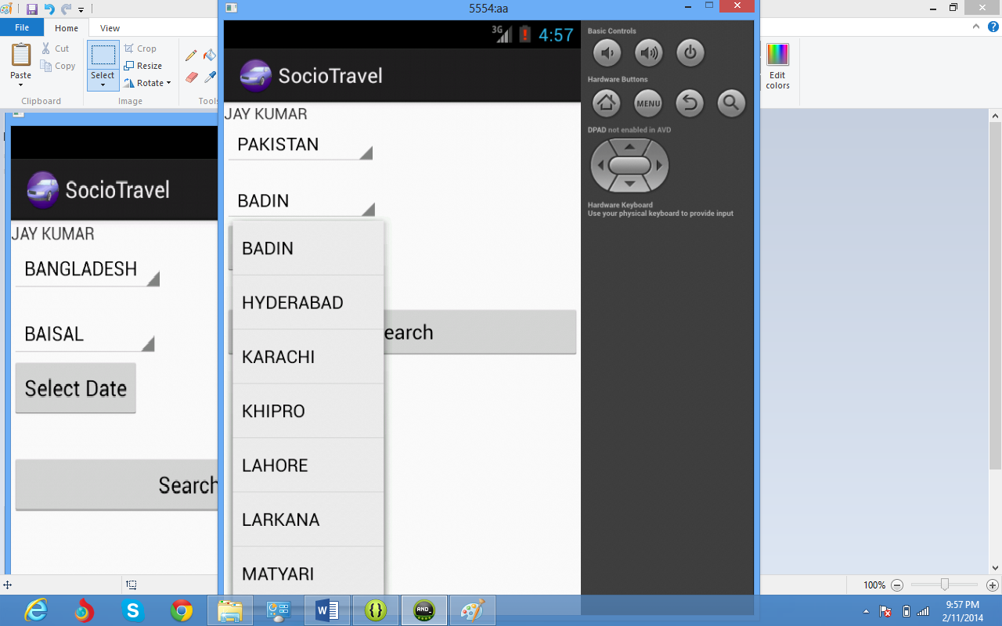
Figure 4.6: Select Country

Result Of Search Vehicle
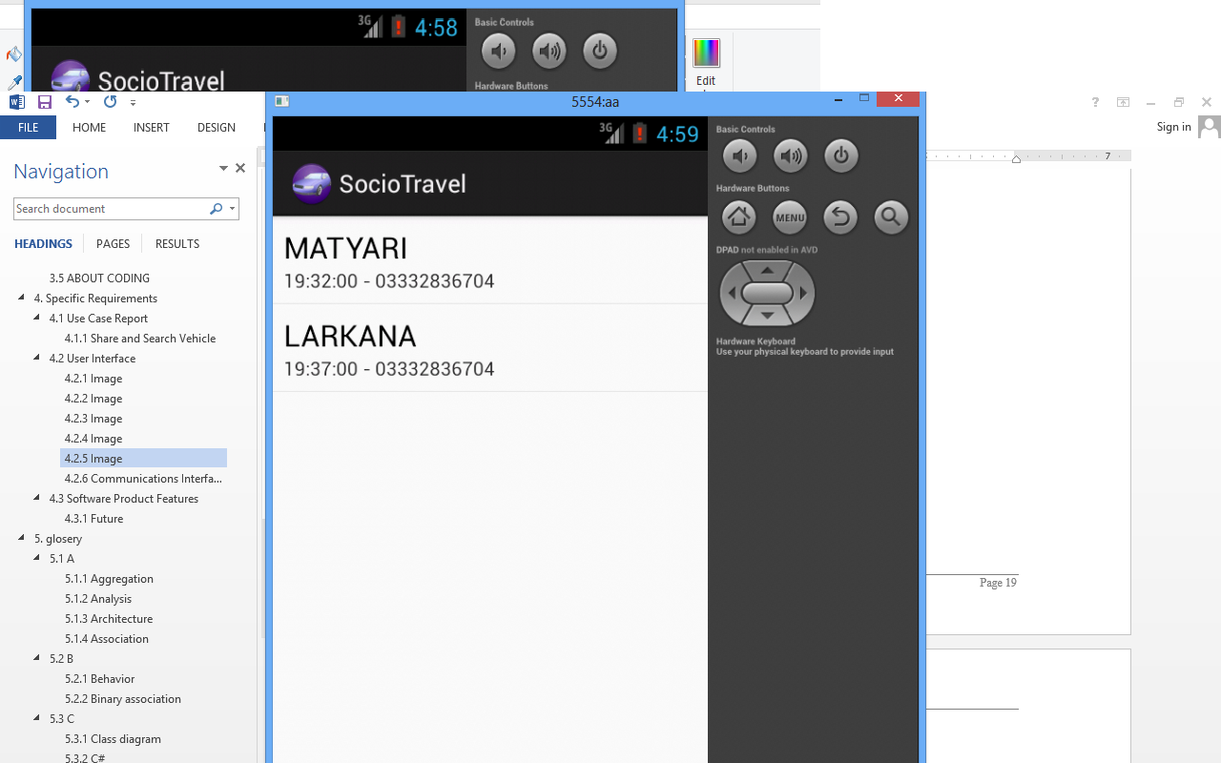
Figure 4.6: Select Country

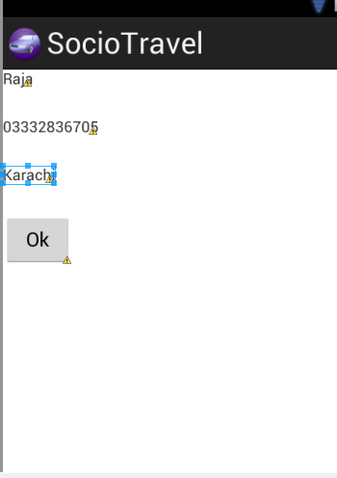
Figure 4.6: Select Country

CONCLUCTION

CONCULATION
This application connects drivers who have empty seats with people looking for a ride through the largest Vehicle share service.
It is very useful in our country (Pakistan) where peoples are facing fuel (CNG) droughts’-so vehicles sharing can help and save some fuel.
Peoples traveling to same destination can share their vehicles’ with others to save expense and fuel. Also helpful for environment (pollution) protection as well as peoples of their interest using this application

FUTURE WORK

Verification of phone number
In order to increase trustworthiness, prevent typos and wrong numbers, any Member can verify their mobile number. The Member may do this by providing application with their mobile phone number, after which the Member will receive a SMS with a 4-digit code which can be validated on application.
This service is free of charge, except for the possible cost levied by a Member’s mobile phone operator for receiving the SMS.

