Situ and Scalable Synthesis of Cu-Ag Nanoalloys Sensitized (rGO, MoS₂)/g-C₃N₄ – based 2D Heterostructures for Selectively CO₂ Conversion to CH₄
I. Specific Aims

This project outlines a novel strategy for the efficient selective conversion of CO₂ into energy-dense chemicals (methane) that represents a viable alternative to fossil fuels, and provides a necessary route for the storage of solar energy. Our goal is to grow nanoalloy (NA) on the sensitized (rGO, MoS₂)/g-C₃N₄–based 2D thin-layers heterostructures by different Methods such as Spin Coating, Pulse Laser Deposition, Dipping and Electrons Beam (NA/MoS₂/rGO/g-C₃N₄) and as a new artificial photosynthesis system to convert water, CO₂ and sunlight into carbon-neutral fuels (CH₄).
- To manipulate the hetero-structures of 2D thin-layers semiconductor materials (NA/MoS₂/rGO/g-C₃N₄) for efficient separation and transfer of photogenerated carriers as well as suitable band alignment to enhance the photocatalytic activities.
- To demonstrate the capability of the 2D layer-by-layer NA/MoS₂/rGO/g-C₃N₄ based conversion of CO₂ in a laboratory environment. The decisive result of the project will be the development of a novel technology for the direct transformation of CO₂ into CH₄ using illumination of visible light.
- To engineer novel photocatalytic materials/nanostructures (Nanoalloys, rGO, g-C₃N₄, 2D metal oxides) and surface modification methods (e.g. ion doping, coupling and controlled termination with suitable atoms and structures) to achieve high photoelectron yield, term stability and performance.
- Further to understand the internal mechanism of these novel 2D layers i.e, materials NA/MoS₂/rGO/g-C₃N₄ catalysts for charge separation and correlation between the structure and photocatalytic/photoelectrocatalytic property of the novel semiconductor materials.

II. Background and Motivation
Owing to the rapidly growing energy demand, dwindling fossil fuel reserves and increasing atmospheric CO₂ concentration, renewable energy sources, such as solar, wind and biomass, foresee increasing usage. Since last decade, there has been a speedily increasing interest in the conversion of carbon dioxide (CO₂) into fuels and chemicals with worldwide government funding due to the twin problems of growing global warming and fast depletion of fossil energy resources.^{1,2} For example, the 2020 Carbon Capture Program (US$106 M), administered by the US Department of Energy (DOE), announced the post-combustion capture goal of achieving 90% CO₂ capture with less than 35% increase in the levelized cost of energy for this achievement.

CO₂ is the ultimate product of oxidation of carbon and its compounds, and is extremely stable thermodynamically at room temperature {$∆$G$°$= 394 kJ·mol⁻¹, cf. -137 kJ·mol⁻¹ for carbon monoxide, CO}.³ If we inspect the thermodynamics of CO₂ reduction, we find that the one-electron reduction of CO₂ to ${CO}_{2}^{•-}$ is a highly adverse process (E$°$= -1.90 V vs NHE, pH 7). Rapid reduction requires an overpotential of 0.1-0.6 V, due at least in part to the kinetic restrictions imposed by the structural difference between linear CO₂ and bent ${CO}_{2}^{•-}$. Although CO₂ reduction via proton-assisted multiple-electron transfer pathways is much more favorable, the processes are still energy intense and useful only if a renewable energy source can be used for the purpose.

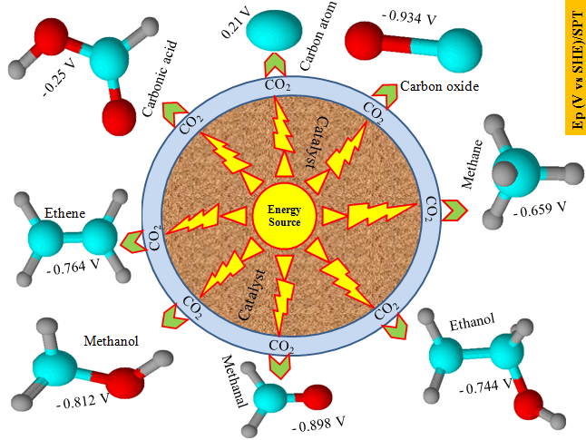
A low-cost, “green” technique that allows for the manufacture of fuels and chemicals using CO₂ as C1 (CH₄, HCOOH and CO) feedstock therefore is needed for sustainable development.⁴ Many experts in the field expect this to be artificial photosynthesis that involves solar conversion of CO₂ into hydrocarbon fuel over synthetic catalysts, not only serving to reduce atmospheric CO₂ concentrations but also supplying clean fuels, such as CH₄, CH₃OH and C₂H₅OH, and/or fine chemicals⁵ as shown in Figure 1.
NSFC 2018

Figure 1: The possible products and required potential energy for photocatalytic CO₂ conversion.

It is accepted that CO₂ adsorption leads to the formation of partially charged species like ${CO}_{2}^{•- }$through interaction with surface atoms. Although, CO₂ molecule has a linear structure and does not show dipole moment. However, each of the oxygen atoms has lone pair of electrons that can be donated to the surface Lewis acid centers. Moreover, the carbon atom could gain electrons from the Lewis base centers such as oxide ions, forming carbonate-like species. Definitely, the CO₂ molecule acts as an electron donor and acceptor simultaneously to form mixed coordination. In addition, the ${CO}_{2}^{•-}$adsorbate no longer has the linear symmetry of free CO₂ molecule and thus has a lower barrier for accepting an electron because the lowest unoccupied molecular orbital (LUMO) level decreases as the molecule bends. Thus, one electron reduction can be possible at low energy electrons, making it possible for the adsorbed CO₂ to be reduced by the low-energy photogenerated electrons (below -1.9 V).

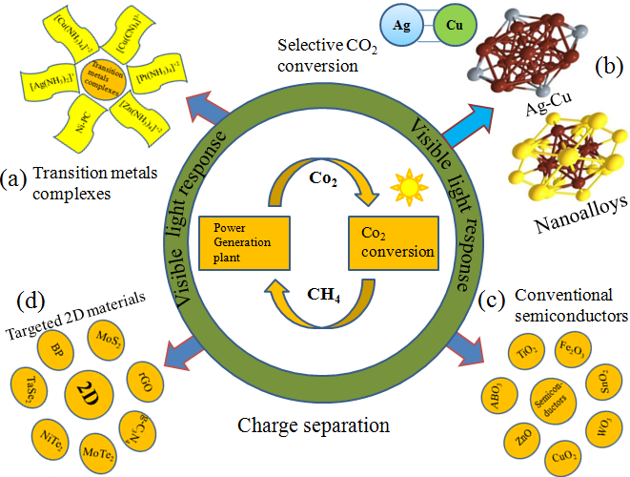
Therefore, since chemical conversion of CO₂ by water is energetically uphill, this process must consume energy, preferably from renewable resources. After more than three decades since its demonstration, the photocatalytic CO₂ conversion by water as reducing agent, is re-gaining growing interest considering it could be carried out using sunlight as the primary energy source. There are a large number of scientific researches on CO₂ photo-conversion into hydrocarbon fuel (CH₄) and a wide diversity of photocatalytical materials, particularly semiconductors employed for water splitting into H₂ and O₂, have been evaluated for this purpose.^{6,7} These catalysts that have been developed so far can be classified into four categories, as shown in Figure 2.

Figure 2: Classification of CO₂ reduction photocatalyst (a) Transition metals complexes (b) Nanoalloys (c) Conventional semiconductors and (d) 2D materials.

One is transition-metal complexes, e.g., metal tetraaza-macrocyclic compounds, super molecular complexes, metalloporphyrins, related metallomacrocyles, and Re(CO)₃(bpy) X-based compounds (X = halide or trialkylphosphite, bpy = 2,2’-bipyridine). These have been systemically reviewed in the recent reviews for the synthesis and CO₂ reduction properties of such metal complexes.^{8,9} The second is metal alloys, particularly precious metals-based catalysts (such as Pt, Au), the performances are normally great but wide application is limited to the production and materials cost. The third is semiconductor based photocatalytic CO₂ conversion, with TiO₂ being the classic representative materials, other commonly used semiconductor CO₂photocatalysts includes: g-C₃N₄,¹⁰ Cu₂O,¹¹ Iridium complex¹² and CuGaS₂¹³ etc. Finally, the fourth one is the recently developed 2D based semiconductor materials for CO₂ photocatalyst such as RGO-CdS,¹⁴ graphene-Ti₀.₉₁O₂ hollow spheres,¹⁵ Bi₂WO₆/C₃N₄ ¹⁶ etc.

Among all above mentioned types of CO₂ photocatalysts, the recently developed g-C₃N₄ has attracted significant attention. Due to their unique physicochemical, optical and electrical properties, a wide variety of g-C₃N₄-based photocatalysts have been designed to drive various reduction and oxidation reactions under light irradiation with suitable wavelengths. Thus, some exceptional experimental results have been achieved, for example” Zhang et al.¹⁷ were the first to investigate carbon self-doped g-C₃N₄ theoretically and experimentally, and demonstrated that this carbon self-doped strategy can increase the visible-light absorption, electrical conductivity and surface area resulting in enhancing the photo-oxidation capability. Kang et al,¹⁸ synthesized metal free carbon nanodot-g-C₃N₄ nanocomposite which demonstrated efficient visible-light photocatalytic overall water splitting. Ping et al,¹⁹ reported an alternative way of band gap tuning of melon from pristine 2.78 to 2.03 eV by self-modification with nitrogen vacancies. The obtained melon with a strong visible light absorption and extremely low recombination of photo-excited charge carriers shows significantly improved photocatalytic activity. Zada et al,²⁰ successfully synthesized plasmonic Au/SnO₂/g-C₃N₄nanocomposites and applied in the H₂ evolution as photocatalysts, which exhibit superior photocatalytic activities and favorable stability. However, the quantum efficiency of g-C₃N₄ is still limited due to the following problems: (1) fast recombination of photoinduced electron−hole pairs; (2) small surface area; (3) low visible-light response; (4) less stability, catalytic poisoning; (5) electrode corrosion and low mechanical strength. Most importantly, the current research ofg-C₃N₄ are mainly based on bulk powder form, however, recently it has been demonstrated that this material actually has a natural 2D character, for example: She et al,²¹ Ansari et al,²² and Hu et al,²³ reported the 2D nature of g-C₃N₄ for enhanced visible-light hydrogen evolution. Moreover, the 2D g-C₃N₄ has also interesting features for magnetic and solar cell applications.^{24,25}

Therefore, as a recently emerged promising CO₂ photoreduction catalyst, the potential of g-C₃N₄ is not fully realized yet. This proposal aims to use novel conceptual material design strategy to further promote the efficiency of g-C₃N₄ by synthesis control to achieve and explore its 2D nature in CO₂ photoreduction applications.²⁶ It is expected that with dimension reduction from 3D to 2D, and together with heterostructural as well as lattice engineering, the thin-layers of g-C₃N₄ is expected to exhibit significantly improved surface area, controlled band gap/alignments, optimized defect character, improved charge separation/transport, thus to achieve enhanced CO₂ photo reduction. The designing concept and strategy can work as a general approach thus to be applied toward to other similar classic bulk semiconductor to develop novel low-cast, efficient, and durable CO₂ reduction photocatalysts for future artificial photosynthesis and renewable energy applications.

- Strategy and Significance
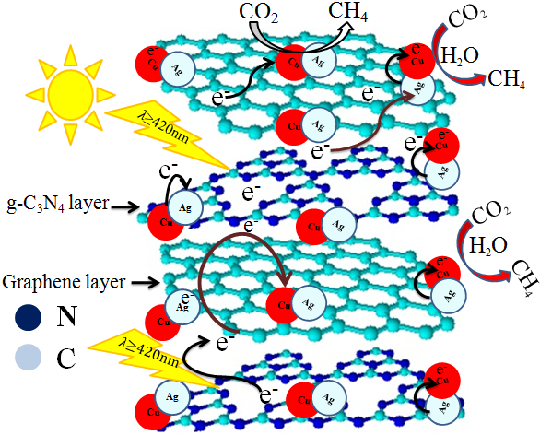
A great deal of efforts has been done to achieve efficient photocatalytic behavior. Generally, there are many aspects that influence the photocatalytic activities such as crystallinity, surface area, surface states, band structure and the interface composition. In this proposal, we describe a new photocatalytic system (Figure 3) for direct solar-light selective conversion of CO₂ into hydrocarbon fuel (CH₄). Such a system involves two synthetically flexible components, which are layers 2D semiconductors and nanoalloys. The core concepts of our strategy and significance will be explained in the following:

Figure 3: Schematic mechanism of layer-by-layer synthesis of rGO/g-C₃N₄ and nanoalloys modified for selective CO₂ solar conversion to CH₄.

- Achieving 2D structure of g-C₃N₄
We will use hydrothermal method to synthesize the thin-layers of g-C₃N₄. These strategies will provide more degrees of freedom to tune the microstructure (i.e. large surface area, better crystallinity and layer quality) and electronic structure (band gap and band edge positions) of g-C₃N₄ towards efficient visible light absorption and charge separation. This will be used for the first time that g-C₃N₄ complex in the 2D form for CO₂photoreduction.

- Heterostructural Engineering
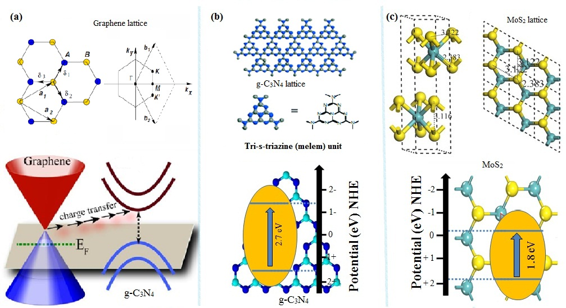
As discussed, the efficiency of the CO₂ reduction can be limited by the charge separation and transport, where band alignments, defects condition, and carrier mobility are very critical parameters. To enhance the charge mobility and suppress the charge recombination, creating heterostructural interface to combine obtained 2D g-C₃N₄ with good electron/hole transport layers is an effective method. For this purpose, rGO, MoS₂ are two good candidates, because good lattice match, suitable band gap alignment for oxidation reduction reaction, large surface area and similar geometry as shown in Figure 4. As illustrated above, the 2D insertion layers of rGO or MoS₂ provide a suitable channel for charge separation and transportation.¹⁶

Figure 4: Lattice constant and band alignments for (a) rGO (b) g-C₃N₄ and (c) MoS₂,

- Nanoalloys Lattice Engineering for CH₄ Selectivity
Nanoalloys (metal alloys with nanostructure, as mention in section II) have been found to be excellent visible light harvesters. It has been reported that the presence of platinum and copper co-catalysts on TiO₂ increases the efficiency of the photocatalytic CO₂ reduction, leading mainly to methane with a good selectivity.⁹ Here we choose Cu as nanoalloys because Cu has the right surface potential to directly reduce CO₂ into CH₄ and also Cu is much cheaper than Au or Pt. However, Cu is very easy to be oxidized thus significantly slow down its reaction with CO₂ and produce unwanted byproducts as shown in Figure 1. Our strategies is to develop lattice engineering to make nanoalloys of the Cu with Ag to improve the structural and reaction stability of Cu atoms, and meanwhile slow down the oxidation of surface Cu atoms in the presence of CO₂ environment. This is expected to significantly increase the efficiency and durability of the overall catalytic behavior. Moreover, unlike Au or Pt, Ag doesn’t have good photocatalytic activity for water splitting, thus this strategy is also expected to provide the possibility of CH₄ selection to achieve maximized CH₄ yield.

Furthermore, the metal alloys can supply various local atomic arrangements on surface, which also offers the capability of manipulating adsorption configuration. Meanwhile, the compositions in alloys hold the key to tuning the band centers of active sites. Therefore, the surface and electronic structures related to catalytic sites are two versatile knobs for tuning the catalytic activity and selectivity, both of which can be tailored by lattice engineering. Taken together, controllable lattice engineering in Cu-based nanoalloys should be a promising approach to achieve the giant enhancement on CO₂ conversion activity and selectivity.¹³

The unique features of the system design are:
- The use of novel layers CN-based nanocomposites for CO₂ conversion and the integration of multiple functional components (i.e., NA, MoS₂, rGO and CN-based polymeric semiconductors) together as a photocatalyst through self-assembly technique,
- The use of synthetically flexible NA and MoS₂/rGO/CN-based polymeric semiconductors as multiple solar energy harvesters,
- The combination of NA-modification and semiconductor-semiconductor heterojunction to broaden visible light responsive range and match the potential required for CO₂ conversion.

The unique features of the system performance are:
- Low cost: MoS₂/rGO and CN-based semiconductor are both largely abundant at low cost via chemical synthesis. Conventional semiconductors, such as TiO₂, were generally thought to be low-cost catalysts compared to metal complexes, however, the production cost for layers semiconductor (CN-based) is even less than that of Degussa TiO₂. The price of dicyandiamide is about $12 per kg. One kg of dicyandiamide can produce about 0.8 kg of CN polymeric semiconductor. The production cost for CN polymeric semiconductor is only around $15 per kg. ⁶ The proposed system therefore has the potential to be a real low-cost catalyst alternative to the existing catalysts for photocatalytic conversion of CO₂.
- High stability: In contrast to organic dyes/metal complexes, nanoalloys and CN-based layer semiconductor are both very stable under light illumination. Particularly, considering the lattice engineering of Ag-Cu, the durability and activity of the system can also be significantly improved.

- Multiple light-harvesters: Similar to organic dyes/metal complexes, nanoalloys and CN-based layers semiconductors both are synthetically flexible, so that not only their absorption properties can be tailored to capture visible light but also their conversion potentials can be tuned to match the potential required for CO₂ conversion. The proposed system therefore has the potential to maximize the utilization of solar energy for photocatalytic conversion of CO₂into hydrocarbon fuels (CH₄).
- Enhance charge separation rate: The formation of NA/MoS₂/rGO/CN-based semiconductor junctions creates an electrical field at the interface between the three functional materials. Upon sunlight irradiation, NA and (MoS₂/rGO)/CN-based semiconductors both act as visible light harvesters and generate electron-hole pairs, which quickly dissociate into separated electrons and holes in the influence of the built-in electrical potential. When electric field is created then the conversion of CO₂ also is also expected to occur on the surface of MoS₂/(MoS2/rGO), because MoS₂/(MoS2/rGO) caring charges have the same potential as CN.

Potential Impacts:
Given the strategic solar-geographical position of throughout, the artificial photosynthesis is a leading option for utilizing such energy to applications related to fuel/H₂ production and environmental remediation. Having access to low-cost, environmentally friendly, highly efficient artificial photosynthesis techniques is very important for global sustainable developments.

As a result of the advantages of our system mentioned above, it has the potential to become the catalyst of choice that is currently sought-after for highly efficient solar conversion of CO₂ into hydrocarbon fuels (CH₄), not only serving to reduce atmospheric CO₂ concentrations but also supplying clean fuels.

- Approach
The proposed interdisciplinary work involves
- The chemical synthesis of thin-layers organic/inorganic (NA/(MoS2/(MoS2/rGO))/g-C₃N₄) nanocomposites materials for enhanced visible-light response and exceptional photocatalytic activities.
- Heterostructural engineering will significantly improve the electronic mobility, surface state, crystallinity and interfacial properties of the novel NA/MoS₂/rGO/g-C₃N₄ based photocatalysts.
- Surface modification (nanoalloys, surface plasma, and ionic doping etc.) and self-assembly techniques will be used to improve the selectively conversion of CO₂ to methane.
- Band gap engineering will be applied to achieve desired energy gap and band positions with a 2D (NA/MoS₂/rGO/g-C₃N₄) semiconductor.
- Engineering layer based hybrid materials for efficient artificial photosynthesis. Details of the approach implantation and experiments will be described in the sections V, VI, and VII.

- Analysis of experimental results using numerical simulation.
The research work-plan is detailed in the following sections, some of the activities will be carried out simultaneously and the expected timeline is described as follows:
- Synthesis of thin layer MoS₂/rGO/CN (Months1-3)
- Synthesis of nanoalloys the surface of MoS₂/rGO /g-C₃N₄(Months4-5)
- Morphological and Structural characterization of the 2D hybrid structures (Months5-7)
- Photocatalytic activities measurements (Months7-9)
- OH radical amount related spectra measurements (Months9-11)
- Single wavelength photocatalytic measurements (Months11-13)
- Isotopic ¹³CO₂ experiments (Months13-15)
- Stability and recyclability tests (Months15-17)
- Photoelectrochemical tests for charge separation (Months17-20)
- Article writing and further applications (Months20-24)
The details of this part will be explained in the next section.

- New methods developments and planned working schedule
1. Synthesis of thin layer electrode (g-C3N4 (Months1-5)

- For the synthesis of thin layer electrode the following procedure will be used: 1st of all the g-C₃N₄ based thin-layer materials will be obtained by spin-coating method. Typical certain amount of g-C₃N₄ will be dispersed in appropriate amount of DMF. Then on the surface of FTO g-C₃N₄ layer will be optimized by spin coating method.
- For MoS₂ layer deposition on g-C3N4 based optimized thin layer electrode, two method will be used.
    - The 1st one spin coating method and the 2nd one is PLD method.
    - In PLD method we will horizontally grow MoS₂ on surface of g-C₃N₄ layer.
- Further for nanoalloy synthesis we will used three methods.
- Spin coating method: In typical procedure, appropriate concentration solution AgNO₃ and Cu(NO₃)₂ will be prepared and will be deposited by spin coating method. Finally, the thin layers electrode will be calcined in H₂ environment at 425 ℃ to reduce Cu and Ag on the surface thin-layers electrode. The Cu and Ag will make nanoalloy on the surface of thin-layers electrodes.
- We will also deposit Ag and Cu on the surface thin layer electrode by electrons beam method and then its will calcine in H2 environment to make nanoalloy.
- 3rd PLD method: this method new for such type of materials. Here we will be used pure Ag and Cu target. In this method we control the growing geometry and will try to get the phase of materials which is active for selective CO2 conversion.
After synthesis and optimization we will do compare all these methods and try develop best method for photoelectrochemical electrode.

Structure, composition and Morphological characterization of the 2D materials (Months5-7)
The structural and morphology characteristics will be investigated by Selective Area Electron Diffraction (SAED), Transmission Electron Microscopy (TEM) and Scanning Electron Microscopy (SEM). Atomic Force Spectroscopy will be used to explore the thickness of layer materials. Raman will be used to determine the vibration, rotational and low frequency modes of the newly synthesized photocatalyst. X-ray photoelectron spectroscopy (XPS) will be used to examine the electronic structure and band alignment.

Photocatalytic activities measurements (Months7-12)
Photocatalytic CO2 reduction measurements. The photocatalytic CO₂ reduction measurements will be conducted on a Lab Solar-III AG system (Perfect Light Limited). In the CO₂ photocatalytic process, the as-synthesized thin-layer electrode will be kept middle. Light irradiation will be provided by a PLS-SXE300/300UV Xe lamp (Beijing China Education Au-light) with a standard AM 1.5G filter, and a 420 nm cutoff filter was used to simulate visible light. The corresponding illumination spectrum will be compared with sunlight. The instrument will be initially vacuum-treated three times and then pump with high-purity CO2 to reach atmospheric pressure. A 2 ml volume of DI water will be injected into this set-up for further photocatalysis. During light irradiation, the gas products were qualitatively will be analysed by a Techcomp GC7900 gas chromatograph (FID detector, TDX-01 column) by identifying the chromatographic peaks. The temperatures of the solutions will be controlled at 298 ± 0.2 K by a recirculating cooling water system during irradiation. The incident light intensity will be determined using a silicon-UV enhanced actinometer.

- Isotopic ¹³CO₂ experiment (Months13-15)
Here we will measure an isotopic experiment, by using ¹³CO₂ under the identical photocatalytic reaction condition. To show that the carbon accompanied with methane comes from CO₂ not from the decomposition of our photocatalysts (NA/MoS₂/rGO/g-C₃N₄). The resultant photocatalytic products will be detected with the help of a gas chromatography-mass spectrometry (GC–MS) apparatus.

5. Catalytic and stability tests (Months15-17)
The long-term stability and reproducibility of the NA/MoS₂/rGO/g-C₃N₄ based semiconductor materials will be studied for photocatalytic CO₂ conversion.

6. Photoelectrochemical tests (Months17-20)
To study the photo-electrochemical performance, following experiments will be performed. In a typical experiment, 0.05g of sample will be dispersed in 2 ml isopropyl alcohol under vigorous magnetic stirring for 1 h. Then 0.025 g of Macrogol-6000 will be added to each sample and ultrasonically treated for 30 min, followed by continuous magnetic stirring for 1 h. Then, 0.05 ml acetyl acetone will be added to the reaction mixture and kept under vigorous magnetic stirring for 72 h. The conductive fluorine doped tin oxide (FTO) coated glasses will be cleaned by ultra-sonication in acetone for 2h and then washed with deionized water and ethanol in turn. The cleaned FTO coated glasses will be used as substrates for NA(MoS₂/rGO)/g-C₃N₄ based samples. Thin films of all samples will be prepared by doctor blade method using Scotch tape as a spacer. The prepared films will be dried in air for 30 minutes and anneal at 450 °C for 30 minutes. The FTO coated glasses with thin film will be made 1.0 cm × 3.0 cm pieces, having film surface area 1.0 cm × 1.0 cm. To prepare photoelectrode, an electrical contact will be made with the FTO substrate by using a silver conducting paste connected to a copper wire and then enclosed in a glass tube.

- Expected research output
This project will provide a pathway to alternative chemical resources, while helping to mitigate emissions and climate change associated with current fossil fuel use. Converting CO₂ to fuels using solar energy is a global research endeavor. The NA(MoS₂/rGO)/g-C₃N₄ based photocatalyst we demonstrated here is a critical step toward practical production of high-value carbon fuels using solar energy. This technology not only provides an alternative way to produce the sustainable fuels, but also convert the waste CO₂ into valuable chemicals, which is important for keeping our environment clean and development sustainable. This project will advance the science and technology of visible-light driven photocatalysis. Materials and Devices to harvest the Chinese abundant supplysolar energy is an anticipated in the longer term.
The following outputs are expected:
- The best photocatalysts currently use having large amounts of Pt or Pd. g-C₃N₄ base metal free structure-controlled nanoparticles are expected to greatly reduce the usage of noble metals and bring down costs.
- This novel 2D (NA/MoS₂/rGO/g-C₃N₄) photocatalyst will promote the light harvesting, charge carries separation and transfer, and interfacial reactions.
- Designed nanoalloys (Cu-Ag) modification it is expected to produce active side for selective CO₂ conversion to CH₄.
- The proposed research is expected to result in 3-4 high impact SCI journal publicaitons, ofwhich2 publications with IF > 10 will be expected.
- The research results will also be shared in important demotic and international conferences. Two Patents will also be applied.
- 3-4 MS and PhD students will be participated and trained for related photocatalytic research under this project.

- Research accumulation and preliminary results
Previously research experiences are summarized as follows:

- The successful synthesis of CdSe quantum dots (QDs) modified phosphorus doped g-C₃N₄ (P-CN) for advanced photocatalytic applications. Phosphorus doping and structural coupling with CdSe QDs are shown to significantly extend visible-light response of g-C₃N₄ up to 700 nm. The optimized sample 4CdSe/P-CN demonstrates enhanced visible-light driven overall water splitting activities for H₂ and O₂ evolution i.e. 113 and 55.5 μmol.h⁻¹.g⁻¹, respectively, as well as very high photocatalytic CO₂ to CH₄ conversion efficiency (47 μmol.h⁻¹. g⁻¹). It also exhibits higher activity (78 %) for 2,4-dichlorophenol degradation as compared to pristine CN-sample. Applied Catalysis B: Environmental 270, 2020, 118867.
- Au-modified reduced graphene oxide coupled with carbon nitride (Au/rGO/g-C3N4) as novel 0D/2D/2D photocatalytic nanocomposites. The optimized sample 2Au/0.6rGO/g-C3N4 exhibits exceptional visible-light activity for water splitting and CO₂ reduction with quantum efficiency of 3.82 % and 1.98 %, respectively. Applied Catalysis B: Environmental 270, 2020, 118870.
- Synthesis of visible-light driven SnO₂ coupled boron and phosphorus co-doped g-C₃N₄ nanocomposites as efficient photocatalyst. It is shown that the amount-optimized nanocomposites exhibit enhanced visible-light activities for CO₂ conversion to CH₄, gas-phase acetaldehyde and liquid-phase phenol degradation. Applied Catalysis B: Environmental 201, 2017, 486–494.
- The sulfur doped porous g-C₃N₄ (S-PCN) using ionic liquid, and then coupled nanocrystalline anatase TiO₂ and Au-modified TiO₂ to obtain nanocomposites. The amount-optimized 1 Au-6 T/6S-PCN nanocomposite exhibits exceptional visible-light activities for CO₂ conversion to CH₄, H₂ evolution, and 2,4- dichlorophenol degradation, respectively by ∼32-time (365 μmol g⁻¹ h⁻¹ ), ∼41-time (330 μmol g⁻¹ h⁻¹) and ∼24-time (95% 10 mg h⁻¹ L−1 ) enhancement compared to the porous g-C₃N₄ (PCN). The calculated quantum efficiencies for CH₄ production and H₂ evolution are ∼4.67% and ∼3.34% at 420 nm wavelength. Applied Catalysis B: Environmental 237, 2018, 1082–1090.
- The flower-like of MoS₂-based hybrid photocatalyst with high efficiency through nanostructure and electronic structure engineering. Nanostructure control is used to fabricate MoS₂ in to flower-like nanosheets (NSs) with large surface-active area. Then MoS₂ is coupled with conduction-band edge matched tin dioxide (SnO₂) and decorated with Ag nanoparticles for suitable work function to create a unique cascade band alignment electronic structure to facilitate photoexcited charge transfer. It is shown that the amount-optimized nannocomposite of SnO₂/Ag/MoS₂ exhibits exceptional visible-light photocatalytic activities for conversion of carbon dioxide (CO₂) to methane (CH₄), approximately one order of magnitude enhancement than original MoS2 with the apparent quantum efficiency 2.38% at 420 nm. Journal of Hazardous Materials 381, 2020, 120972.
- Synthesis of visible-light-driven Au-TiO₂/MnO_{x}-porous g-C₃N₄ heterogeneous photocatalysts. The newly design Au-TiO₂/MnO_{x}-porous g-C₃N₄ nanocomposite exhibits enhanced visible-light activities for CO₂ conversion, water splitting and pollutants degradation. Such markedly increase in the photoactivities might be related with the participation of Au-TiO₂ and MnO_{x}/PCN in the charge separation and transfer process. The remarkable enhanced CO₂ conversion and H₂ production over the newly designed Au-TiO₂/MnO_{x}-porous g-C3N₄ nanocomposite can be attributed to the simultaneous capture of holes by MnOx and electrons by Au-TiO₂. Hence, the photogenerated electron and holes are efficiently separated which is beneficial for improving the photoactivities for CO₂ conversion, H₂ production and pollutants degradation. Adv. Energy Mater. 2017, 1701580.
- Synthesis of TiO₂/B-doped g-C₃N₄ nanocomposites via simple wet-chemical method. The resultant nanocomposites show greatly enhanced visible-light activities for H₂ evolution and CO₂ reduction. This is attributed to the improved charge separation as a result of B introduced surface states that effectively captures photogenerated holes and extend visible-light response and to the further improved charge separation by the coupled TiO₂ that accepts the photogenerated electrons of CN. Moreover, the T/BCN nanocomposites exhibit high quantum efficiency for H₂ evolution and CO₂ conversion to CH₄. J. Phys. Chem. C 2016, 120, 98−107

Moreover, in our previous work we have detected different CO₂ conversion gas phase products such as CO, O₂ and CH₄. Due to these different products the CO₂ conversion efficiency is not satisfactory. To enhance the quantum efficiency of CO₂ conversion to useful organic compounds must be focus on selectively CO₂ conversion. This idea along with the research content of the current works was summarized in Figure 5.
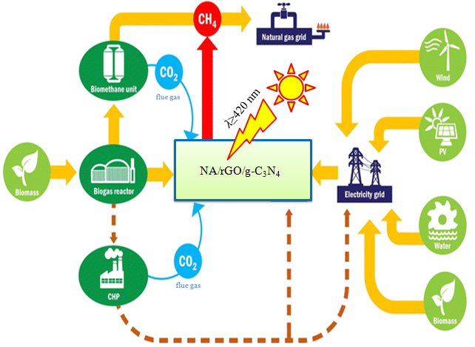

Figure 5: Schematic diagram for CO₂evolution sources and conversion to renewable energy (Methane).

In summary, the above-mentioned previous research results prove that the applicant has very strong track record and necessary knowledge as well as research experiences, which provide solid foundation for the successful implementation of the proposed research.

- Working conditions

The proposed study of the 2D thin-layer materials physicochemical properties of photocatalysis is one of the main focuses in our research group. The necessary experimental amenities can be accessed in our group, UESTC, or through national/international collaborations. Our group has some dedicated equipment for samples synthesis and characterization such as auto-control CVD, Oven and Raman etc.. We have access to nanosecond pulsed laser to study absorption of the formed active species and life time. UESTC provides good access to critical instrumentation such as XRD to investigate the crystalline structure of the materials, XPS to examine the chemical composition and binding energy of the as-synthesized materials, PL to study the charge recombination, FT-IR used for functional group determination, and TEM to study the internal structure of the materials. We also have good success to synchrotron based XAS to precisely probe the electronic structure of the materials in Advanced Photon Source (USA) and Australia Synchrotron light source. Some other special equipment such as SS-SPS and TR-SPV and can be achieved by collaborations work with Heilongjiang University, South China University of China and Wuhan University of Science and Technology. Our working group allows both the qualitative and quantitative analysis of the reaction intermediates and end products for the deeper understanding of the mechanisms of the studied photocatalytic reactions.

References
1. J. Artz, T. E. Müller, K. Thenert, J. Kleinekorte, R. Meys, A. Sternberg, A. Bardow and W. Leitner.Chem.rev.2017.
2. R. Snoeckx and A. Bogaerts.Chem. Soc. Rev.2017, 46, 5805-5863.
3. Y. Yang, S. Ajmal, X. Zheng and L. Zhang.Sustain. Ene.& Fuels, 2018.
4. Q. Liu, X. Yang, L. Li, S. Miao, Y. Li, Y. Li, X. Wang, Y. Huang and T. Zhang.Nat. commun. 2017, 8, 1407.
5. A. Álvarez, A. Bansode, A. Urakawa, A. V. Bavykina, T. A. Wezendonk, M. Makkee. J. Gascon and F. Kapteijn.Chem. rev.2017, 117, 9804-9838.
6. X. Yang, R. J. Rees, W. Conway, G. Puxty, Q. Yang and D. A. Winkler.Chem. Rev. 2017.
7. L. Liang, C. Liu, F. Jiang, Q. Chen, L. Zhang, H. Xue, H.-L. Jiang, J. Qian, D. Yuan and M. Hong.Nat. commun.2017, 8, 1233.
8. T. W. Woolerton, S. Sheard, E. Reisner, E. Pierce, S. W. Ragsdale and F. A. Armstrong.J. Am. Chem. Soc.2010, 132, 2132-2133.
9. C. Wang, R. L. Thompson, J. Baltrus and C. Matranga. J. Phys. Chem. Let. 2009, 1, 4853.
10. F. Raziq, L. Sun, Y. Wang, X. Zhang, M. Humayun, S. Ali, L. Bai, Y. Qu, H. Yu and L. Jing.Adv. Ene. Mater., 2018, 8.
11. L. Hurtado, R. Natividad and H. García.Cata. Commun.2016, 84, 30-35.
12. S. Sato, T. Morikawa, T. Kajino and O. Ishitani.Angew. Chem.2013, 125, 1022-1026.
13. T. Takayama, K. Sato, T. Fujimura, Y. Kojima, A. Iwase and A. Kudo.Faraday dis.2017, 198, 397-407.
14. J. Yu, J. Jin, B. Cheng and M. Jaroniec.J. mater. chem. A, 2014, 2, 3407-3416.
15. W. Tu, Y. Zhou, Q. Liu, Z. Tian, J. Gao, X. Chen, H. Zhang, J. Liu and Z. Zou.Adv. Fun. Mater. 2012, 22, 1215-1221.
16. M. Li, L. Zhang, X. Fan, Y. Zhou, M. Wu and J. Shi.J. Mater. Chem. A, 2015, 3, 51895196. 17. G. Dong and L. Zhang.J. Mater. Chem.2012, 22, 1160-1166.
18. J. Liu, Y. Liu, N. Liu, Y. Han, X. Zhang, H. Huang, Y. Lifshitz, S.-T. Lee. J. Zhong and Z. Kang, Science.2015, 347, 970-974.
19. P. Niu, L. C. Yin, Y. Q. Yang, G. Liu and H. M. Cheng.Adv. Mater.2014, 26, 8046-8052.
20. A. Zada, M. Humayun, F. Raziq, X. Zhang, Y. Qu, L. Bai, C. Qin, L. Jing and H. Fu.Adv. Ene. Mater.2016, 6.
21. X. She, L. Liu, H. Ji, Z. Mo, Y. Li, L. Huang, D. Du, H. Xu and H. Li.Appl. Cata. B: Environ.2016, 187, 144-153.
22. S. A. Ansari and M. H. Cho.Scientific reports, 2017, 7, 43055. 23. J. Hu, C. Yu, C. Zhai, S. Hu, Y. Wang, N. Fu, L. Zeng and M. Zhu.Cata, Today.2018.
24. S. Zhang, J. Li, M. Zeng, G. Zhao, J. Xu, W. Hu and X. Wang.ACS appl. mater,& inter.2013, 5, 12735-12743. 25. X. Chen, Q. Liu, Q. Wu, P. Du, J. Zhu, S. Dai and S. Yang.Adv. Fun. Mater. 2016, 26, 1719-1728.
26. G. Liu, P. Niu, C. Sun, S. C. Smith, Z. Chen, G. Q. Lu and H.-M. Cheng.J. Am. Chem. Soc.2010, 132, 11642-11648.

