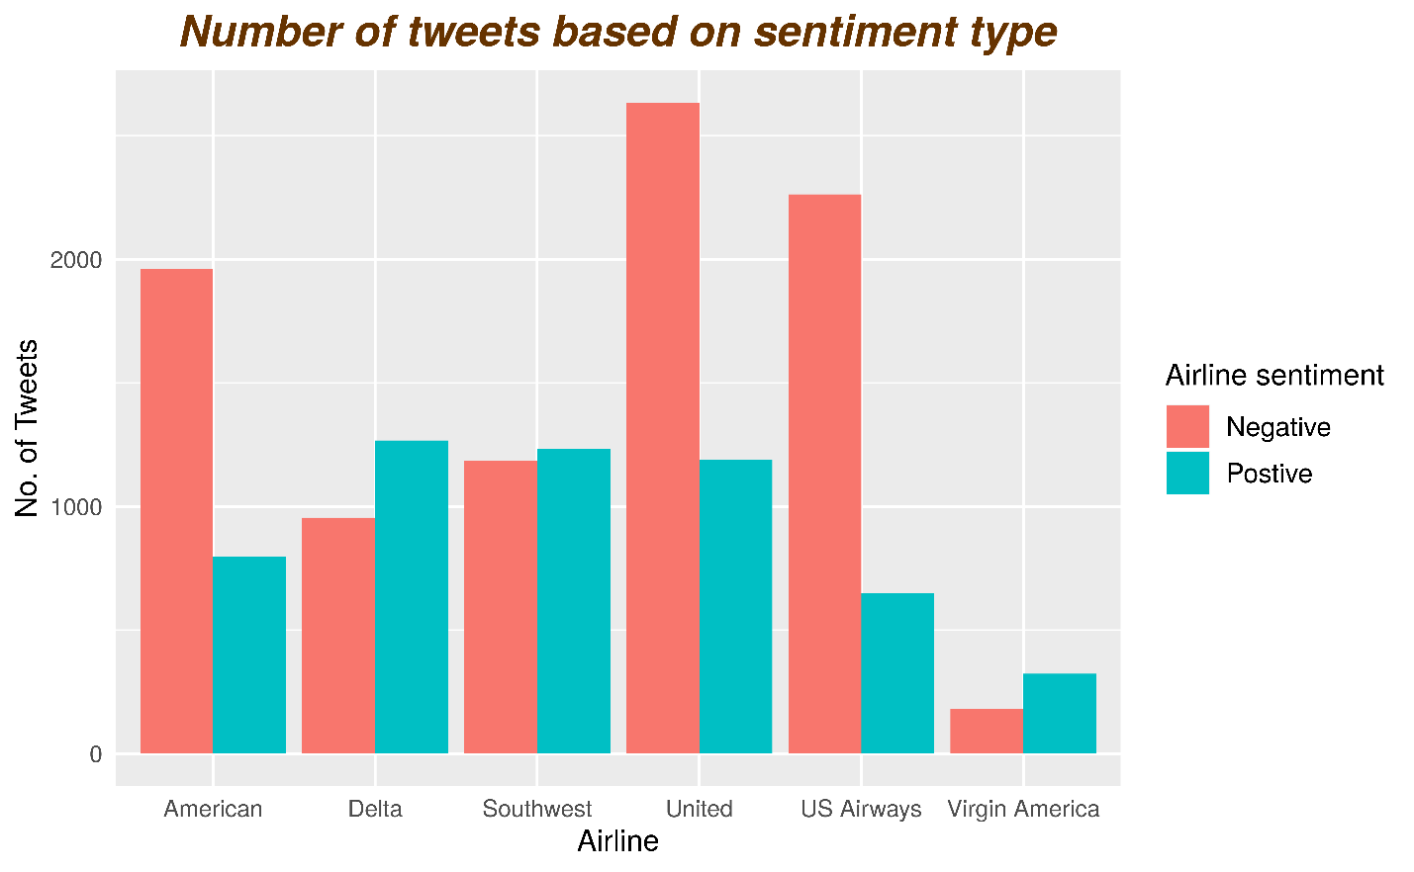

The bar plot shows the number of Positive and Negative tweets of all the airlines, as we can see American, United and US Airways have more Negative tweets compared to Positive Tweets, While Delta, Southwest and Virgin America has more Positive tweets then Negative Tweets. On looking closer we can observe US Airways seems to have the highest value of Negative to positive Tweets and Virgin America has the least negative score.

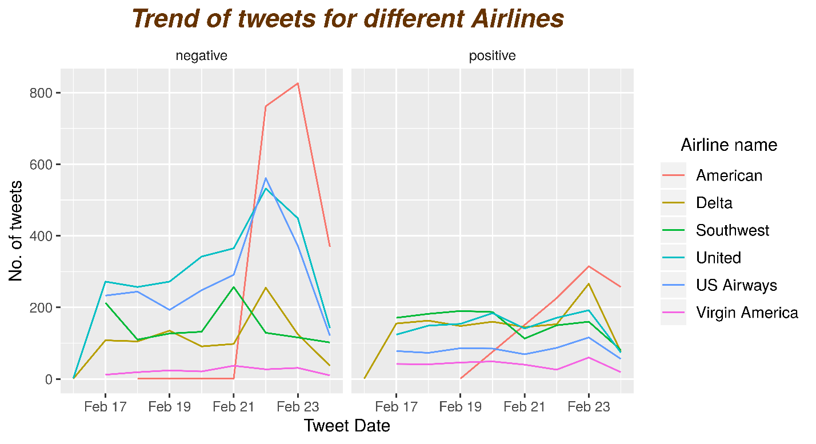

From the trend lines we can make the following observations, Virgin America doesn’t show much changes in either category. Delta Airlines has an almost identical variation. United and US Airways shows more fluctuation towards negative sentiment. We can clearly see spike in the number of negative tweets suddenly for American Airlines.

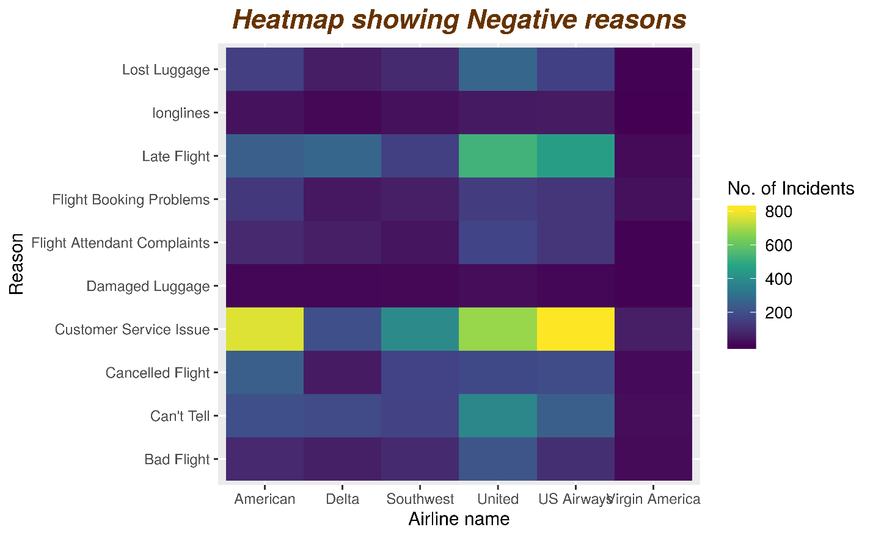

The Heatmap shows the negative reasons for different airlines. We can get some interesting information looking at this. It shows why passenger sentiment is negative towards an airline. Most common reason for having the negative sentiment is due to poor customer service from the airline. Many of the passengers have expressed they have an issue with the customer service of American, United and US Airways. The second reason seems to be because of Late flight. Followed by other reasons.

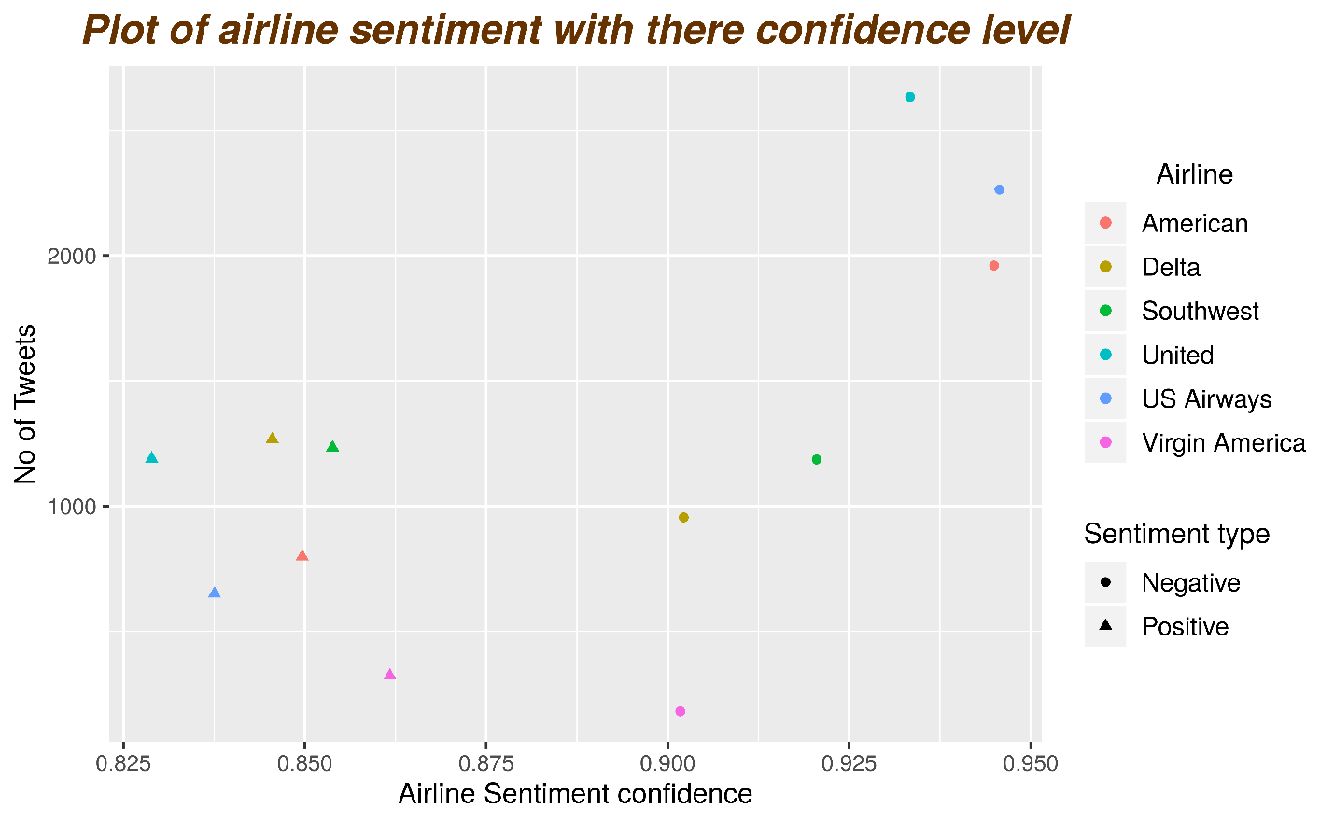

The above plot shows the Average Airline sentiment confidence Probability of different airlines for Negative and positive Tweets. American, United and US Airways has the highest confidence levels of being Negative, while their Positive counterparts has low Positive confidence.