**Tools**

ST-Link V2 Debugger

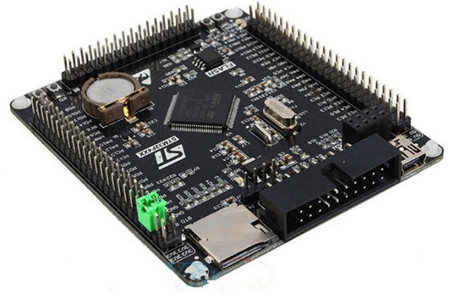

**Evaluation Board**

STM32F4XX Black Board

LED D3

LED D2

**Software Tool** – STM32 Cube IDE

Button K0

Button K1

Sender Task

Receiver Task

B

Blink LED D3 for 100 ms

Send alternatively 0 and 1 to mailbox queue

A

Is Button K1 Pressed

NO

YES

Stop receiving from Mailbox queue.

Continue Receiving from Mailbox

A

Is received value == 0

Is Buffer full

YES

NO

NO

SET LED D2

RESET LED D2

Yes

Block until buffer is full

B

Is Buffer empty

Block until buffer is empty

Yes

NO

* Normally Sender task sends data in Mailbox buffer and receiver receives it, if data is 0 receiver sets the LED D2 and if data is 1 it resets the LED D2.
* Whenever sender sends data it makes LED D3 blink for 100 milliseconds.
* We can stop receiver from receiving data by using Button K1, if it is pressed receiver will not receive data.
* In case of Button K1 pressed – Sender will send data 5 times because Mailbox size is 5, and then it will go to the blocking state. Means LED D3 will blink 5 times then Sender Task will go to Block.
* All the blocking and Wakeup functionality is inbuild in FreeRTOS.

Please watch Demonstration video for the same.