# Bug Report:

Bug 1: Game does not pay out at correct level.

When player wins on 1 match, balance does not increase.

## 

Bug 2: Player cannot reach betting limit:

Limit set to 0, but game ends with player still with 5 (dollars) remaining.

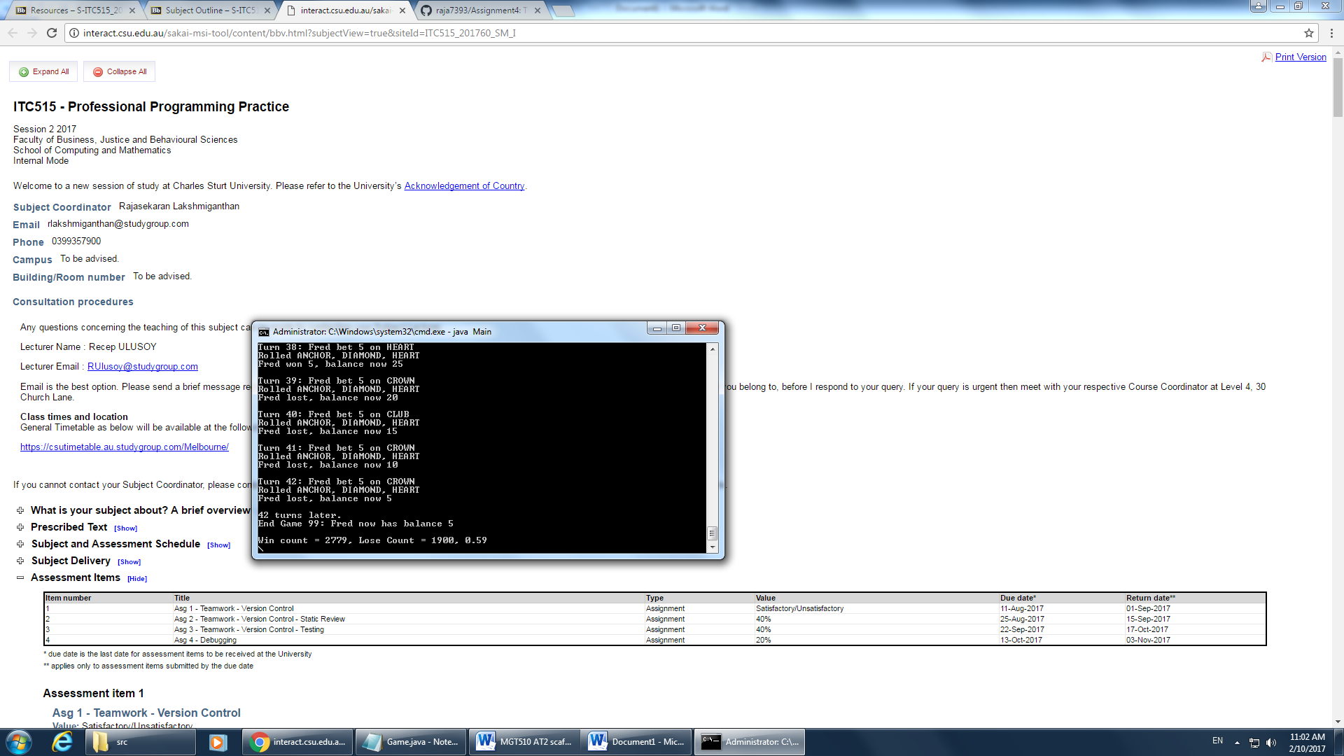

Bug 3: Odds in the game do not appear to be correct.

Crown and Anchor games have an approximate 8% bias to the house. So the win: (win+lose) ratio should approximately equal 0.42. This does not appear to be the case.



Bug 4: Program does not say people under age of 18 can’t play

The program does not display a warning message at the start:

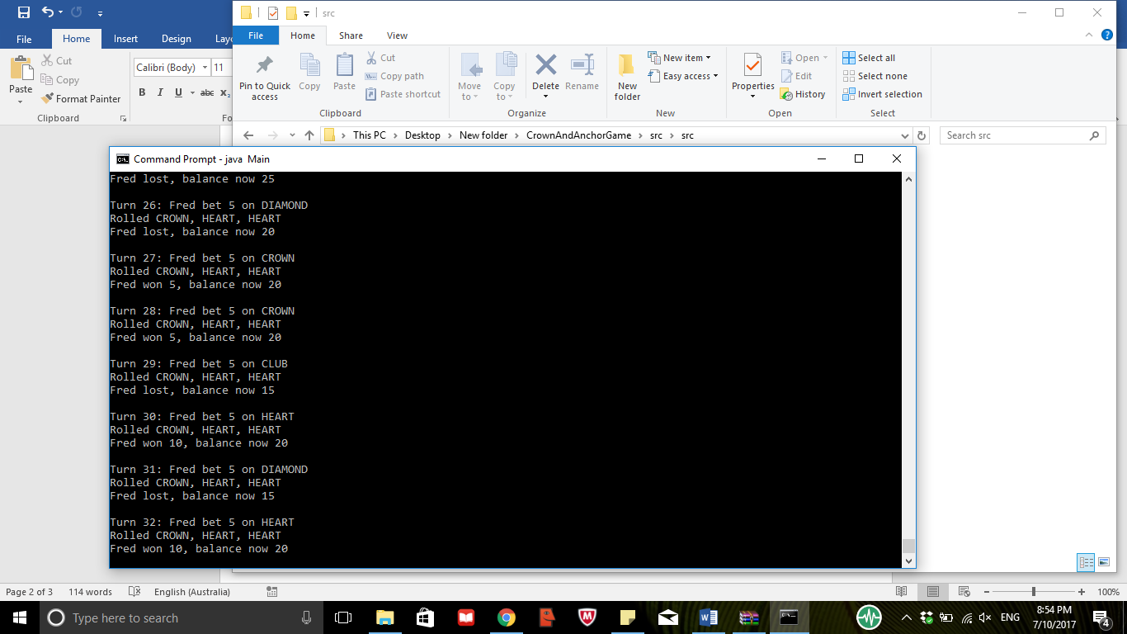

Bug 5: Symbols are getting repeated.

