Bug 1: Game does not pay out at correct level.

As you can see that before the identified origin, variable values are sane:

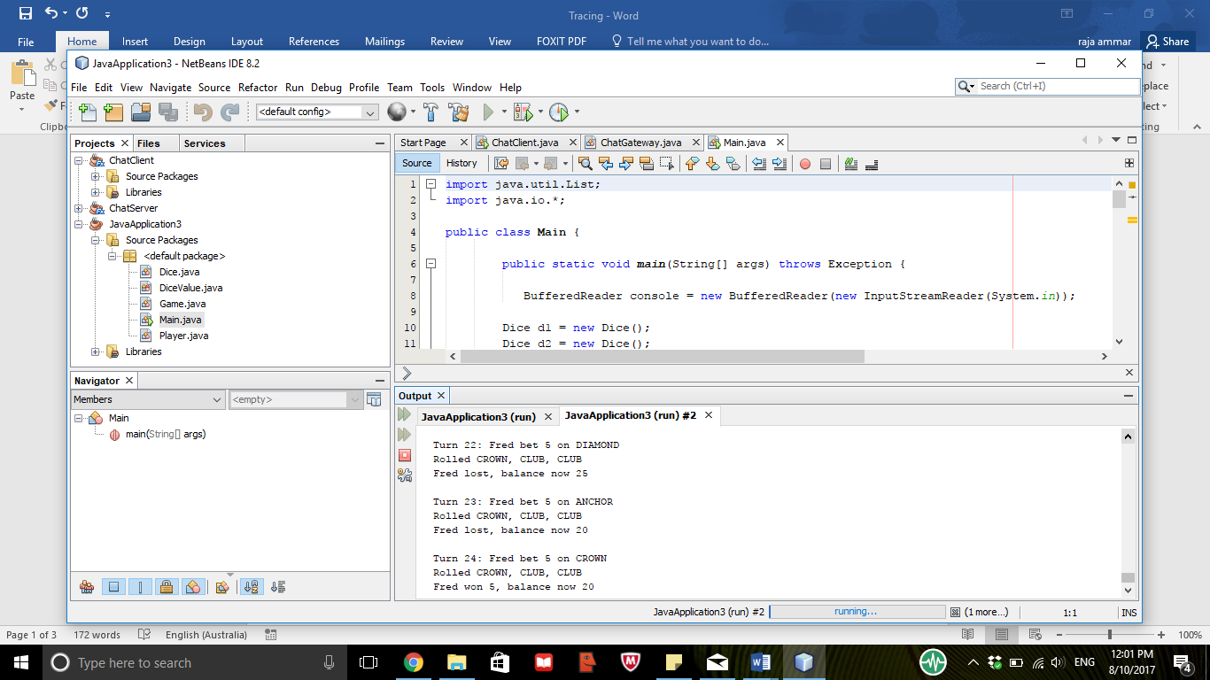

After the origin, value of balance is infected:



Bug 2: Player cannot reach betting limit:

As you can see that before the identified origin, variable values are sane:

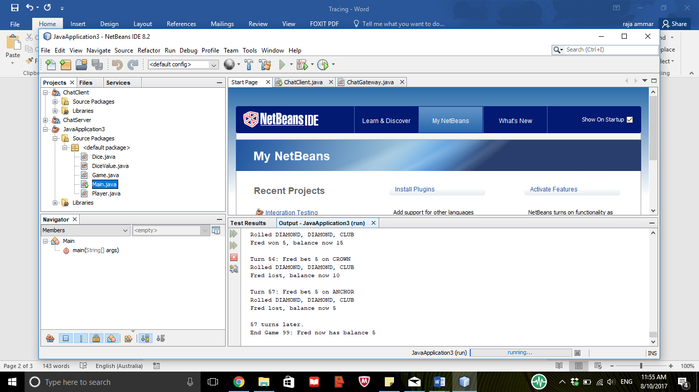

After the origin, value is infected:

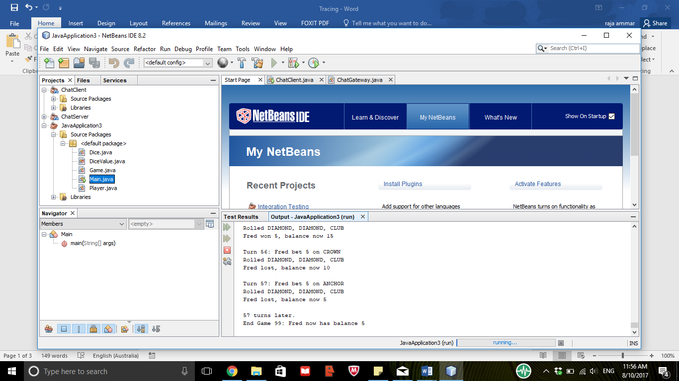

**Bug 3:**

As you can see that before the identified origin, variable values are sane:

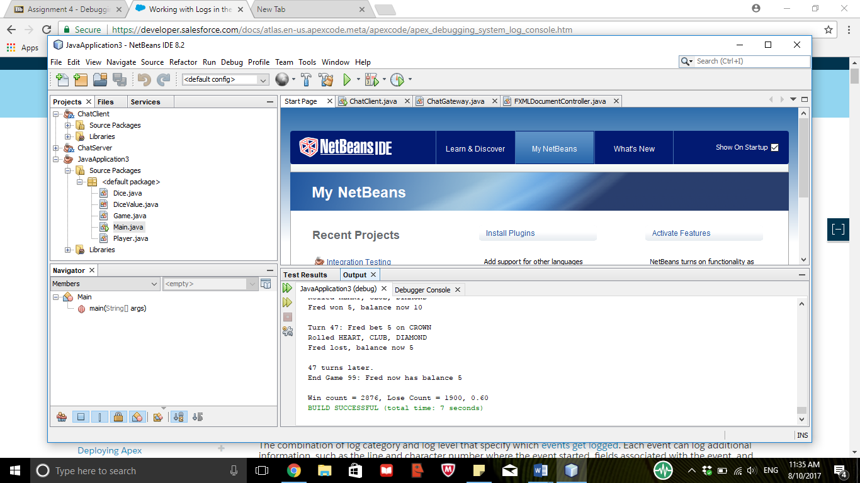

After the origin, value is infected:

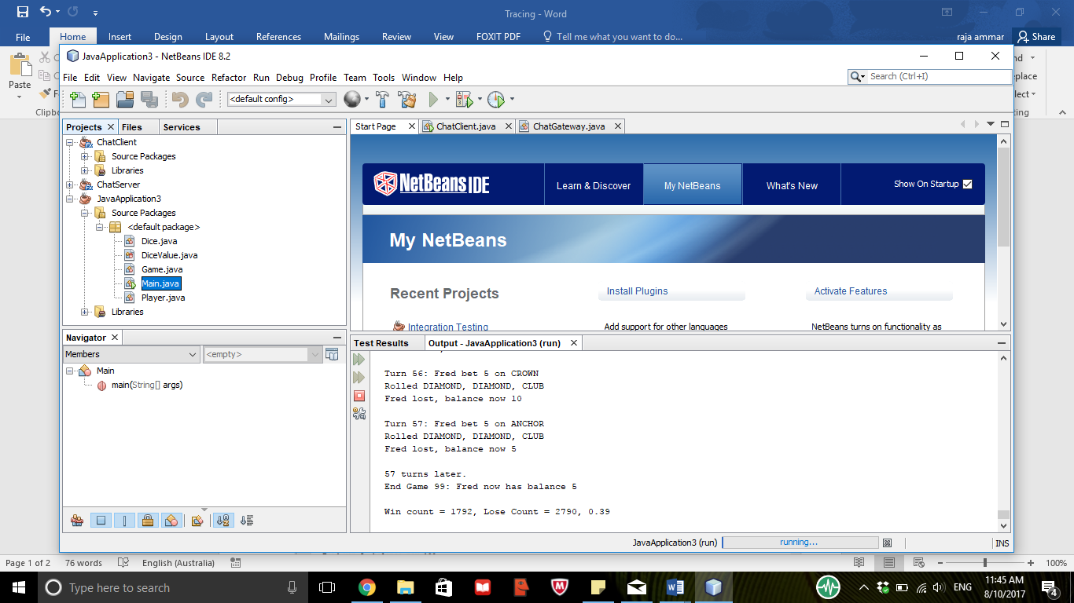

**Bug 4:** Program does not say people under age of 18 can’t play

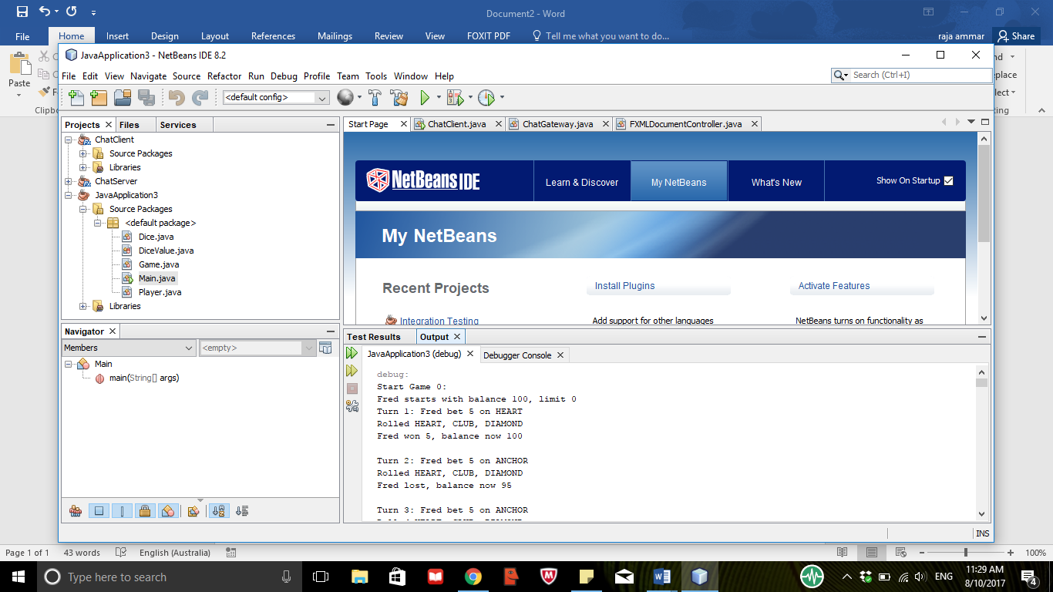

**Bug 5:** Symbols are getting repeated

As you can see that before the identified origin, variable values are sane:





