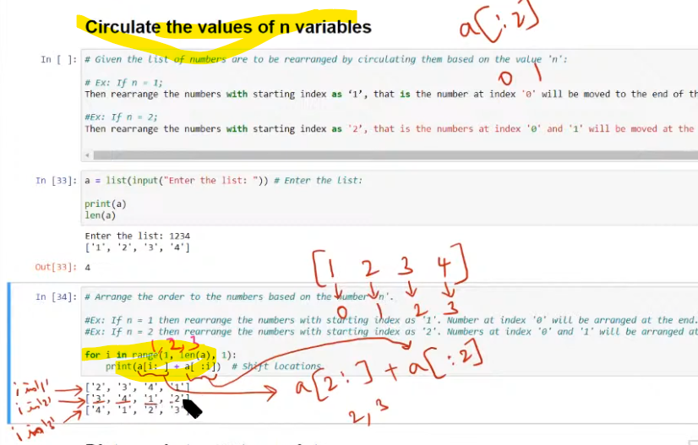

**FINDING DISTANCE BETWEEN TO POINTS**

Important to develop machine leaning algorithm like clustering, on there Euclidean distance is used.

