**PARTITTION (**[**𝗦𝗤𝗟 𝗠𝗮𝘀𝘁𝗲𝗿 𝗖𝗹𝗮𝘀𝘀 For 𝗗𝗮𝘁𝗮 Engineers | 𝗗𝗮𝘁𝗮 Analyst | 𝗗𝗮𝘁𝗮 Scientist | 𝗙𝗿𝗲𝘀𝗵𝗲𝗿𝘀 in Tamil**](https://www.youtube.com/watch?v=JtaOmwnR6AM&t=18635s)**)**

One of the search optimization technique used to search data from a big space in efficient way. It looks only a partition which has the needed data, skips all other partitions which doesn’t have our data.

EX: if we have our needed content on pc’s D drive then we have to make a search only on D, not on C.

What really it does is it separated whole data into different chunks, remove unwanted chunks which doesn’t have needed data.

**PARTITION METHODS**

List, range are the partiotion methods

Partitions can be created by values,

**EX:**

In below when we create a record with the year of 2021, then that data goes to 2021 partition, when we tries to search the 2021 record with where then it will takes the record from this partition instead of searching all records in table. The time taken without this partition to take this record will takes too much time

**NOTE:**  Column specified in partition by should be primary key. Below command used in sql

**EXAMPLE FOR RANGE:** helps to create partition for int based data

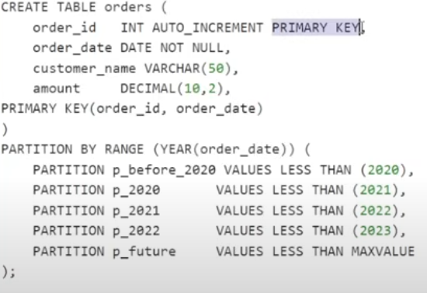

**EXAMPLE FOR LIST COLUMN:** Helps to create partition for string based data.

