**ROW_NUMBER()**

Gives unique row number to each and every data in incremental order by specifying some condition. It is also useful to search data in more optimized way.

EX:

In below table the row number can be created for salesAmount in descending order, so it start puts one for the highest value and puts all other values for the rest of the data. When ever we searches for high sales amount it just looks the row_number and takes the data instead of go troughing whole data.

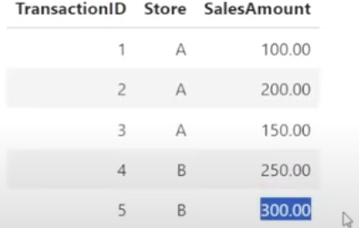

Order by will be given to over window to create this row_number, In below example it puts unique row number for the same campaign_id.

