1. **What is marginal probability**

It is a probability of one event occurred calculation by ignoring all other variables.

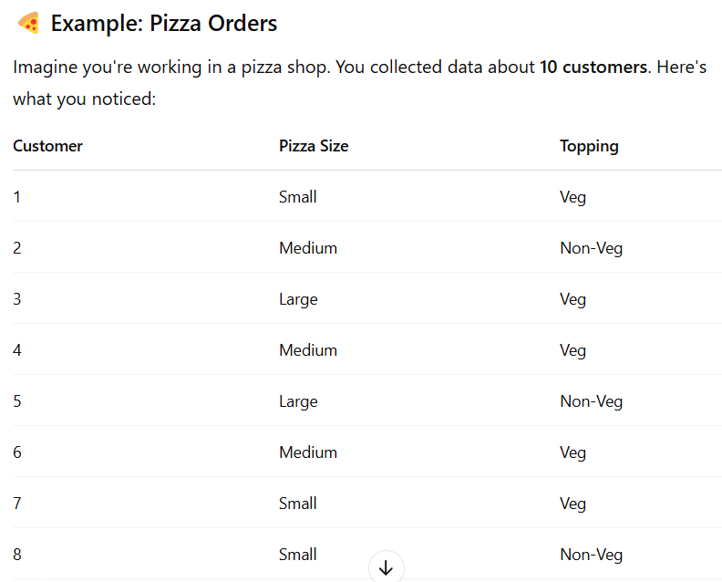

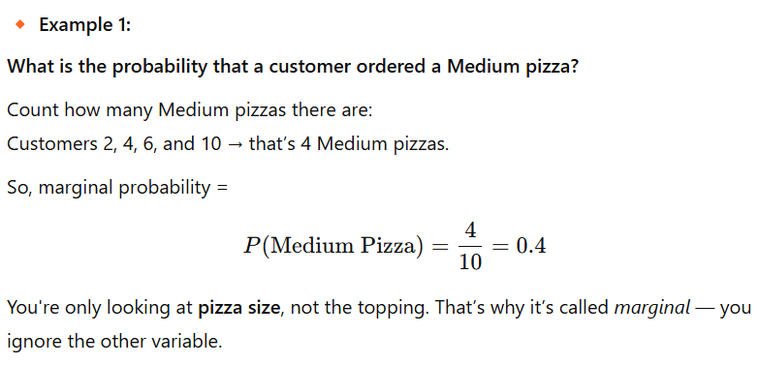

1. **What are the probability axioms?**

It is called rules or principles of probability theory, has three rules

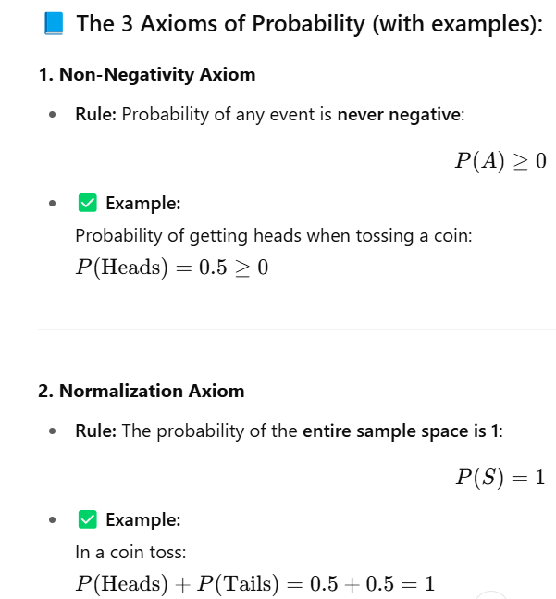

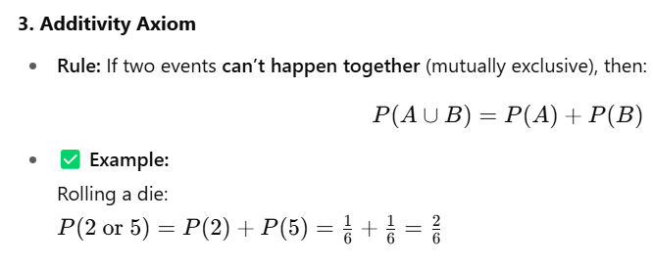

This calculation will used in **Naive Bayes** where naïve mean assumption, so in **Naive Bayes** is a **probabilistic classifier** based on **Bayes' Theorem** that assumes features are independent — it predicts the class with the highest probability.

1. **What is Conditional probability ?**

Conditional probability is the chance of event **A** happening **if** event **B** has already happened — like the chance it’s raining (**A**) given that it’s cloudy (**B**).

**Example**: If 30 out of 50 cloudy days are rainy, then  
**P(Rain | Cloudy) = 30 / 50 = 0.6**.

1. **What is Bayes’ Theorem and when is it used in data science?**

Bayes' Theorem helps us find the probability of a cause given an observed result. For example, if a person tests positive for a disease, Bayes' Theorem helps calculate how likely they truly have it, considering the test’s accuracy and disease rate. It's useful in areas like medical diagnosis, spam detection, and predictive modeling.

• Bayes' Theorem = Formula for conditional probability

• Naive Bayes = A classification model built using Bayes’ Theorem

Naive Bayes is widely used for spam detection, sentiment analysis, and text classification.

1. **Define variance and conditional variance.**

**Variance**: It shows how spread out numbers are from the average — for example, in the numbers [2, 4, 6], the variance is small because they’re close to the mean (4).

**Conditional Variance**: It’s the variance of a variable given some condition — for example, if we know it’s a rainy day, the variance of people carrying umbrellas may be less than on random days.

**EX**:

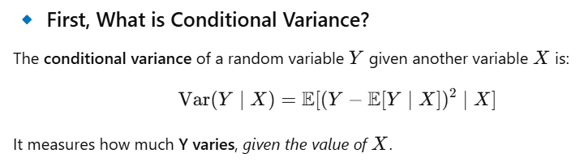

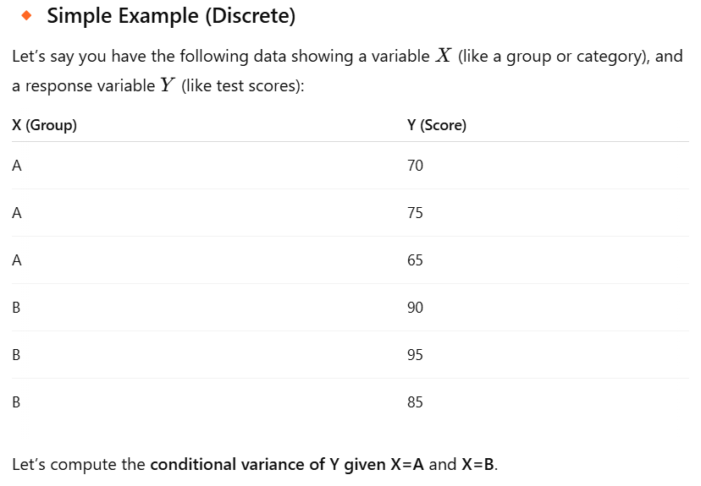

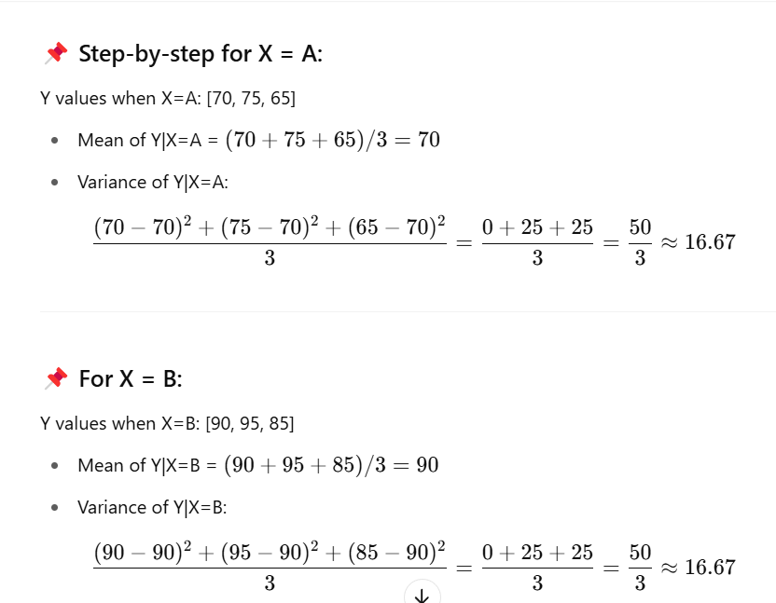

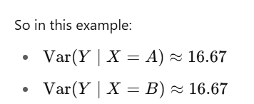`

1. **Explain the concepts of mean, median, mode, and standard deviation.**

**Mean:**The mean, often referred to as the average, is calculated by summing up all the values in a dataset and then dividing by the total number of values.

**Median:**When data are sorted in either ascending or descending order, the median is the value in the middle of the dataset. The median is the average of the two middle values when the number of data points is even. In comparison to the mean, the median is less impacted by extreme numbers, making it a more reliable indicator of central tendency.

**Mode:** The value that appears most frequently in a dataset is the mode. One mode (unimodal), several modes (multimodal), or no mode (if all values occur with the same frequency) can all exist in a dataset.

**Standard deviation:** The spread or dispersion of data points in a dataset is measured by the standard deviation. It quantifies the variance between different data points

1. **Difference between normal distribution and standard normal distribution**

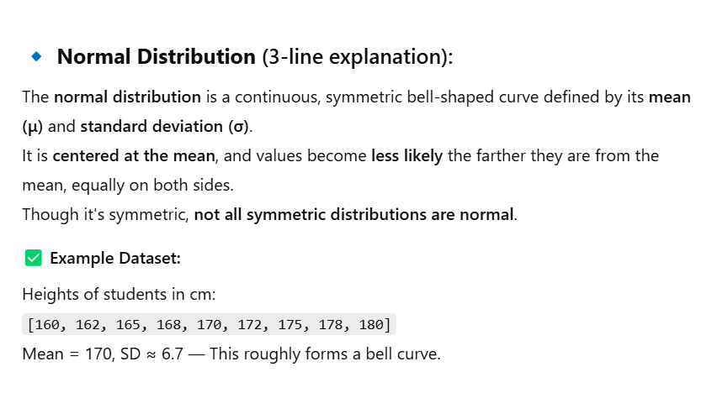

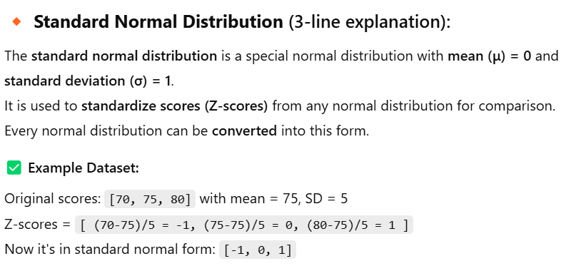

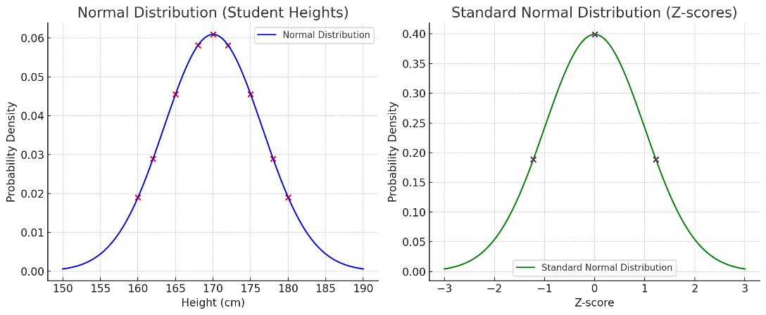

we use normal and standard normal distributions primarily to understand how data is distributed,

And also it has the following usage too.

The **normal distribution** models real-world data, estimates probabilities, supports hypothesis testing, and underpins the Central Limit Theorem.  
The **standard normal distribution** standardizes data for easy comparison, simplifies probability calculations, detects outliers, and improves machine learning performance.

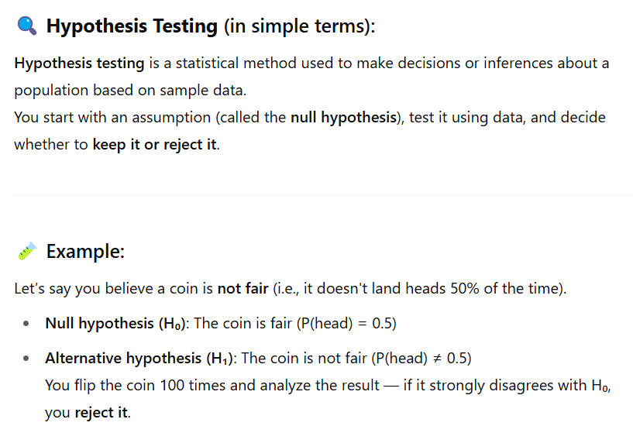



1. **What is SQL, and what does it stand for?**

SQL stands for Structured Query Language.It is a specialized programming language used for managing and manipulating relational databases. It is designed for tasks related to database management, data retrieval, data manipulation, and data definition.

1. **SQL vs NoSQL Databases – Key Differences**

* Data Structure:
  + SQL: Uses structured, relational data (tables with rows and columns).
  + NoSQL: Uses flexible formats like documents (JSON/BSON), key-value pairs, columns, or graphs.
* Schema:
  + SQL: Has a fixed schema; structure must be defined before data is added.
  + NoSQL: Schema-less or dynamic; data can be added without a predefined structure.
* Query Language:
  + SQL: Uses standard SQL language; supports complex queries (joins, subqueries, aggregations).
  + NoSQL: Uses varied, model-specific query languages or APIs.
* Use Cases:
  + SQL: Best for structured data and complex queries.
  + NoSQL: Suitable for unstructured data, scalability, and flexible application needs.

**10. What are the primary SQL database management systems (DBMS)?** Relational database systems, both open source and commercial, are the main SQL (Structured Query Language) database management systems (DBMS), which are widely used for managing and processing structured data. Some of the most popular SQL database management systems are listed below: MySQL Microsoft SQL Server SQLite PostgreSQL Oracle Database 6. Amazon RDS.

**11. What is the ER model in SQL?**

The structure and relationships between the data entities in a database are represented by the Entity-Relationship (ER) model, a conceptual framework used in database architecture. The ER model is frequently used in conjunction with SQL for creating the structure of relational databases even though it is not a component of the SQL language itself.

**12 What is data transformation?**

The process of transforming data from one structure, format, or representation into another is referred to as data transformation. In order to make the data more suited for a given goal, such as analysis, visualisation, reporting, or storage, this procedure may involve a variety of actions and changes to the data. Data integration, cleansing, and analysis depend heavily on data transformation, which is a common stage in data preparation and processing pipelines.

**13 What are the main components of a SQL query?**

A relational database’s data can be retrieved, modified, or managed via a SQL (Structured Query Language) query. The operation of a SQL query is defined by a number of essential components, each of which serves a different function. 1. SELECT 2. FROM 3. WHERE 4. GROUP BY 5. HAVING 6. ORDER BY 7. LIMIT 8. JOIN