Error Caused By Incorrect Input Layer Size
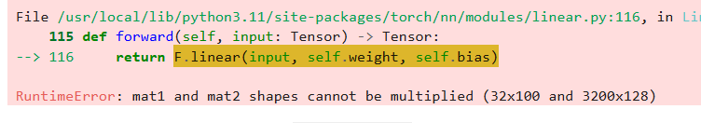
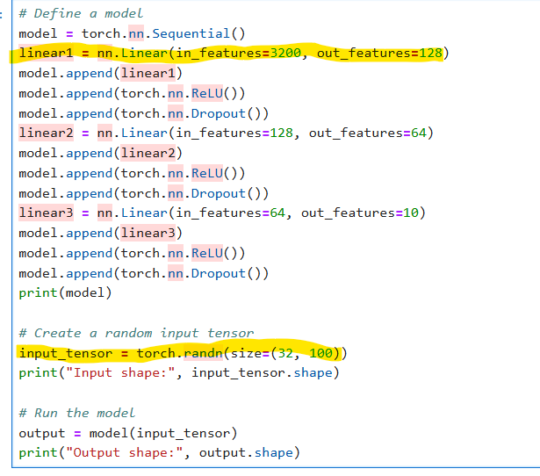
At the heart of deep learning is matrix algebra. Matrix algebra has very specific rules for matrix multiplication. One crucial rule is that the number of columns in the first matrix (mat1) must equal the number of rows in the second matrix (mat2). This condition is not met in the current input, where the first matrix has 100 columns and the second matrix has 3200 rows.
This error commonly stems from incorrectly specifying layer dimensions, particularly in the input layer. The value passed to the in_features argument must exactly match the input data dimensions. Dimensional mismatches often lead to runtime errors or unexpected model behavior.
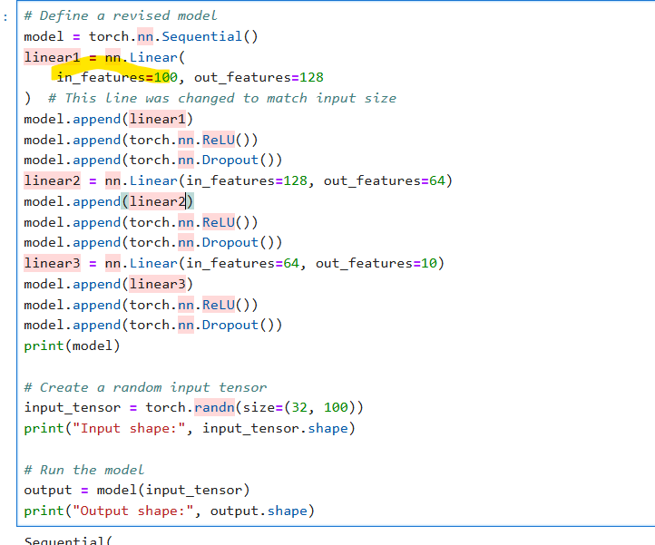

Error Caused By Adding The Same Layer Twice
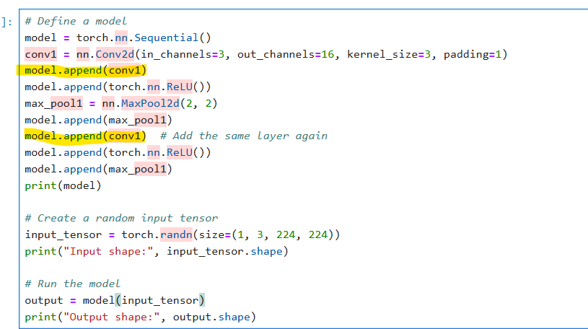
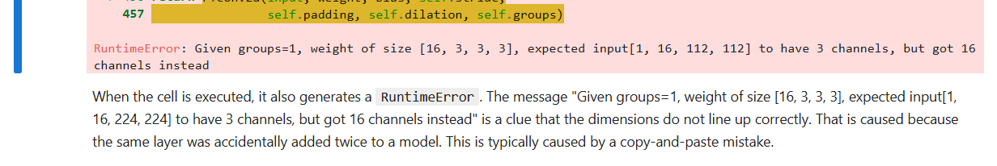
Error Caused By Forgetting to Flatten
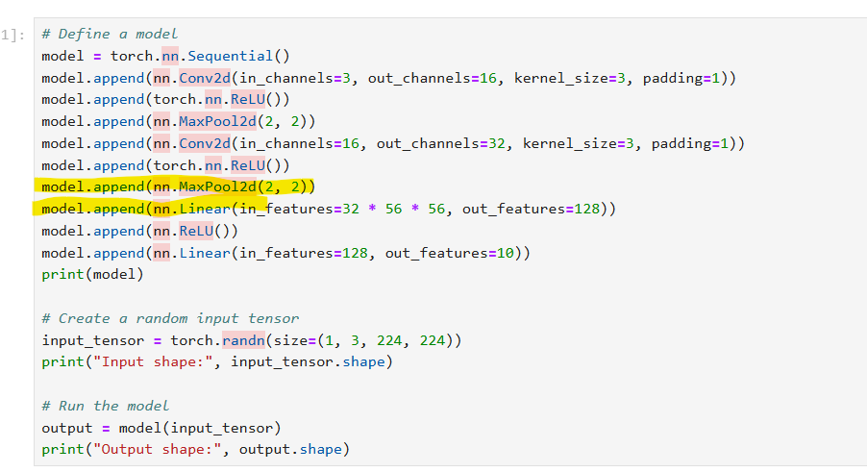
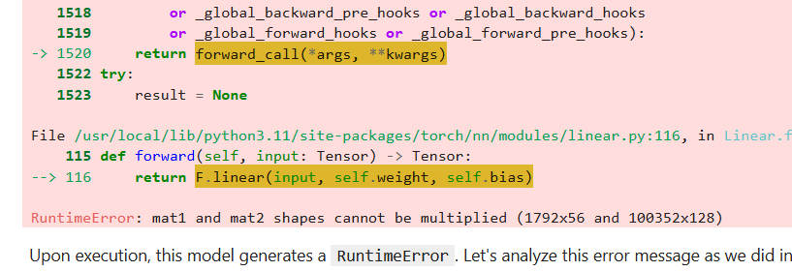
This fails because Conv2d layers produce a 4D tensor (batch_size, channels, height, width), while Linear layers expect a 2D tensor (batch_size, features).
To resolve this issue, the tensor needs to be flattened before it enters the fully connected layers. This flattening step transforms the 4D output from the convolutional layers into a 2D tensor that the Linear layers can process.
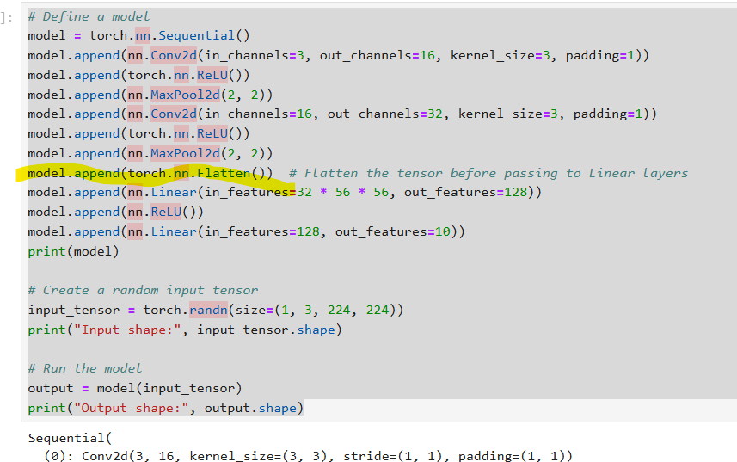

Error Caused By Incorrect Layer Size After Flattening

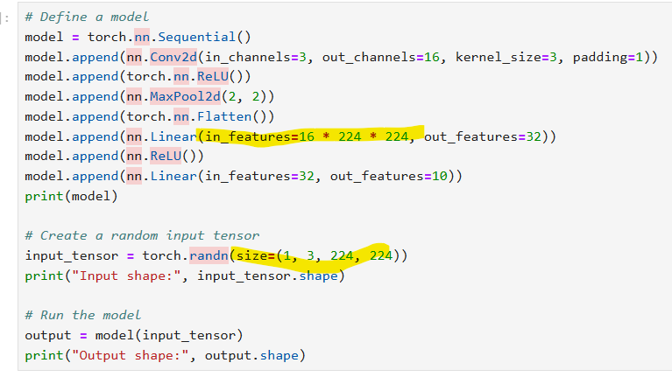
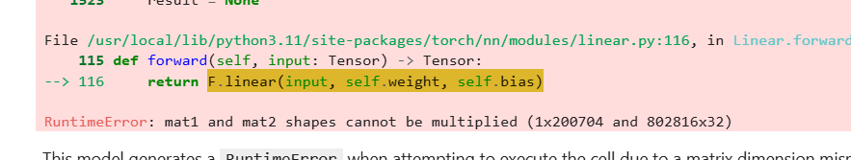
the spatial dimensions should be 112x112 (half of 224x224 due to the MaxPool2d(2, 2) layer). The correct value for in_features should be 16 * 112 * 112.
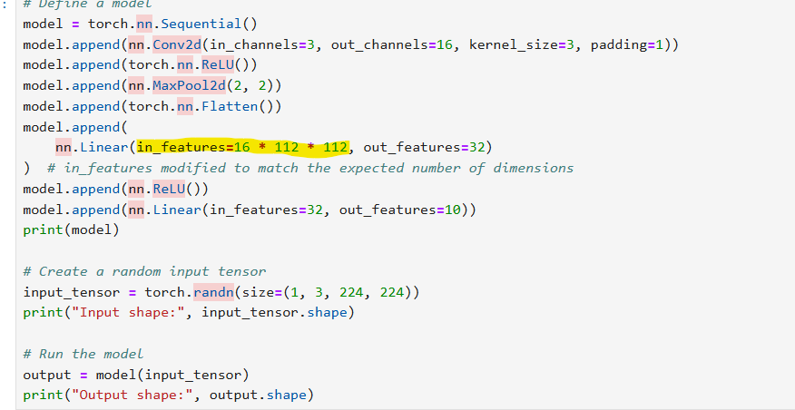

The below code also gives the same error like the above one

But here we use stride 2 so the in_feature not will be half of kernel_size+stride
