1. How to choose an optimal number of clusters
Silhouette Score
It measures data points distance inside a cluster and the distance between current and other cluster, has three values +1, 0, -1 that indicates how well the points are clustered properly.

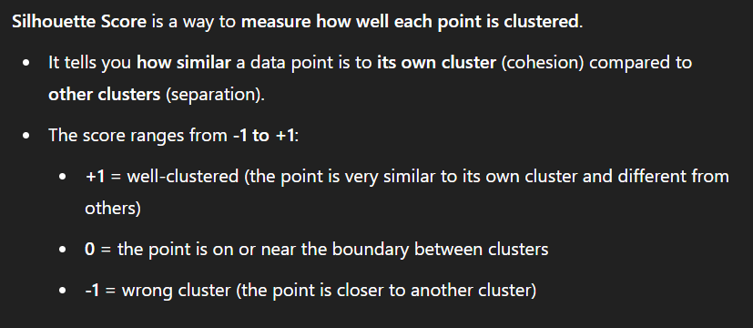
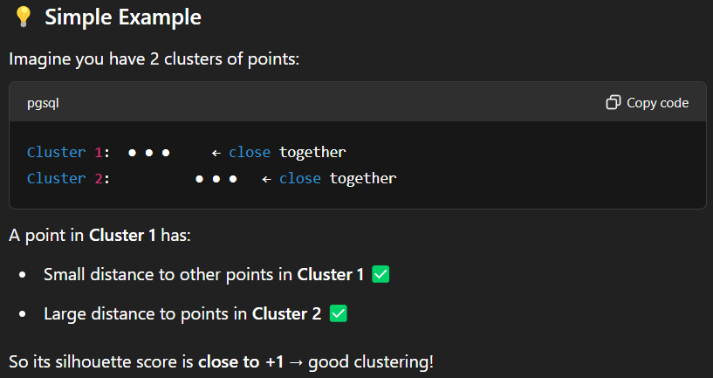
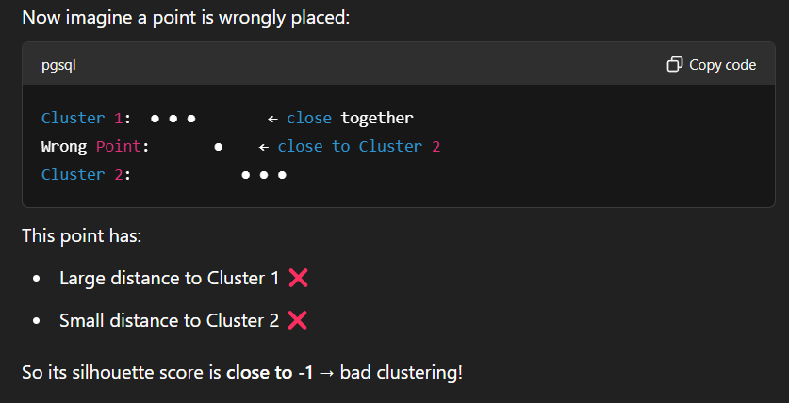

GAP STATISTICS:
We create random data (not random clustered data) with the same shape and range as the original data. Then, for both the real data and the random data, we calculate the mean within-cluster distance (dispersion) for different values of k. The difference between the log of these values gives us the Gap Statistic.
