-------------------------------------------------------------------------------------------------------------------------------------ANSWERS:
1. Unsupervised learning is used in Anomaly detection, Dimensionality
reduction (feature extraction - process of combining correlated
features into single feature)

Dimensionality reduction should be done before going to give the
data to machine to train it. So that the machine can learn in more
faster manner.
Semi supervised learning
Since labeling data is usually time-consuming and costly, you will often
have plenty of unlabeled instances, and few labeled instances. Some
algorithms can deal with data that’s partially labeled. This is called
semisupervised learning
EX:
Some photo-hosting services, such as Google Photos, are good examples of this. Once you upload all your family photos to the service, it automatically recognizes that the same person A shows up in photos 1, 5, and 11, while another person B shows up in photos 2, 5, and 7. This is the unsupervised part of the algorithm (clustering). Now all the system needs is for you to tell it who these people are. Just add one label per person and it is able to name everyone in every photo, which is useful for searching photos. 4 Most semisupervised learning algorithms are combinations of unsupervised and supervised algorithms.
3. Yes
4. 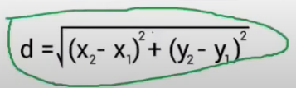
5. For classification KNN
In below the k value is 7 so we found 7 nearest data points from that we can see the class red has the maximum nearest neighbours, so here the bias is increased, variance decreased.
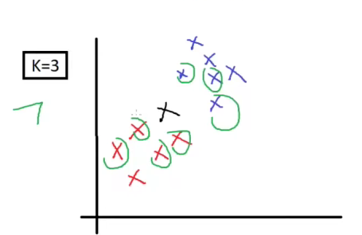
For Regression KNN
In the example we find 2 nearest data points from two class and find the y value of two data points, from the y values we will calculate the average.
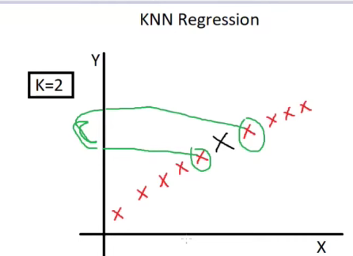
6. 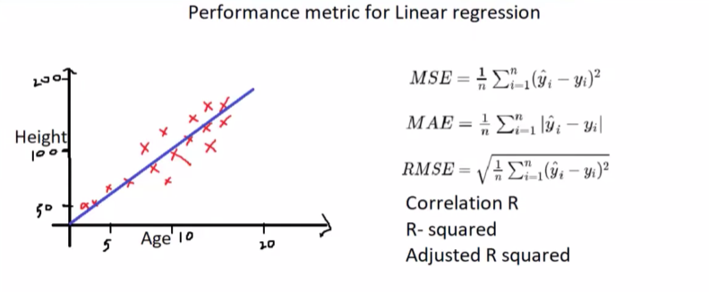
7. Used to check the performance for multi linear regression, simple r square cannot be used for multi linear regression which has more than two input variables or features. Because normal r square values are getting increased abnormally when more than two columns are added for calculation.
In below formula P is number of input variables. N total number of`samples.
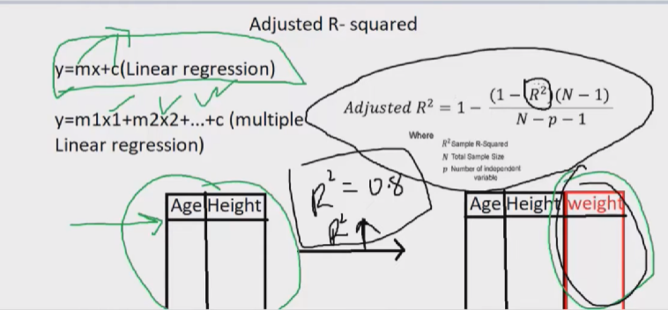

8. 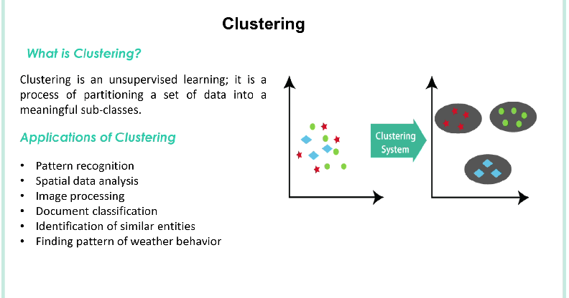
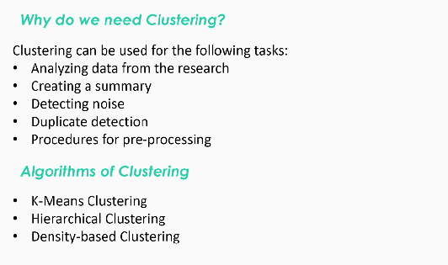
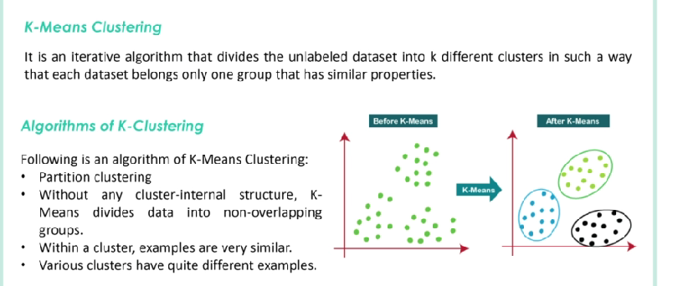

9. Correlation in ML measures the strength and direction of a linear relationship between two variables. It ranges from -1 (perfect negative x values will decrease when y is increased) to +1(perfect positive x,y will increased), with 0 indicating no linear correlation.
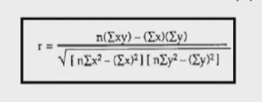
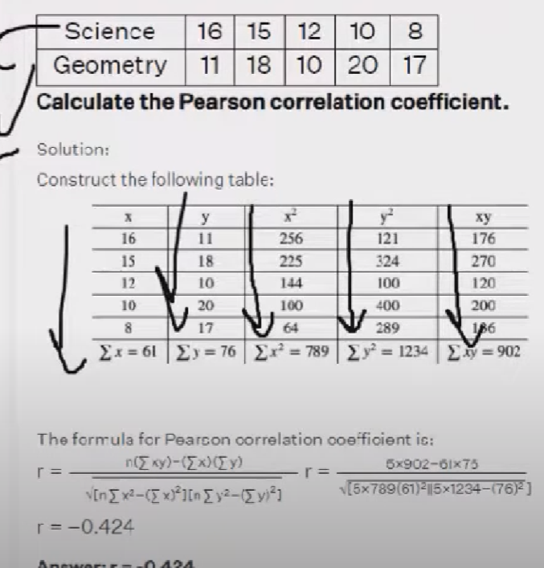
IMPORTANCE OF GIVING HIGH CORRELATED FEATURE TO MODEL TRAINING
For all kind of regression model we have to give highly corelated fields with target variable is important, we have to pick a feature that has correlation greater than or equal to the 0.5, in the below describes the house price prediction correlation, the target label price has highly correlated with the feature called room size, so this needs to be give to the model for training, if we give less correlated feature than the model’s accuracy will be decreased.

10. 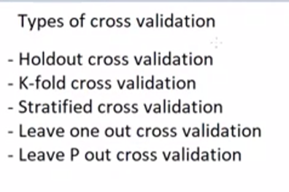
Holdout is splitting the data to 80,20 ratio.
In kfold all the red box will be the validation data. Validation error for each fold will be added to find the average
Stratified cross validation
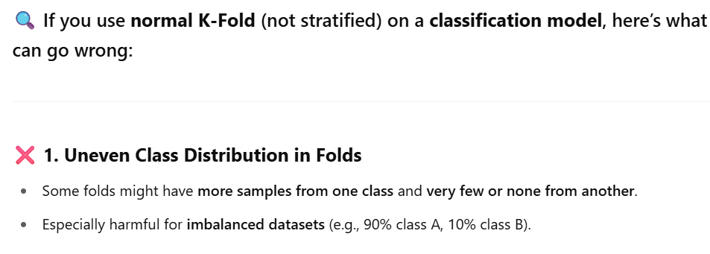
Leave one out
Here we will take only 1% data for testing for each fold, rest of the 90% data used for train. If we have 100 rows for data the iteration of this k-fold validation will be 100, on each iteration it takes only on data for test, So in first iteration only the first row will be used for test, and second iteration second row will be used for test and so on.
Note: Most of the time it is not used because it becomes overfitting to model
Leave P out
It is like leave one out but instead of taking one data for testing it take P number of data for testing, if the p is 3 then it will take only 3 row for each iteration fold.

11. It is one of the supervised learning technique that takes some feature
from dataset and break down's those feature into different segmentation
to determine the importance of the feature.

Decision tree has several leaf nodes and edge nodes
It will repeat this process for all feature
EX: Consider age is the feature decision tree takes from dataset, it
will segment like the below one.

AGE
|
|--------------|
|
young middle senior
age
|
Sex
|
------
| |
F M

ENTROPY
Decision tree uses entropy measurement to make decision tree. This measurement
gives the uncertainty or randomness of the data
Decision tree takes the parameter with high randomness, so that it can
identify all possible value.
FORMULA:
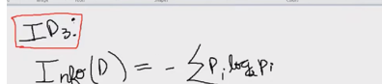
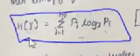
EX:
In below image 3rd cluster has no random data all are red points on that entropy will be zero, because there is only one category of data. But in 1st and 2nd cluster we have combinations of data points or more than two categories. In this entropy will have value.
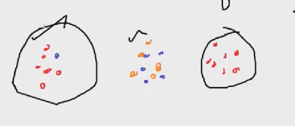

INFORMATION GAIN
Information Gain is calculated by measuring the entropy before and after splitting the data. It selects the feature that best separates the messy (impure) data into more organized (pure) parts. The feature with the highest Information Gain is chosen as the root node of the decision tree.
Based on the information gain we splitting the tree
Formula:
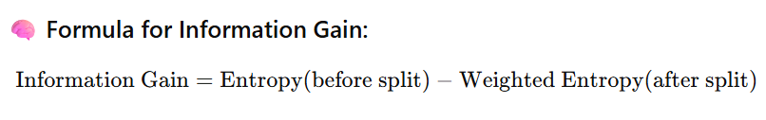
SUMMARY:
✅ Corrected and Clear Version:
- Entropy measures how mixed or impure the dataset is — it tells us whether the dataset has multiple classes and how evenly they are distributed.
- Information Gain helps us choose the best feature to split the data, so that the resulting groups are as pure (separated by class) as possible.

🧠 Why This Matters:
- If entropy is 0, the data is already pure (only one class).
- If entropy is high, the data has a mix of classes.
- Information Gain looks at how much entropy is reduced when we split the data using a feature.

12. Simple linear regression - only single input variable used to predict output
Multiple linear regression - more than one input variables used
REFER multi linear regression.docx for more
Non linear regression - Non linear combination of input like (curve)
* Polynomial Regression - not all of the model's data fit into linear
straight line, some model's data will be
fully fit in slightly curved line,
So this is used to fit curved line model's
data
It is basically used where we can't apply
simple and multi linear regression.
HOW POLYNOMIAL REGRESSION IMPLEMENTED
The formula for polynomial regression is
for degree 2 y = b0 + b1x + b2x**2
for degree 3 y = b0 + b1x + b2x**2 + b3x**3 .... +bnx**n
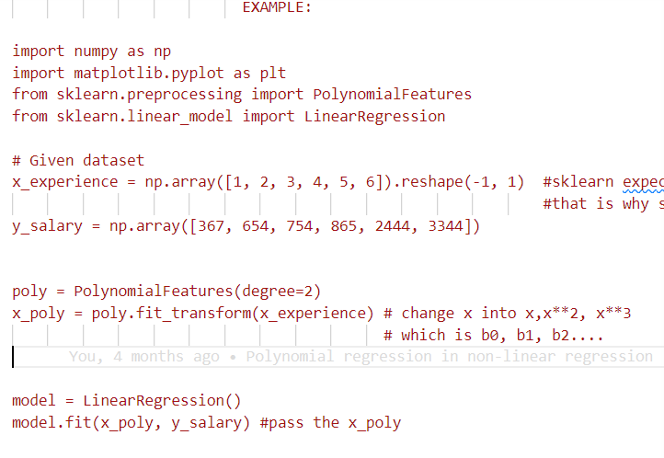
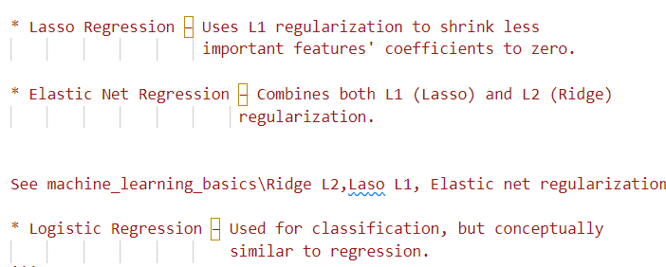
13. When train accuracy is hight and test accuracy is low overfitting will
occurred, the are fitted while training, but while we trying to see
the prediction accuracy on test data there will be a variance
occur in prediction, this is called the variance.
This problem can be solved by regularization technique

In regularization we will eliminate some parts of the data to
fit the correct data to train model.

14. 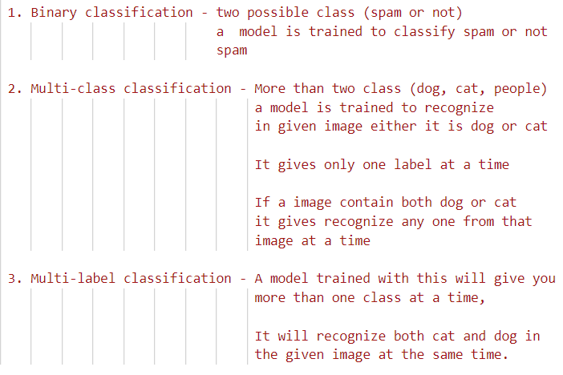
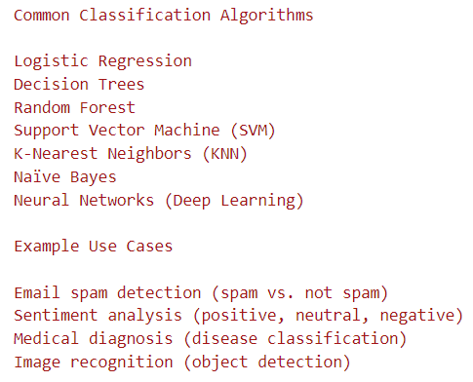
15.
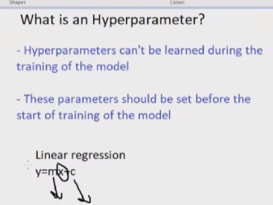
In linear regression x is the input y is the output that we are going to predict, m and c are the parameters with that help of that y will be predicted, so the optimal value to predict y can’t be find in learning stage of the model. So we have to the this hyper parameter to predict y, that is called hyper parameter tuning.
Summary:
Hyper parameter tuning is the process of changing the parameters of the model (weight) to predict the values in desired way. And it can be changed externally.
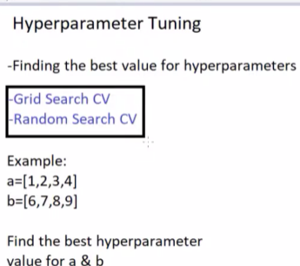

16. Finds the best hyper parameter in faster way in random search while grid takes time.
17. It is a classification technique that uses set of data points to learn
to predict new data point.

ALGORITHM:

step1: choose a value of k
step2: find the distance between unknow data point to all
other data point
step3: if any of the other points are near to the unknow point
then the unknown point will become a member of that all
other points.
step4: predict the response of unknown point.

Example:
If k=3 means we have to find top three nearest neighbour
data points by finding the distance from unknow data point to
all other data points, if the value of k is large
then bias will increase, for low k value bias will decrease and
variance will increase.

For regression it will find the average of the nearest data points.
For classification it will take max no of nearest data point from
one class.
18. It is a supervised classification algorithm which predicts the given
input is belongs to some class.

It uses S curve above curve is one category below curve is another
category

so it uses sigmoid function, which put any real number into the
range of 0-1.

It uses 1/1+(e)-z where z= wX+b

If the output probability is ≥ 0.5, the input is classified as 1 (positive class).
If the output probability is < 0.5, the input is classified as 0 (negative class).

Types of Logistic Regression:

Binary Logistic Regression – Used when there are only two classes
(e.g., Spam or Not Spam).

Multiclass Logistic Regression (Multinomial Regression) – Used when
there are more than two classes.

Ordinal Logistic Regression – Used when classes have an order
(e.g., Low, Medium, High).

19. Models performance are evaluated using following metrics

1. Accuracy - sum of correct prediction / total no of prediction

Accuracy can be misleading because of
imbalanced dataset.

2. Precision and Recall - Precision measure accuracy of the model's positive prediction.
It is mainly used when false positive increases

True positive / true positive + false positive

Recall ensures that can a model predicts all
true predictions. It is used when False negative
is in high.

True positive / True positive + False negative

In a cancer based system a model doesn't predicts
the person who have cancer will make huge risk.

3. F1 Score - Used when both precision and recall is important

f1-score = 2 * (precision * recall / precision + recall)

It is particularly useful in imbalanced dataset.

20.
It allows other users to verify your model's prediction, it is very
crucial because various users have various device capability but
still some of the techniques that can be used on torch to give the
same good prediction result to all users.
It can be achieved by doing
- Set random seeds
- Document dependencies
- Control hardware variations
21.
Both of the distribution is very important in probability distribution, All the ML algorithm needs the normalized data to learn it smoother, if the data is not normally distributed than it will be distributed by some techniques.
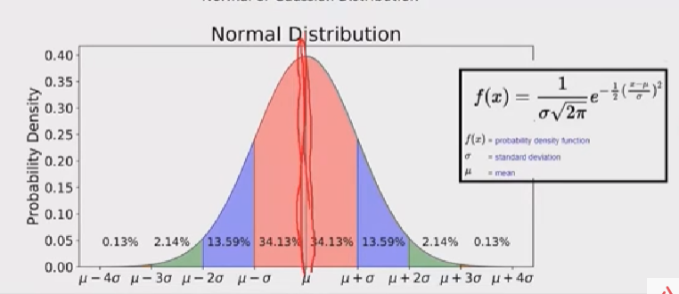
Types of distribution:
• Poisson distribution: Models the number of times an event happens in a fixed interval of time or space.
Example: Number of customer calls received per hour at a call center.
• Binomial distribution: Models the number of successes in a fixed number of independent yes/no trials.
Example: Number of heads in 10 coin tosses.
• Exponential distribution: Models the time between events in a Poisson process.
Example: Time between incoming calls at a help desk.
• Negative binomial distribution: Models the number of trials needed to get a fixed number of successes.
Example: Number of coin tosses needed to get 3 heads.
22.
Receiver operating characterizes and Area under curve are helps to find the best classifier algorithm to build classification model.
Here we will find a value called threshold, that helps to increase, decrease the true positive and false positive values.
A threshold is the center value for classification problem
EX: In binary classification problem we predict labels as 0 and 1, we will conclude if the value is less than threshold then the person has no diabetes, if a value is greater than threshold then the person has diabetes. That is what describes in below image, We will increase or decrease the threshold value to get good prediction
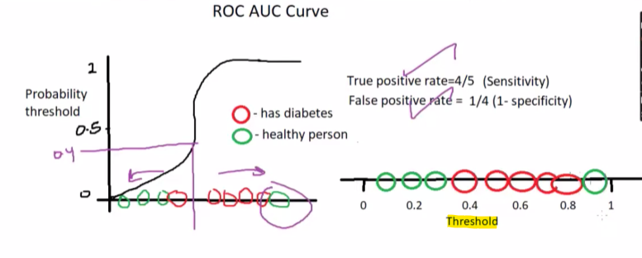
With ROC curve we will find confusion Metrix for this each threshold, the curved line are called ROC curve and the space under the curved line are called AUC, In Roc curve we will pot the True positive rate on y axis and False positive(wrong predictions) on x axis.
NOTE: Higher ROC value will has the good model prediction rate.
Following image the example of both ROC and AUC, we saw the performance of three classification model in this image. In this way we can find the best classification model, on the below image random forest classifier has the good prediction.
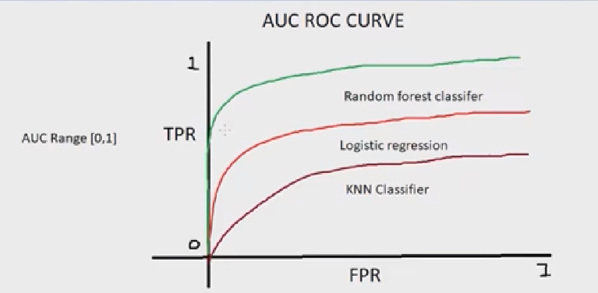

23.
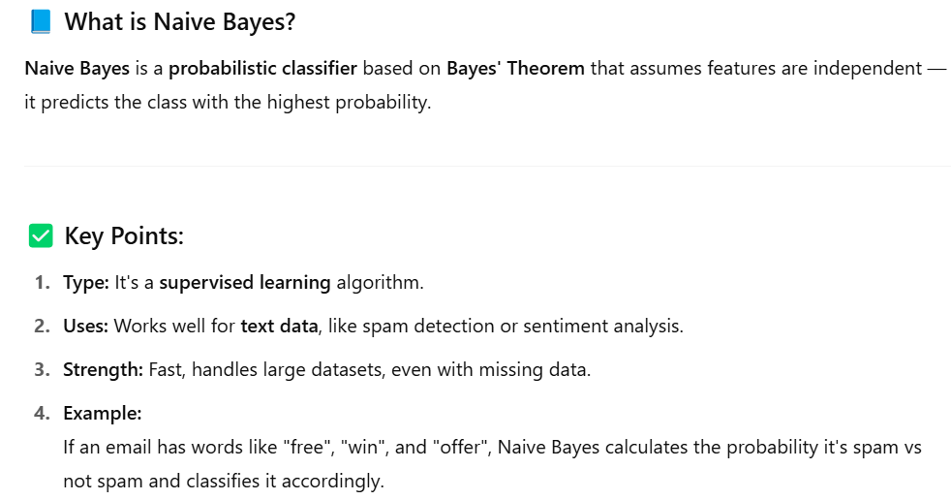
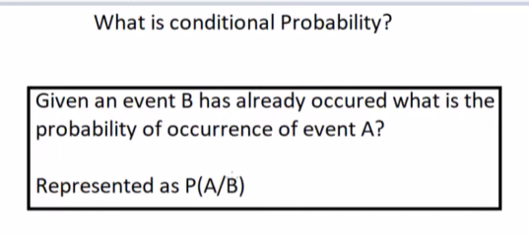
EXAMPLE FOR CONDIITONAL PROBABILITY(Used in naïve bayes model)
If a student study well(Event A) than what is the probability of he got good score in exam(Event B)
This same theory are used in naïve baise
Likelihood and prios
In below data set yellow highlight is a event(event A) that already occurred, blue highlight is the event(event B) that are going to occur because of the event A.
With the provided dataset we are going to find is the input X are fall in which type of category(yes/no)
Pink highlight is called likelihood of a event. And orange is called prior, a prior will give the probability result without finding the likelihood.

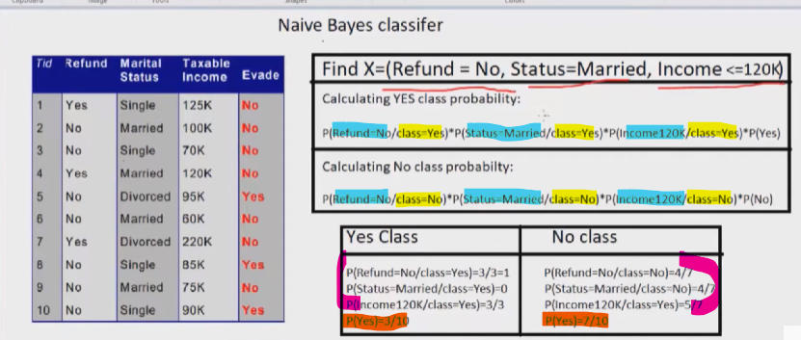
Importing naïve bayes
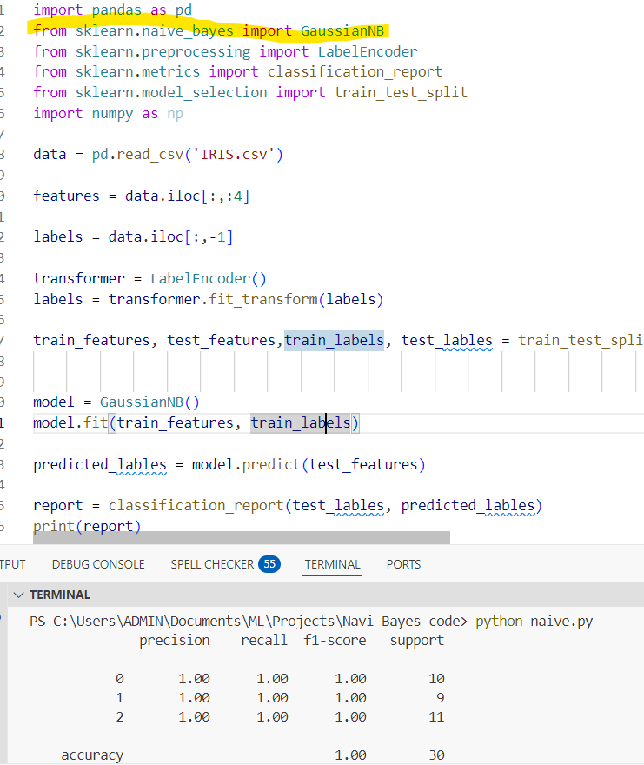

24.
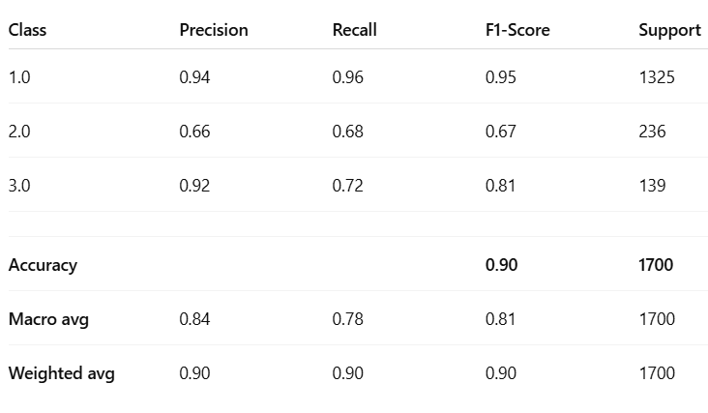
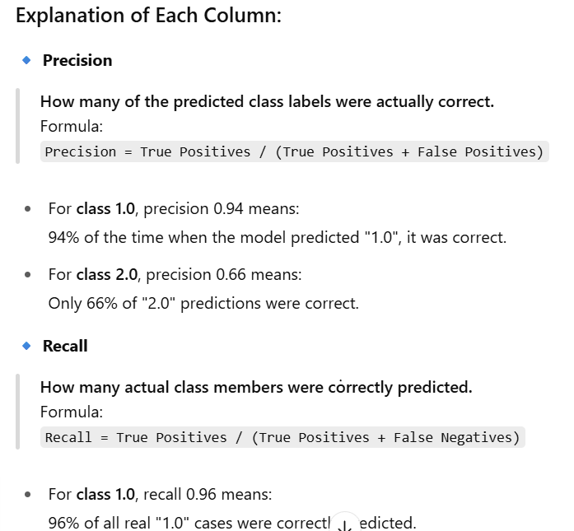
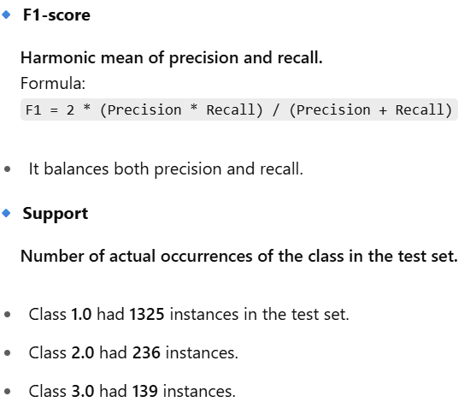
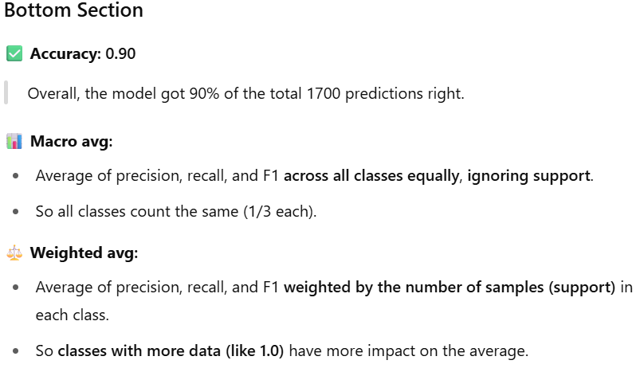
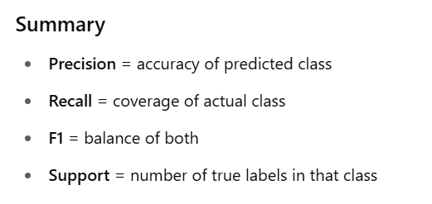
25.
Support Vector Machine (SVM) is a machine learning model that classifies data by finding the best dividing line (called a hyperplane) between different categories.
Kernel:
If the data cannot be separated in its original form (low dimension), SVM uses kernels to transform it into a higher-dimensional space where it becomes easier to separate. This helps SVM handle non-linear problems.
Threshold, margin:
The line which separates the red and green are also called threshold value for 1D vector it is called as point for From 2d it is also called ad threshold or hyperplane. And a point near to the threshold are called margins

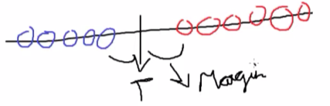
26.
- Polynomial kernel function – It tries to fit a polynomial(curved linear line) line to the dataset to make all the data separable, Takes argument d which says the dim that are going to be changed, it is used with cross validations to find the optimal d value

- Radial kernel function – This automatically chooses a dim to make all the data separable, it doesn’t take d argument

27.
