INTRO:
Before going to know about tensorflow we have to know what machine learning is.
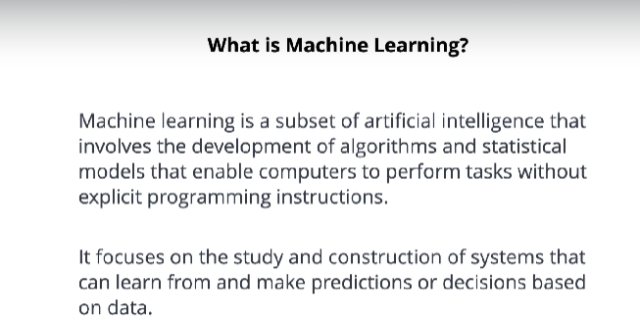

Here Models are developed and trained with that trained knowledge machines make predictions, that is called machine learning, so tensorflow is one of the open source library used to develop and train model.
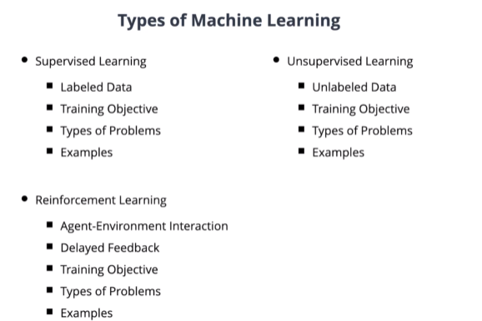

Image classification uses supervised learning
Unsupervisied learning are used for clustering, grouping similar data, dimensionality reduction.
Customer product analysis uses unsupervised learning.
In Reinforcement learning it works in the process of reward and loss, it is used in game playing, robot control.
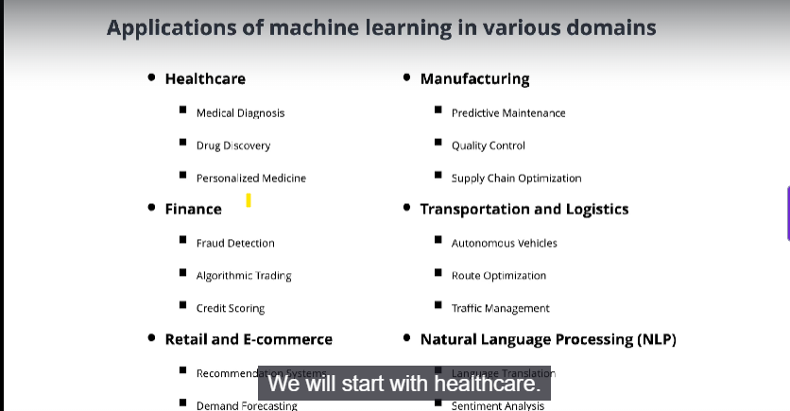

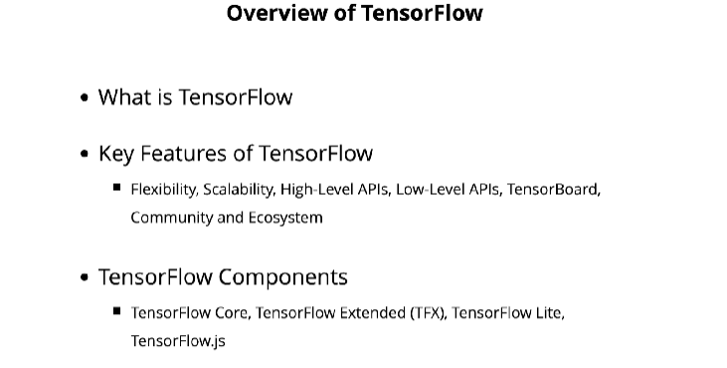
Tensorflow allows to develop and deploy models on various platforms like CPUs, GPUs, TPUs.
It supports distributed computing for training large models.

