Loss function that have been used to build custom model with the pre trained yolo model.
When we do object detection with yolo three problems will occur
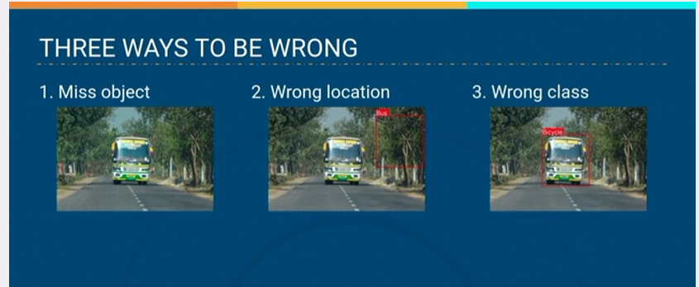
We need three different component of loss function to fix this errors.
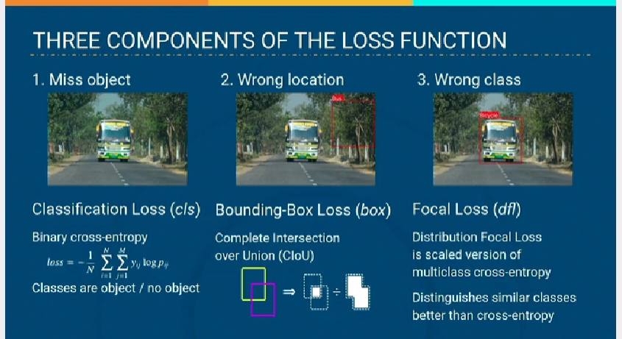
Yolo combines this three component and that can be adjusted to fix these errors. Below image shows that
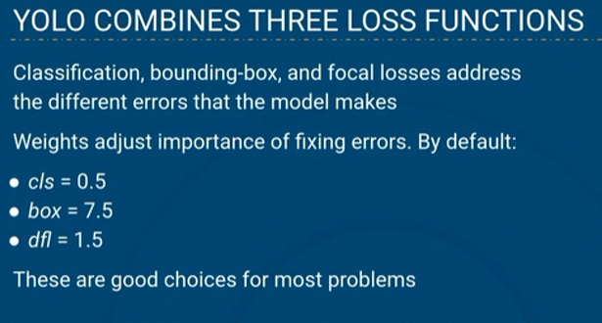
Weights of the each of this losses can be adjusted, above are the default weights value(cls, box, dlf) that have been used to correct this error
An custom model can be developed by adjusting this.

