1. What is Supervised and unsupervised learning
2. How can we import decision tree and kMean clustering sklearn
3. What is KNN, Does it can be used for both classification and regression?
4. What is the formula used in KNN, and the importance of k in KNN?
5. What is the visualization chart for KNN classification and regression, how
KNN works for classification and regression.
6. List of performance metric for regression and classification?
7. Difference between R-square and Adjust R-square
8. What is clustering why do we need clustering?
9. What is correlation in linear regression, formula for this, importance selecting correlated feature?
10. Types of cross validations
11. What is Decision Tree
12. Types of regressions
13. What is variance and regularization
14. Types of classification

-------------------------------------------------------------------------------------------------------------------------------------ANSWERS:
3. Yes
4. 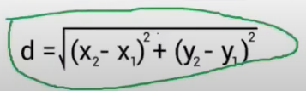
5. For classification KNN
In below the k value is 7 so we found 7 nearest data points from that we can see the class red has the maximum nearest neighbours, so here the bias is increased, variance decreased.
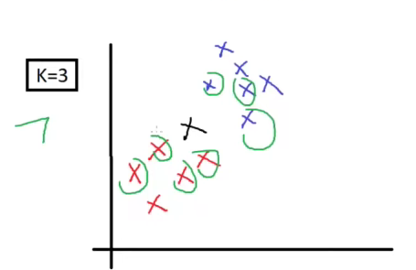
For Regression KNN
In the example we find 2 nearest data points from two class and find the y value of two data points, from the y values we will calculate the average.
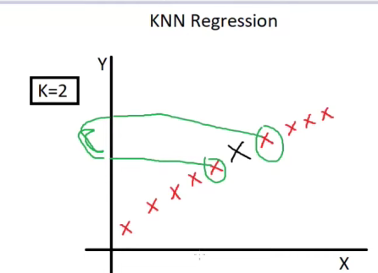
6. 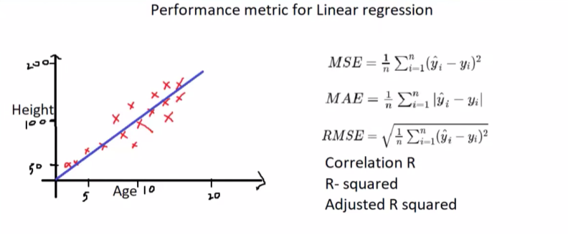
7. Used to check the performance for multi linear regression, simple r square cannot be used for multi linear regression which has more than two input variables or features. Because normal r square values are getting increased abnormally when more than two columns are added for calculation.
In below formula P is number of input variables. N total number of`samples.
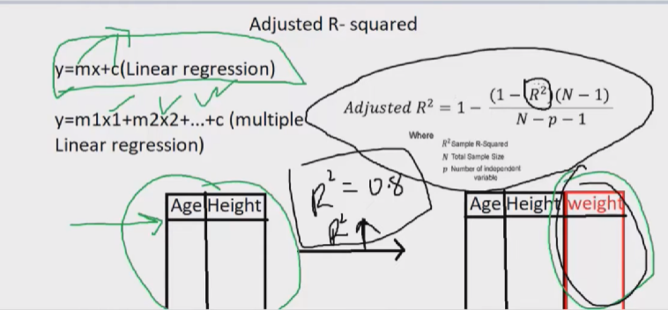

8. 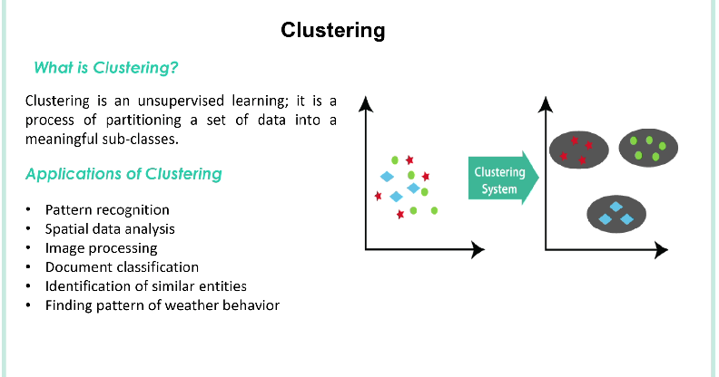
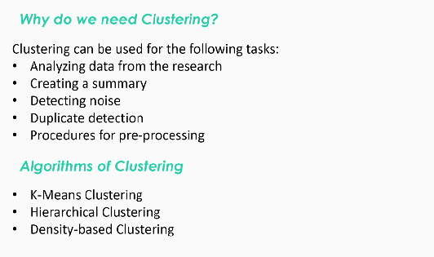
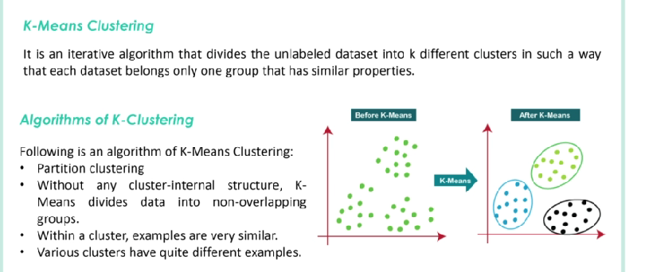

9. Correlation in ML measures the strength and direction of a linear relationship between two variables. It ranges from -1 (perfect negative x values will decrease when y is increased) to +1(perfect positive x,y will increased), with 0 indicating no linear correlation.
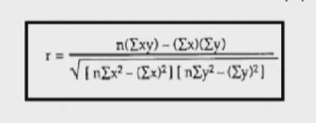
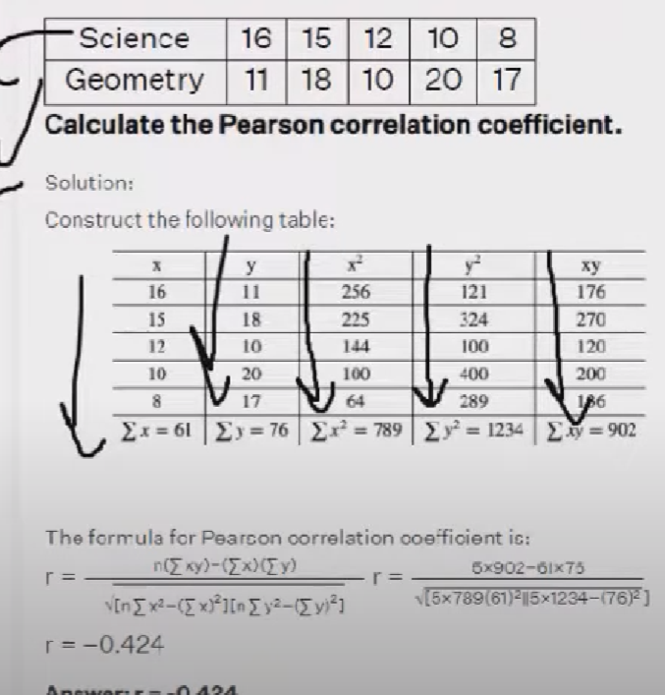
IMPORTANCE OF GIVING HIGH CORRELATED FEATURE TO MODEL TRAINING
For all kind of regression model we have to give highly corelated fields with target variable is important, we have to pick a feature that has correlation greater than or equal to the 0.5, in the below describes the house price prediction correlation, the target label price has highly correlated with the feature called room size, so this needs to be give to the model for training, if we give less correlated feature than the model’s accuracy will be decreased.

10. 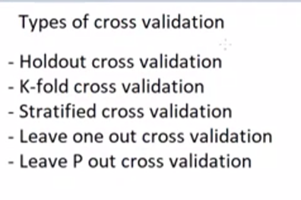
Holdout is splitting the data to 80,20 ratio.
In kfold all the red box will be the validation data. Validation error for each fold will be added to find the average
Stratified cross validation
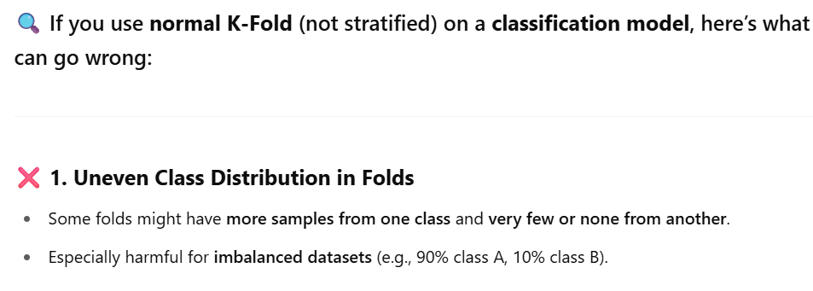
Leave one out
Here we will take only 1% data for testing for each fold, rest of the 90% data used for train. If we have 100 rows for data the iteration of this k-fold validation will be 100, on each iteration it takes only on data for test, So in first iteration only the first row will be used for test, and second iteration second row will be used for test and so on.
Note: Most of the time it is not used because it becomes overfitting to model
Leave P out
It is like leave one out but instead of taking one data for testing it take P number of data for testing, if the p is 3 then it will take only 3 row for each iteration fold.

11. It is one of the supervised learning technique that some feature
from dataset and break down's those feature into different segmentation
to determine the importance of the feature.

Decision tree has several leaf nodes and edge nodes
It will repeat this process for all feature
EX: Consider age is the feature decision tree takes from dataset, it
will segment like the below one.

AGE
|
|--------------|
|
young middle senior
age
|
Sex
|
------
| |
F M

ENTROPY
Decision tree uses entropy measurement to make decision tree. This measurement
gives the uncertainty or randomness of the data
Decision tree takes the parameter with high randomness, so that it can
identify all possible value.
EX: in coin toss head probability - 0 (no randomness) (when a coin has head
in both side)
tail probability - 1 (high randomness) (when a coin head, tail
both side)
12. Simple linear regression - only single input variable used to predict output
Multiple linear regression - more than one input variables used
REFER multi linear regression.docx for more
Non linear regression - Non linear combination of input like (curve)
* Polynomial Regression - not all of the model's data fit into linear
straight line, some model's data will be
fully fit in slightly curved line,
So this is used to fit curved line model's
data
It is basically used where we can't apply
simple and multi linear regression.
HOW POLYNOMIAL REGRESSION IMPLEMENTED
The formula for polynomial regression is
for degree 2 y = b0 + b1x + b2x**2
for degree 3 y = b0 + b1x + b2x**2 + b3x**3 .... +bnx**n
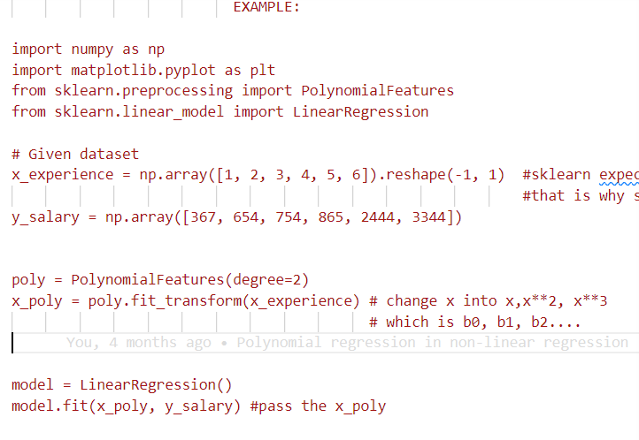
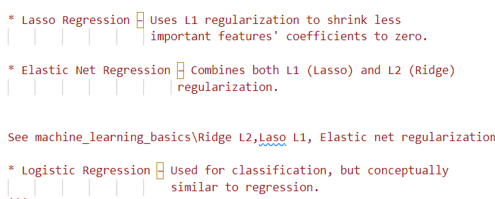
13. When train accuracy is hight and test accuracy is low overfitting will
occurred, the are fitted while training, but while we trying to see
the prediction accuracy on test data there will be a variance
occur in prediction, this is called the variance.
This problem can be solved by regularization technique

In regularization we will eliminate some parts of the data to
fit the correct data to train model.

14. 