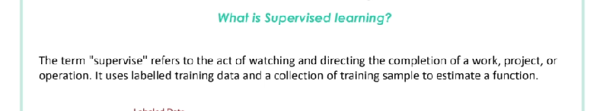

In supervised learning they uses patterns to predict and put output on unlabeled data. It uses historical data to make prediction on current data. In this we put labels on training data

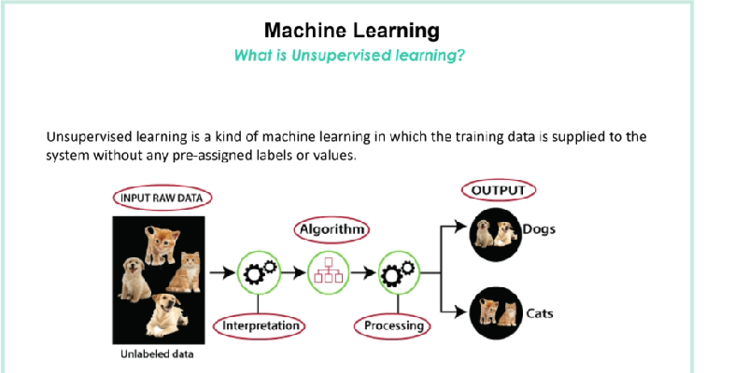

In unsupervised learning the model will finds the hidden similar pattern on raw data to classify it.

