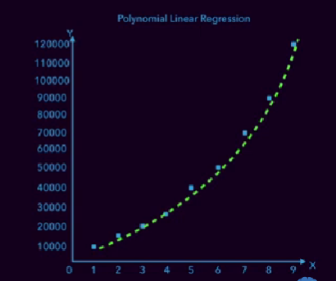

Used to fit this type of curved line model’s data.

**HOW TO IMPLEMENT IT**

