CNNs are a class of deep neural networks designed to process and analyze structured, grid like data, such as image.

They have revolutionized the field of computer vision and are widely used in tasks such as image classification, object detection, and segmentation.

So convolutional neural networks have transformed the field of computer vision

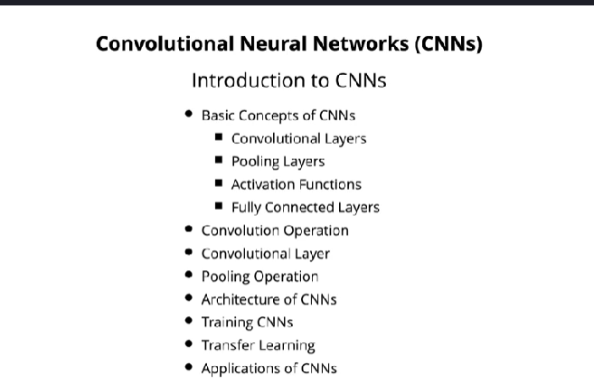

**Basic concepts of CNNS**

Convolutional layers apply convolution operations to input data, extracting features through learnable filters or kernels. These filters capture spatial pattern in the input.

Pooling layers downsample the feature maps produced by convolutional layers, reducing their spatial dimensions while retaining important information.

Nonlinear activation functions such as ReLU.

Rectified linear unit, which we have seen before, are applied after convolutional and pooling layers to introduce nonlinearity into the network and enable it to learn complex patterns.

fully connected layers are added to the network to perform classification or regression based on the learned features.

**Convolution operation:**

The convolution operation involves sliding a filter, also known as a kernel, over the input data,

and computing the element wise multiplication between the filter and the corresponding input patch,

**Convolutin Layer**

A convolutional layer consists of multiple filters that slide over the input data, each producing a

feature map by convolution convolving with the input.

These features feature maps represent different learned patterns or feature present or features present

in the input.

**Pooling operation:**

The pooling pooling layers reduce the spatial dimensions of feature maps by downsampling.

Max pooling, for example, selects the maximum value within each pooling window, while average pooling

computes the average value.

**Architect of CNNS:**

CNN architecture typically consists of alternating convolutional and pooling layers, followed by fully

connected layers for classification or regression.

Modern architectures, such as the VGG, GPS, ResNet and inception are deeper and more complex, achieving

state of the art performance on various tasks.

**Training CNNS:**

CNNs are trained using using gradient based optimization algorithms such as stochastic gradient descent,

which is SGD, Adam or Rmsprop, which we saw before.

The loss function measures the discrepancy between the predicted outputs and the actual labels, and

back propagation is used to update the network's parameters like weights and biases to minimize the

loss.

**Transfer learning:**

Transfer learning is a common technique in CNNs, where pre-trained models trained on a large data set

example ImageNet, are fine tuned on smaller data sets or specific tasks.

This approach leverages the learned features from pre-trained models and adapts them to the new task,

often leading to improved performance with less data.

**Application of CNN:**

image classification, object detection, facial

recognition, medical image analysis, autonomous vehicles, and more.